Victoria’s Accommodation Sector 2022-23
  - Data from the Australian Accommodation Monitor (includes properties with 10 or more rooms only).
  - This report was produced by the Tourism and Events Research Unit from the Department of Jobs, Skills, Industry and Regions, Victorian Government, October 2023.

Table of contents
Key results for Victoria 2
Revenue 2
Room nights occupied 2
Revenue per available room 2
Occupancy 2
Luxury and upper upscale class accommodation 2
Upscale and upper mid class accommodation 2
Midscale and economy class accommodation 2
Key results for Melbourne 2
Revenue 2
Occupancy 3
Room nights occupied 3
Revenue per available room 3
Supply indicators for Victoria 3
Rooms available 3
Supply by accommodation type 3
Accommodation demand and supply 3
Occupancy rates 5
Data notes 5

Key results for Victoria

Revenue
- In 2022-23 Victoria’s accommodation sector generated $3.3 billion in total revenue.
- This represents a 82.9% increase from 2021-22.

Room nights occupied
- In 2022-23 Victoria’s accommodation sector noted 14.6 million rooms nights occupied.
- This represents a 57.7% increase from 2021-22.

Revenue per available room or RevPAR
- In 2022-23 Victoria’s accommodation sector noted $147.26 in revenue per available room.
- This represents a 73.0% increase from 2021-22.

Occupancy
- In 2022-23 Victoria’s accommodation sector noted an average occupancy rate of 65.9%.
- This represents a 49.2% increase from 2021-22.

Luxury and upper upscale class accommodation

- Generated $992.4 million in revenue in 2022-23.
- Noted an average occupancy rate of 64.6%. This was a 59.5% increase from 2021-22.
- Noted an average revenue per room of $198.41. This was a 74.5% increase from 2021-22.

Upscale and upper mid class accommodation

- Generated $1.4 billion in revenue in 2022-23.
- Noted an average occupancy rate of 66.1%. This was a 46.0% increase from 2021-22.
- Noted an average revenue per room of $131.10. This was a 73.0% increase from 2021-22.

Midscale and economy class accommodation

- Generated $661.8 million in revenue in 2022-23.
- Noted an average occupancy rate of 67.8%. This was a 41.7% increase from 2021-22.
- Noted an average revenue per room of $97.79. This was a 56.3% increase from 2021-22.

Key results for Melbourne

Revenue
- In 2022-23 Melbourne’s accommodation sector generated $2.2 billion in total revenue.
- This represents a 98.2% increase from 2021-22.

Occupancy
- In 2022-23 Melbourne’s accommodation sector noted an average occupancy rate of 66.9%.
- This represents a 57.8% increase from 2021-22.

Room nights occupied
- In 2022-23 Melbourne’s accommodation sector noted 9.9 million rooms nights occupied.
- This represents a 69.5% increase from 2021-22.

Revenue per available room or RevPAR
- In 2022-23 Melbourne’s accommodation sector noted $150.92 in revenue per available room.
- This represents a 86.0% increase from 2021-22.

Supply indicators for Victoria

Rooms available
- In 2022-23 Victoria’s accommodation sector noted 22.1 million rooms available.
- This represents a 5.7% increase from 2021-22.

Supply by accommodation type
- 11.2 million hotels and resorts in 2022-23, up by 8.8% compared to 2021-22.
- 5.7 million serviced apartments in 2022-23, up by 5.7% compared to 2021-22.
- 4.3 million motels, private hotel and guest houses in 2022-23, down 0.9% compared to 2021-22.
- 968,600 holiday parks in 2022-23, up by 3.4% compared to 2021-22.

Accommodation demand and supply
- Recovery in accommodation occupancy in Victoria has accelerated in 2023, buoyed by pent up demand and boosted during key events such as the Formula One Grand Prix in March.
- Overall occupancy in Victoria has recovered back to a rate of 63.0% in the June 2023 quarter as travel demand has continued to strengthen.
- Supply in Victoria has grown by 5.7% year-on- year to 22.1 million rooms available in 2022-23.

Victorian accommodation establishments 10+ Rooms. Quarterly supply, demand and occupancy rates.
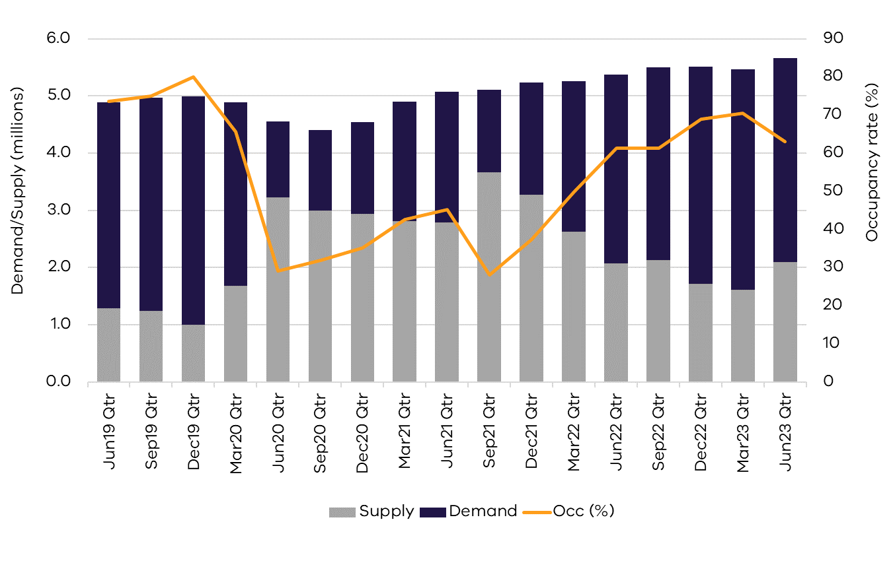

Occupancy rates
- Hotels and resorts noted the highest demand in March 2023 at 76.4%, with serviced apartments at 74.0% and motels, private hotels and guesthouses at 72.4%. Occupancy rates were boosted in March by major events such as the Formula One Grand Prix and Ed Sheeran concert.
- Occupancy rates for all accommodation types have softened slightly in May/June 2023 in line with seasonal trends during the winter period.

Victorian accommodation establishments 10+ rooms monthly occupancy rates (%) from July 2019 to June 2023.
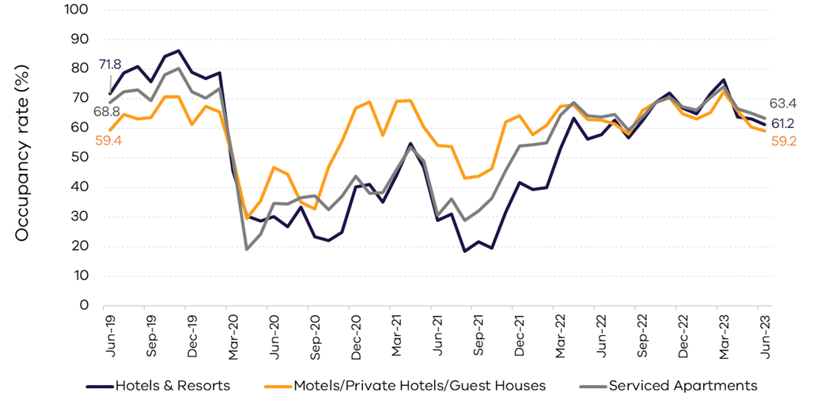

Data notes
Source: 2022-23 Australian Accommodation Monitor (AAM), STR, released in October 2023.
The report is available on the STR website: https://str.com/whitepaper/australian-accommodation-monitor-summary-financial-year-performance-2022-2023

The 2022-23 AAM results for Victoria are based on a sample of 423 properties, with 10 or more rooms, out of a census of 1,121 properties (or 41,968 rooms out of a total 62,566 rooms).
Accommodation establishments included are:
- hotels and resorts
- motels, private hotels and guest houses
- serviced apartments
- holiday parks.

To note: some estimates have been updated in this release and do not reflect previously reported figures. Revenue per available room is also noted in the industry as RevPAR.
Report produced by the Tourism and Events Research Unit
Department of Jobs, Skills, Industry and Regions (DJSIR)
Victorian Government
Data published October 2023

Due care is taken in the production of this factsheet, however DJSIR accepts no responsibility for use of this information. Data is considered correct at the time of publishing.
Please contact the Research team at email address: research@ecodev.vic.gov.au with any queries.

