Victoria’s Accommodation Sector 2023-24

Results from the Australian Accommodation Monitor (properties 10+ rooms)

# Table of contents

1.0 Key results for Victoria 2

1.1 Revenue 2

1.2 Room nights occupied 2

1.3 Revenue per available room or RevPAR 2

1.4 Occupancy 2

2.0 Luxury and upper upscale class accommodation 2

3.0 Upscale and upper mid class accommodation 2

4.0 Midscale and economy class accommodation 2

5.0 Key results for Melbourne 3

5.1 Revenue 3

5.2 Occupancy 3

5.3 Room nights occupied 3

5.4 Revenue per available room or RevPAR 3

6.0 Supply indicators for Victoria 3

6.1 Rooms available 3

6.2 Supply by accommodation type 3

7.0 Accommodation demand and supply 3

Chart 1. Victorian accommodation establishments 10+ Rooms. Quarterly supply, demand and occupancy rates. 4

8.0 Occupancy rates 4

Chart 2. Victorian accommodation establishments 10+ rooms monthly occupancy rates (%) from July 2019 to June 2024. 5

9.0 Data notes 5

# Key results for Victoria

## 1.1 Revenue

* In 2023-24 Victoria’s accommodation sector generated $3.5 billion in total revenue.
* This represents a 6.5% increase from 2022-23.

## 1.2 Room nights occupied

* In 2023-24 Victoria’s accommodation sector noted 15.9 million rooms nights occupied.
* This represents an 8.4% increase from 2022-23.

## 1.3 Revenue per available room or RevPAR

* In 2023-24 Victoria’s accommodation sector noted $149.19 in revenue per available room.
* This represents a 1.6% increase from 2022-23.

## 1.4 Occupancy

* In 2023-24 Victoria’s accommodation sector noted an average occupancy rate of 68.3%.
* This represents a 4.0% increase from 2022-23.

# 2.0 Luxury and upper upscale class accommodation

* Generated $1.1 billion in revenue in 2023-24.
* Noted an average occupancy rate of 67.9%. This was a 6.6% increase from 2022-23.
* Noted an average revenue per room of $201.12. This was a 2.7% increase from 2022-23.

# 3.0 Upscale and upper mid class accommodation

* Generated $1.4 billion in revenue in 2023-24.
* Noted an average occupancy rate of 69.0%. This was a 3.8% increase from 2022-23.
* Noted an average revenue per room of $133.86. This was a 1.7% increase from 2022-23.

# 4.0 Midscale and economy class accommodation

* Generated $658.3 million in revenue in 2023-24.
* Noted an average occupancy rate of 66.3%. This was a 0.8% decrease from 2022-23.
* Noted an average revenue per room of $94.49. This was a 2.9% decrease from 2022-23.

# 5.0 Key results for Melbourne

## 5.1 Revenue

* In 2023-24 Melbourne’s accommodation sector generated $2.4 billion in total revenue.
* This represents an 8.4% increase from 2022-23.

## 5.2 Occupancy

* In 2023-24 Melbourne’s accommodation sector noted an average occupancy rate of 70.4%.
* This represents a 5.2% increase from 2022-23.

## 5.3 Room nights occupied

* In 2023-24 Melbourne’s accommodation sector noted 11.0 million rooms nights occupied.
* This represents a 11.0% increase from 2022-23.

## 5.4 Revenue per available room or RevPAR

* In 2023-24 Melbourne’s accommodation sector noted $154.13 in revenue per available room.
* This represents an 2.2% increase from 2022-23.

# 6.0 Supply indicators for Victoria

## 6.1 Rooms available

* In 2023-24 Victoria’s accommodation sector noted 23.3 million rooms available.
* This represents a 4.3% increase from 2022-23.

## 6.2 Supply by accommodation type

* 11.9 million hotels and resorts in 2023-24, up by 5.1% compared to 2022-23.
* 6.0 million serviced apartments in 2023-24, up by 5.3% compared to 2022-23.
* 4.3 million motels, private hotel and guest houses in 2023-24, up 1.2% compared to 2022-23.
* 1.1 million holiday parks in 2023-24, up by 3.2% compared to 2022-23.

# 7.0 Accommodation demand and supply

Accommodation demand strengthened.

* Accommodation occupancy in Victoria has remained solid in 2023-24, boosted by key events such as the Australian Formula One Grand Prix in March.
* Overall accommodation occupancy in Victoria in 2023-24 averaged a rate of 68.3%, reflecting good momentum in demand.
* Supply in Victoria has grown by 4.3% year-on-year to 23.3 million rooms available in 2023-24.

# Chart 1. Victorian accommodation establishments 10+ Rooms. Quarterly supply, demand and occupancy rates.A stacked bar chart showing supply and demand for Victorian accommodation from June quarter 2019 quarter to June quarter 2024. A line graph shows changes in occupancy rates for accommodation in this period. Occupancy rates have fluctuated in this time and declined sharply during the COVID-19 period. However, have strengthened in 2023-24, peaking in key periods such as in the March quarter during the Australian Formula One Grand Prix.

# 8.0 Occupancy rates

Solid performances were noted across accommodation categories.

* Hotels and resorts (76.4%) noted the highest demand in March 2024 boosted by major events such as the Australian Formula One Grand Prix.
* In February, peak occupancy rates were recorded for serviced apartments (76.7%) and motels/private hotels/guesthouses (71.6%), largely driven by the heightened demand generated by Taylor Swift's concerts.
* Occupancy rates for all accommodation types have softened slightly in May/June 2024 reflecting seasonal trends during the winter period, as well as broader weakening in travel demand as cost-of-living pressures mount.

## Chart 2. Victorian accommodation establishments 10+ rooms monthly occupancy rates (%) from July 2019 to June 2024.

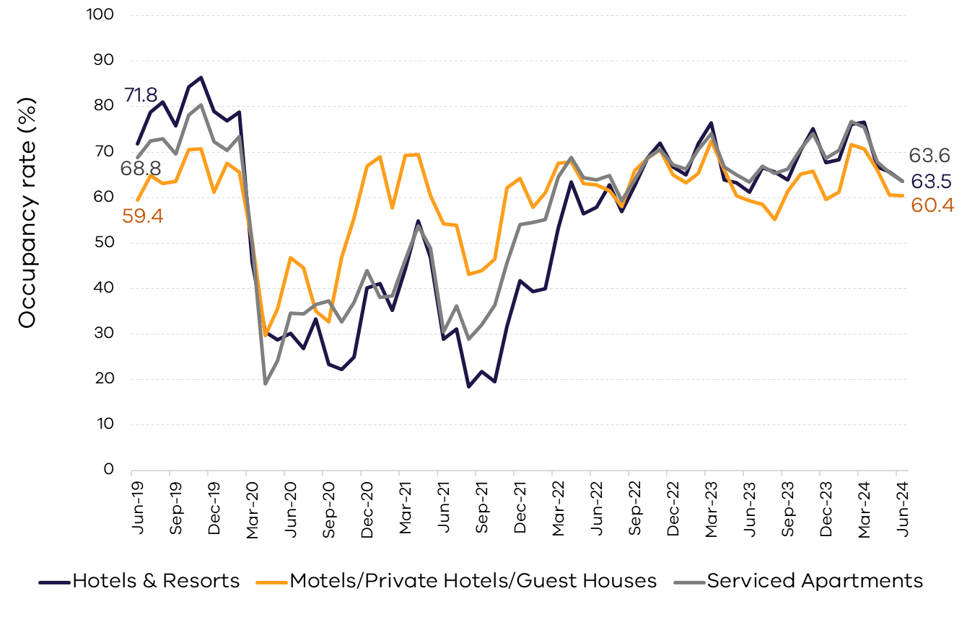

# 9.0 Data notes

Source: 2023-24 Australian Accommodation Monitor (AAM), STR, released in October 2024.

The report is available on the [STR website](https://str.com/aam).

The 2023-24 AAM results for Victoria are based on a sample of 443 properties, with 10 or more rooms, out of a census of 1,143 properties (or 43,839 rooms out of a total 64,166 rooms).

Accommodation establishments included are:

* hotels and resorts
* motels, private hotels and guest houses
* serviced apartments
* holiday parks.

To note: some estimates have been updated in this release and do not reflect previously reported figures.

Revenue per available room is also noted in the industry as RevPAR.

Report produced by the Tourism and Events Research Unit

Department of Jobs, Skills, Industry and Regions (DJSIR)

Victorian Government

Data published October 2024.

Due care is taken in the production of this factsheet, however DJSIR accepts no responsibility for use of this information. Data is considered correct at the time of publishing.

Please contact the Research team with any queries at [research@ecodev.vic.gov.au](mailto:research@ecodev.vic.gov.au).