A guide to tourism investment
  - From concept to reality
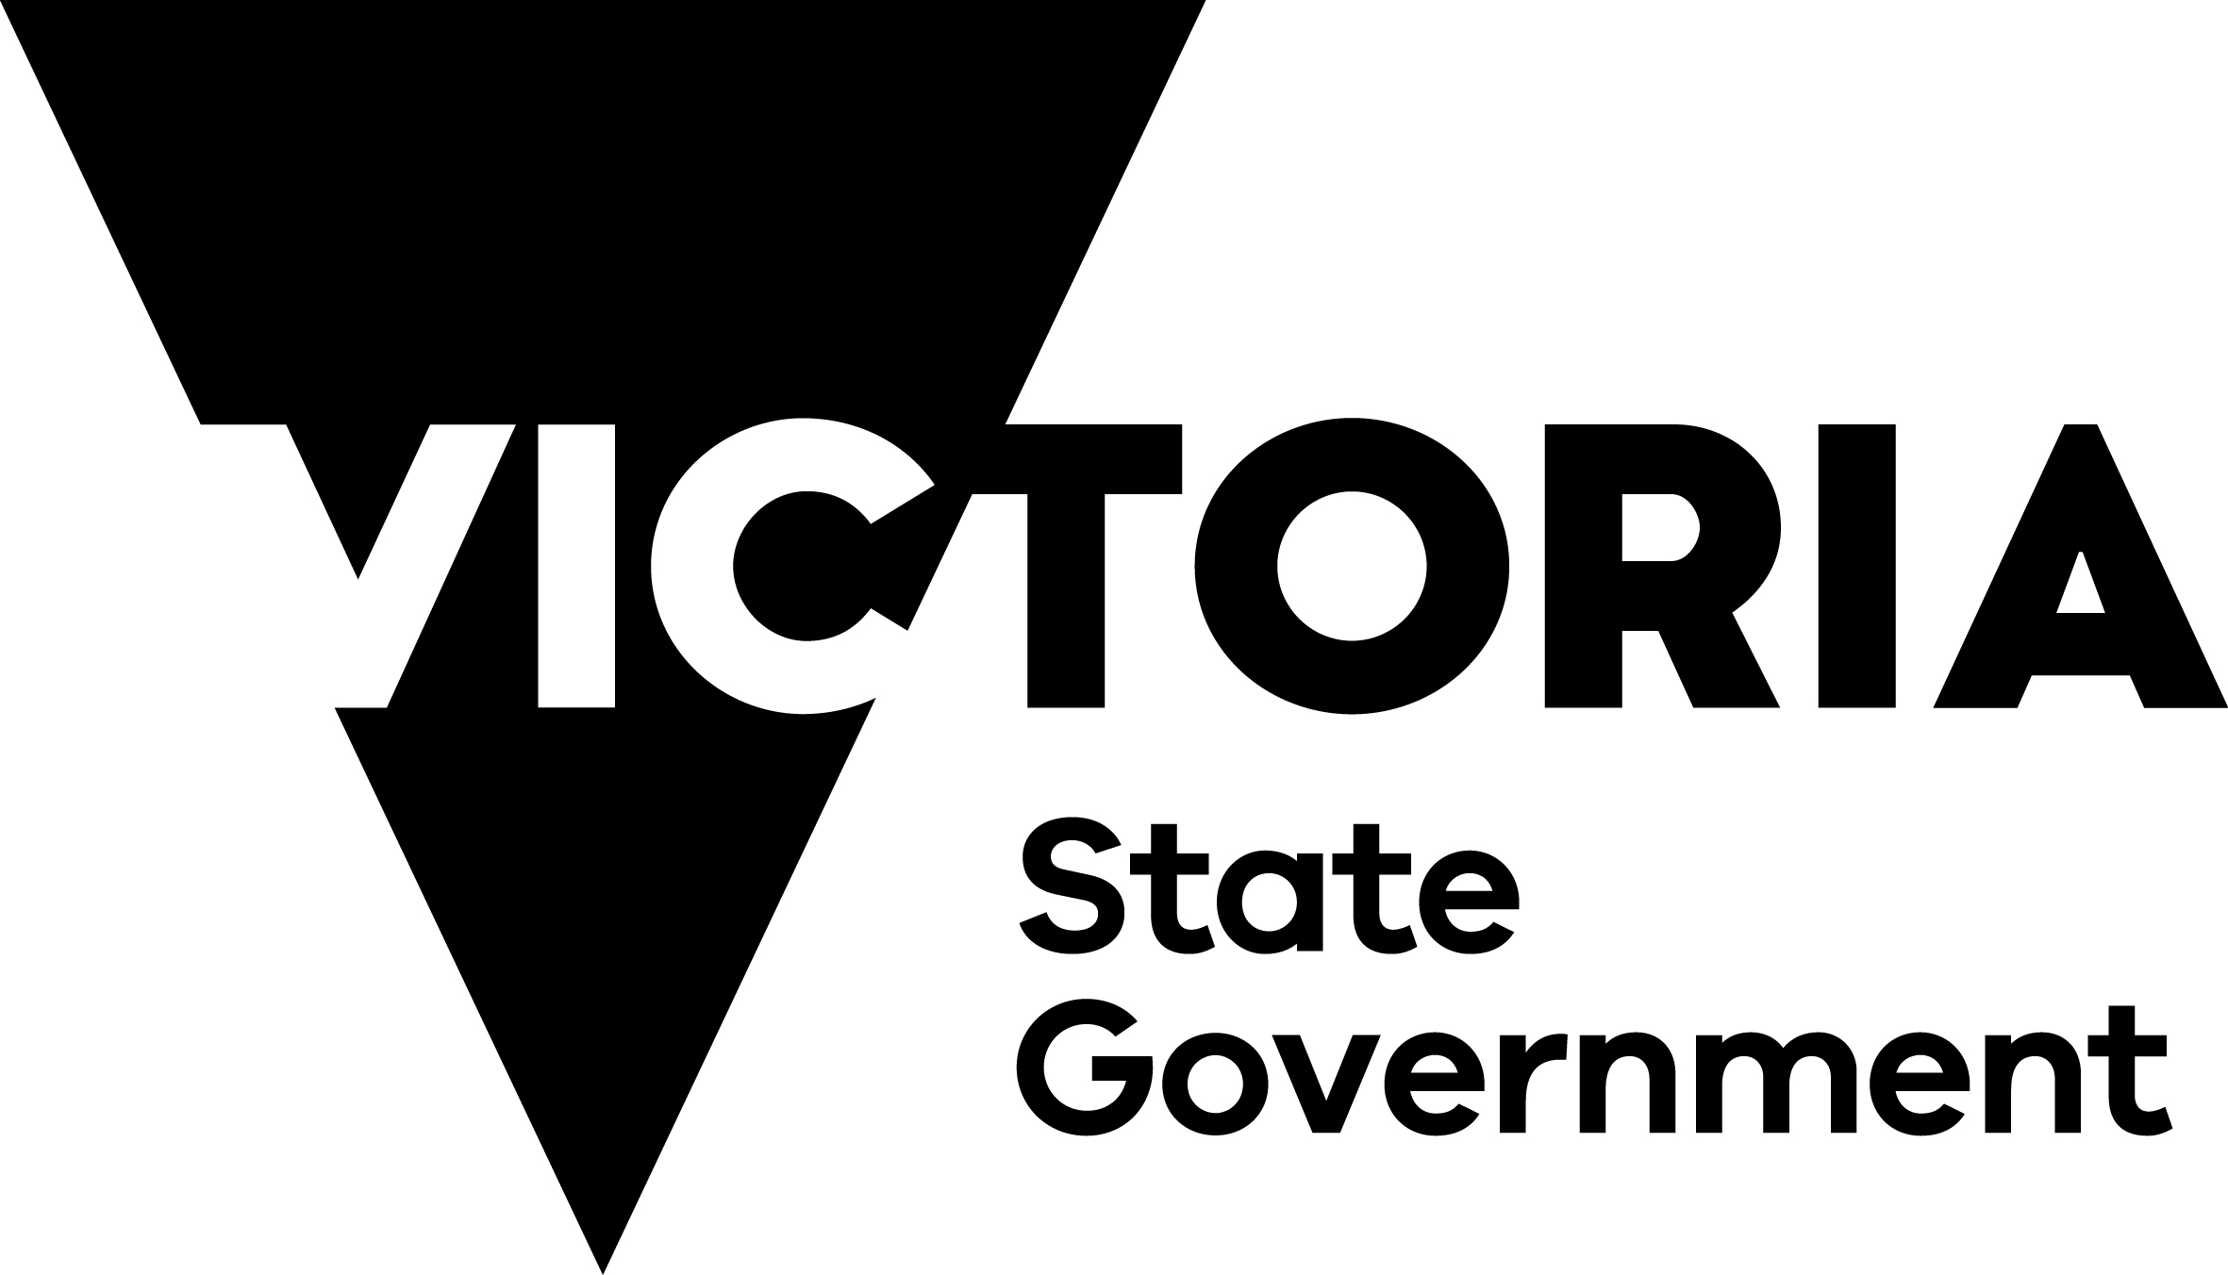
This guide has been created to help you successfully invest in Victoria’s visitor economy. Our visitor economy is dynamic and competitive.

Table of Contents
Message from the Minister 4
Acknowledgement of Country 5
Language statement 5
About this guide 6
Purpose of this guide 6
Acknowledgement of contributors 6
What is the investment lifecycle? 7
Key success factors 8
Who should use this guide? 9
Should I seek professional advice? 9
The Victorian Government’s role 9
Tourism Entities 10
Tourism investment lifecycle summary 11
Introducing Registered Aboriginal Parties (RAPs) 12
The Victorian Government’s commitment to self-determination 13
Potential Project Benefits 13
Phase 1 14
Testing the concept 14
Idea Development 14
Defining your idea 15
Defining the visitor experience 16
Defining your investment motivation and budget 17
Motivation 17
Budget 17
Market Assessment 18
Site analysis 28
Investment Proposal 34
Early business planning 45
Phase 2 64
Preparing for investment 64
Project planning and approvals 70
Detailed business planning and funding strategy 89
Detailed design 95
Phase 3 100
Construction and delivery 100
During construction 106
Completion and post–construction 108
Phase 4 111
Product launch 111
Marketing 115
Future expansion 117
Budj Bim Cultural Landscape 118
Puffing Billy Railway Lakeside Visitor Centre 120
Green Olive at Red Hill 122
Metung Hot Springs 123
Silverwoods Resort Yarrawonga 125
Melbourne Cable Park 126
Glossary 127

Message from the Minister
Victoria is home to some of Australia’s best tourism experiences.
From our spectacular coastal drives, picturesque High Country, world-class food and drink venues to an enviable calendar of major events, no matter where you find yourself on the map there are incredible cultural, sport and creative experiences that welcome millions of visitors each year.
Tourism supports Victoria’s economy through direct spending, employment, and investment. In 2021-22, tourism in Victoria was estimated to be worth $16 billion to the economy in Gross State Product and generated approximately 171,100 filled jobs. The Victorian Government recognises that Victoria’s tourism businesses, local government and investors need direction to help the industry thrive into the future. A guide to tourism investment: from concept to reality provides step-by-step advice on how to progress new and enhanced visitor experiences and helping tourism investors buy into our booming visitor economy.
Our goal is to enable great ideas and projects, and this guide showcases Victoria’s tourism investment potential and serves as a guiding document to support our much-loved attractions to grow. Supporting new ideas to progress through the investment lifecycle including concept development, project feasibility, financing, design, approvals, construction and product launch are also a major focus of the guide.
It supports delivery of our Experience Victoria 2033 strategic plan by leveraging the state’s competitive product priorities: Wellness, Arts and Culture, First Peoples-led experiences, Food and Drink, and Nature to grow visitor expenditure towards the projected $58 billion by 2033.
We are proud of what our state has to offer, and we are delighted to present this valuable industry resource because the more investment and visitors we attract, the more jobs we create and businesses we support.
Steve Dimopoulos MP
Minister for Tourism, Sport and Major Events

Acknowledgement of Country
The landscapes of Victoria are home to diverse Nations. For more than 60,000 years, the First Peoples in Victoria have cared for and nurtured Country. The lands and waters are a living cultural landscape. We acknowledge the Traditional Owners of the lands and waters throughout Victoria, and we pay our respects to their Elders past and present.
We recognise the rights and aspirations of Victorian First Peoples and acknowledge their self-determination is a human right enshrined in the United Nations Declaration on the Rights of Indigenous Peoples.
Building on this and guided by the 11 principles of First Peoples’ Self-Determination, we aim to enable true self-determination for Victoria’s First Peoples by working towards a treaty – or treaties – with Traditional Owners and Aboriginal Victorians. This document acknowledges the growing demand for experiences celebrating Victoria’s rich and diverse First Peoples’ culture. It aims to encourage greater dialogue with Traditional Owners and the First Peoples of Victoria to ensure initiatives are self-determined and reflect their aspirations and priorities.

Language statement
We recognise the diversity of First Peoples living throughout Victoria. While the terms ‘Koorie’ or ‘Koori’ are commonly used to describe First Peoples of South East Australia, we have used the term ‘First Peoples’ to include all Aboriginal and/or Torres Strait Islander people in Victoria.

About this guide
The tourism industry is reaching new heights globally. In Victoria, tourism spend and visitation have grown dramatically over the last two decades. Victoria has appealing natural attractions, arts and culture, food and drink experiences, and sports and cultural events. Victorian tourism supports unique, artisanal and authentic local offerings, as well as ‘hidden gems’, history and heritage, and First Peoples-led experiences.
Tourism is a dynamic and competitive industry. Factors affecting the sector’s performance and operation include:
- Rapid technology changes.
- Market influences.
- Social influences.
- Climate change and natural disasters.
- Dynamic consumer preferences and aspirations.
Understanding the full spectrum of factors, and how they influence, and drive visitor behaviour is essential for a successful and sustainable tourism industry.

Purpose of this guide
This guide sets out an ideal pathway for successful investment in the tourism sector. Successful tourism projects need strategic direction, a coordinated approach and consideration of all stages of the investment lifecycle.
This document should serve as a useful reference tool for project owners looking to develop tourism products. Depending on the project status, we encourage you to use the sections that are relevant to your project.

Acknowledgement of contributors
In developing this document, the Victorian Government consulted with investors, operators and developers in the tourism sector. Many local councils and government departments provided input and advice. We also engaged with several Registered Aboriginal Parties (RAPs) and First Peoples majority-owned businesses, including Traditional Owners. We acknowledge and thank these contributors for their support to develop this document.

What is the investment lifecycle?
The Investment Lifecycle includes the key steps required to establish a successful tourism project in Victoria. By following the steps in the lifecycle, this guide can help you turn an idea into an operational and sustainable product.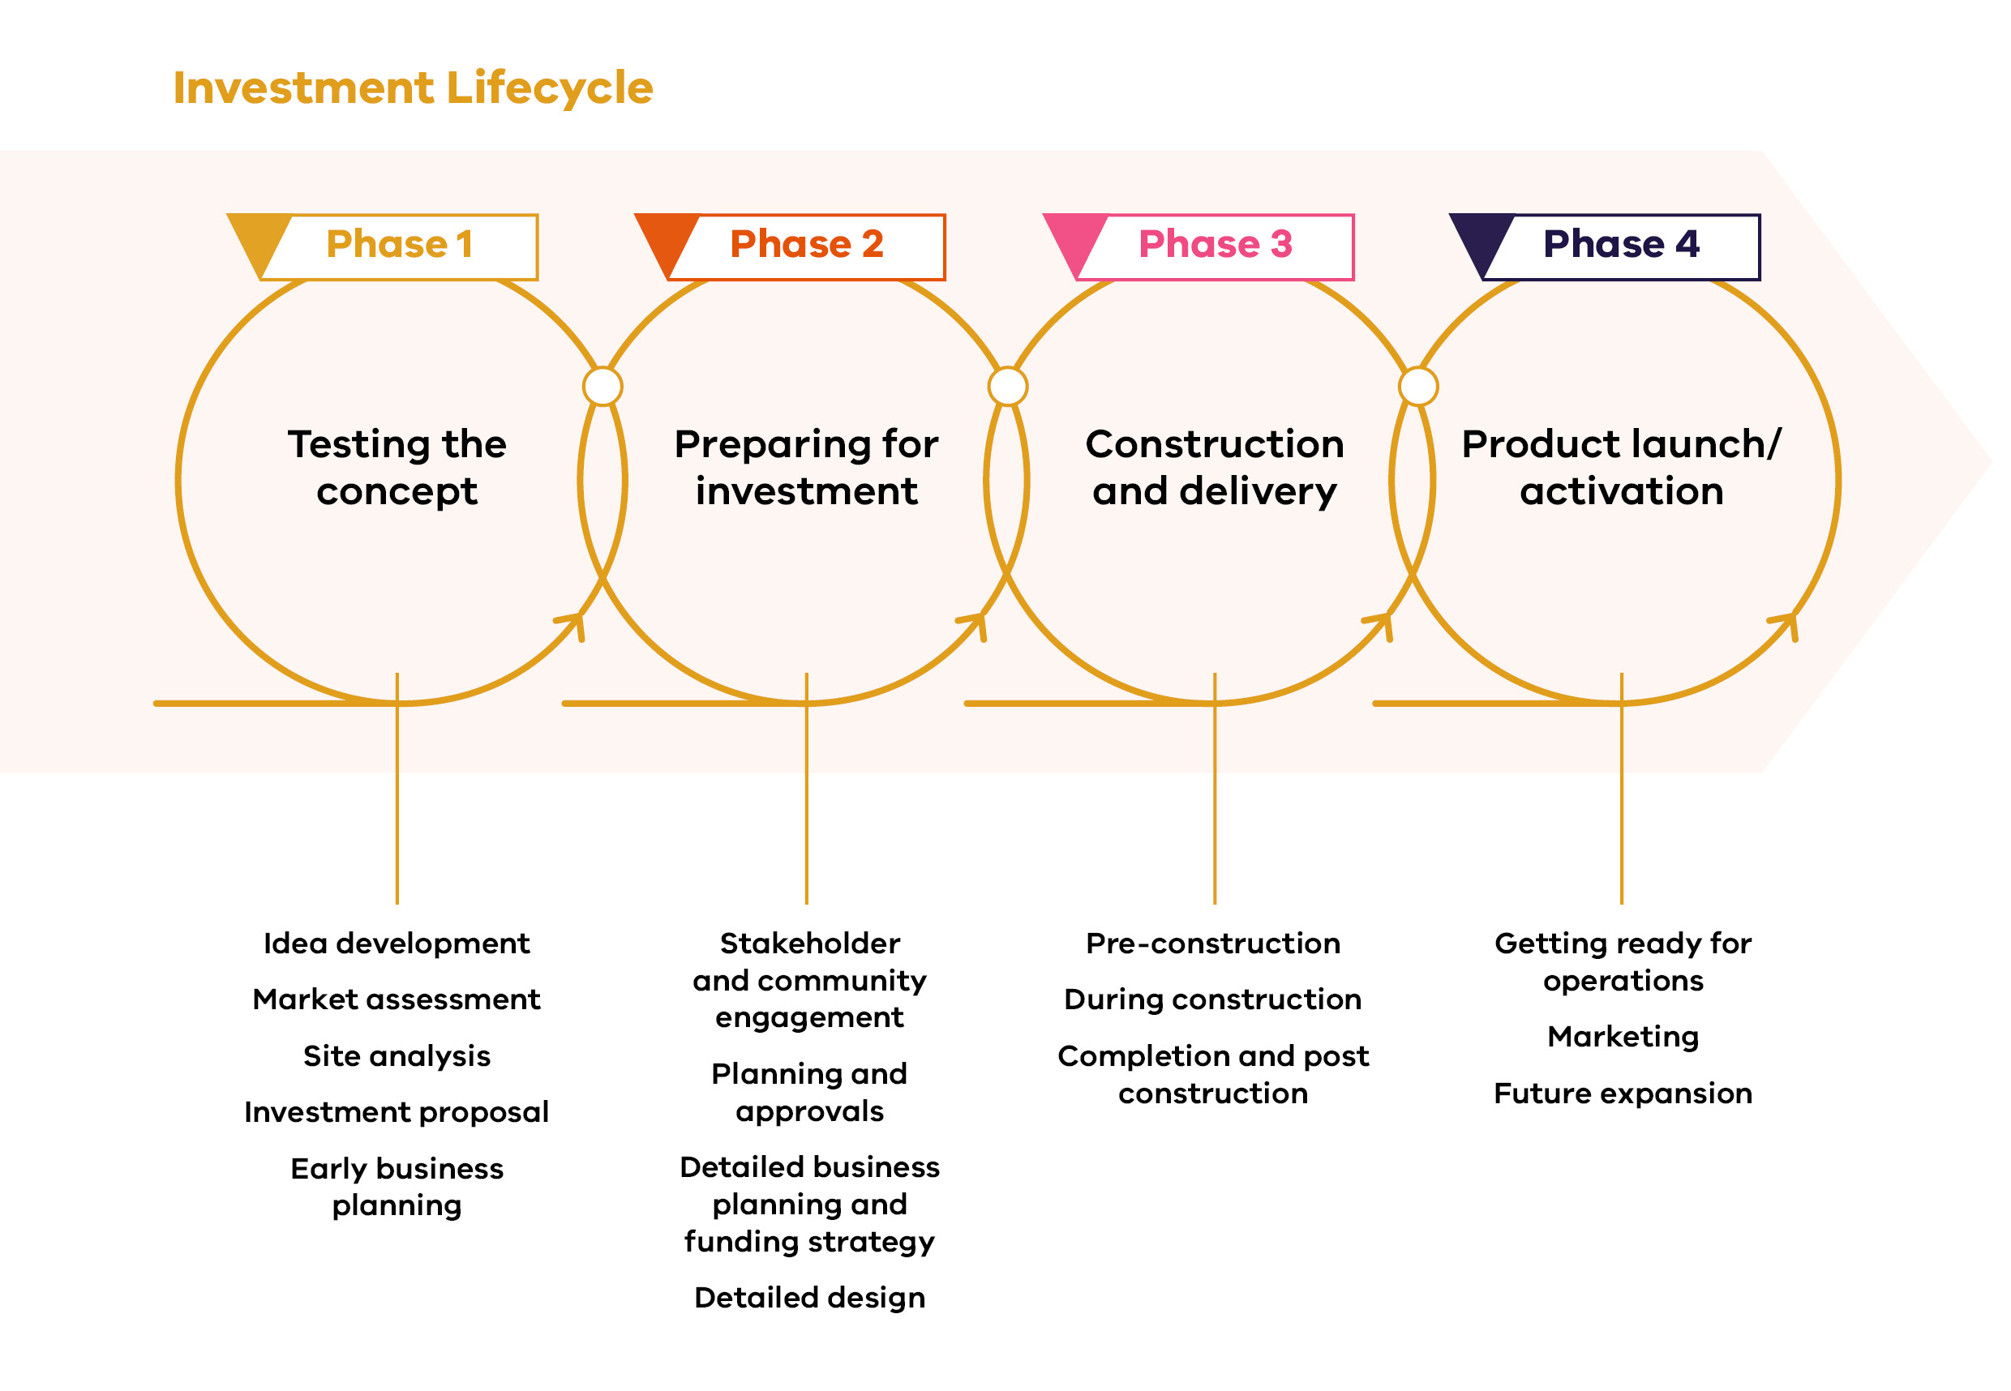
This document provides details on:
- Developing an idea into a realistic project.
- Identifying target markets and where to find information to help you do this.
- Defining the visitor experience.
- Confirming the suitability of a site and its appeal to the market.
- Engaging with community, industry and stakeholders to inform the project.
- Demonstrating project feasibility and viability.
- Obtaining development approval for the project, as well as identifying key risks.
- Obtaining finance for the development.
- Progressing the project to detailed design, tendering and construction.
- Reinforcing quality and cost control during the construction phase.
- Setting up your organisational structure and marketing plan.
- Launching the project.
By the end of this document, you should understand what success looks like. Below is a list of the key success factors.

Key success factors
- Point of difference – The project is based on a unique idea that is market tested.
- Quantified market demand - There is comprehensive research on the target market and consumer preferences.
- Defined visitor experience - You have defined the visitor experience for your project.
- Location, location, location - The location suits the proposed use and enhances its appeal through transport access and supporting facilities.
- Community support - You have consulted with the community and can clearly outline the benefits your project will deliver to the community.
- Sustainable design - The project is designed for your visitors, budget and the surrounding environment.
- Financial feasibility - The financial viability of your project has been tested and risk areas have been identified. The project meets required hurdle rates of return on investment and is not over-capitalised.
- Manage the approvals process - The approval processes are understood, and you have consulted broadly to minimise delays.
- Sound business plan - You have a detailed business plan and, are able to obtain financing.
- Effective construction management - Construction activities have been managed to ensure that your project will be delivered on time and budget. You have a project manager responsible for project delivery.
- Clear marketing strategy - You understand your audience: your marketing strategy understands the needs and preferences of the visitors you want to attract.
- Experienced specialist advisors - You have chosen experienced specialists to advise and assist in the project throughout its various stages.
- Strong partnerships - If you are seeking a business partner, either for operations or capital funding, you are clear about the terms of your partnership.

Who should use this guide?
This guide is for project owners of tourism investments – everyone from people with an idea, to those in development, or who are already operating a tourism project. This guide is suitable for sole traders, small and medium enterprises, and large-scale tourism investors.

Should I seek professional advice?
You should consult qualified advisors for investment. You can find experienced and suitable advisors by undertaking research. Advisors may include project managers, town planners, architects, civil and other engineers, landscape designers, marketing consultants, financial and legal advisors, or other specialists. Each advisor may be helpful for different project stages.
You can also speak to professional associations and tourism boards. To get the advice you need, define the scope of work in a written brief that includes expected costs, where possible.
This guide outlines where to seek advice.

The Victorian Government’s role
The Victorian Government supports investment in tourism by funding tourism agencies, grants, marketing and product development. Its role is to support Victoria to become Australia’s number one tourism destination.
This guide has been developed using principles from the Visitor Economy Recovery and Reform Plan (VERRP), and the Experience Victoria 2033 Plan. These plans outline the Victorian Government’s commitment to supporting investment and project facilitation for priority tourism investment and development.

Visitor Economy Recovery and Reform Plan
The Visitor Economy Recovery and Reform Plan (2021) (VERRP) outlines key directions for reforming and directing Victoria’s visitor economy. Victoria’s key regional tourism objectives outlined in the VERRP are:
- Strengthening the state’s tourism offering.
- Making the most of the state’s marketing spend.
- Supporting industry.
- Enhancing regional tourism boards.
- Better coordination across government, industry, and the community.
Learn more about the Visitor Economy Recovery and Reform Plan

Experience Victoria 2033
The Victorian Government’s Experience Victoria 2033 is Victoria’s strategy to drive tourism development over the next ten years. This plan positions Victoria as a tourist destination now, and into the future.
The plan has five product priorities which guide tourism investment in Victoria:
- First Peoples-led experiences
- Wellness
- Arts and culture
- Nature
- Food and drink
Learn more about Experience Victoria 2033.

Tourism Entities
In addition to the Victorian Government, there are several other tourism bodies that can support investment and the success of your project.

Visit Victoria – Tourism Marketing
Visit Victoria is Victoria’s tourism and events company. Its role is to drive visitation and expenditure through destination marketing, and ensuring a strong pipeline of major, regional and business events that support the visitor economy. The company aims to build Melbourne and Victoria into Australia’s number one tourism destination by delivering strong and sustainable growth across priority markets.
Visit Victoria is headquartered in Melbourne and has satellite offices in London, Frankfurt, Shanghai, Beijing, Guangzhou, Tokyo, Singapore, and Los Angeles, and agency representation in Korea, India and Indonesia.
The company undertakes a wide range of marketing campaigns and public relations activities to promote tourism across the State. Visit Victoria assists with advice on priority markets, market intelligence, provides introductions to global markets via tradeshows and missions, gives advice and offers programs on marketing, and has a range of marketing tools to assist investors pre and post launch.

Melbourne Convention Bureau – Membership marketing and lead generation
As a part of Visit Victoria, Melbourne Convention Bureau (MCB) leads the acquisition and delivery of national and global business events for Melbourne and regional Victoria. They offer membership marketing, partnerships and lead generation for events both locally and abroad. Co-located with Visit Victoria in Melbourne, the MCB also has representation in the United Kingdom, United States of America, China, and Malaysia.

Regional Tourism Boards (RTBs) – Partnerships and capability building
RTBs can act as a key connection between project owners, other tourism providers and local services to build capability and provide marketing opportunities to boost the local visitor economy. The regional tourism network is undergoing a reform process that will see RTBs transition into Visitor Economy Partnerships (VEPs). For more information, select corporate.visitvictoria.com/resources/our-ecosystem/regional-tourism-boards.

Victoria Tourism Industry Council – Training and networking opportunities
Victoria Tourism Industry Council (VTIC) is the dedicated peak body and leading advocate for Victoria’s tourism and events industry. VTIC connects and informs businesses in Victoria’s visitor economy. It offers advocacy, business support services, training and professional development, accreditation, and events and networking opportunities for project owners.

Tourism investment lifecycle summary
This guide will assist you to become part of the Victorian tourism industry, by providing advice across the investment lifecycle. It includes four key phases to help you to plan and develop projects.
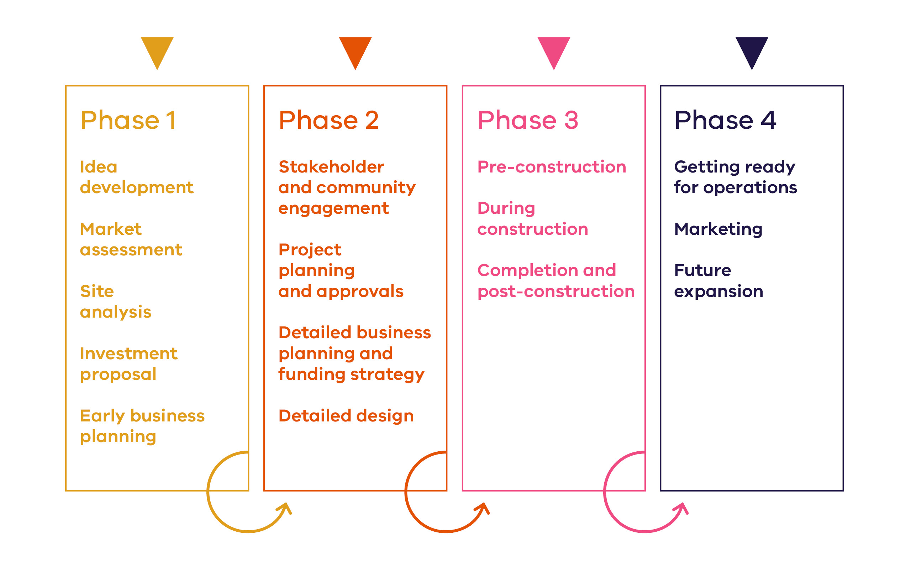
Following the steps in this guide can help you to turn an idea into an operational and sustainable product.

Introducing Registered Aboriginal Parties (RAPs)
The Aboriginal Heritage Act 2006 aims to recognise, protect, empower, strengthen and promote Aboriginal Peoples in Victoria, respecting knowledge, culture and traditional practices. As Victoria shifts towards treaty, the government recognises the importance of supporting self-determination, engaging and working with RAPs throughout the planning and development process. The role and function of RAPs, in accordance with the Aboriginal Heritage Act, should be considered and can include:
- Evaluating Cultural Heritage Management Plans.
- Assessing Cultural Heritage Permit applications.
- Making decisions about Cultural Heritage Agreements.
- Providing advice on applications for interim or ongoing Protection Declarations.
- Entering into Aboriginal Cultural Heritage Land Management Agreements with public land managers.
- Nominating Aboriginal Intangible Heritage to the Victorian Aboriginal Heritage Register and managing Intangible Heritage Agreements.
To identify and consult with a RAP, refer to Phase 2: Stakeholder and community engagement.

The Victorian Government’s commitment to self-determination
The commitments to self-determination and treaty are enshrined in law by the Victorian Government. You can embed self-determination throughout all phases of the project lifecycle and by considering the following questions:
- What opportunities are there for your project to support the aspirations of the Traditional Owners, local First Peoples community, to connect with Country and the local community?
- What opportunities are there for your project to benefit through engagement with RAPs, Traditional Owners, and First Peoples majority-owned businesses?
- When and how can you engage with RAPs, Traditional Owners, and First Peoples majority-owned businesses?
- What type of support would you like from RAPs, Traditional Owners, and First Peoples majority-owned businesses?
Self-determination is defined by the Victorian Government, as per the United Nations Declaration on the Rights of Indigenous Peoples, as the right of Aboriginal and Torres Strait Islander peoples to ‘freely determine political status’ and ‘freely pursue their economic, social and cultural development’.
It is recommended that these questions are considered early, and that you design your project to support self-determination.

Potential Project Benefits

The Victorian Closing the Gap Implementation Plan (2021-2023)
Tourism in Victoria can contribute to:
- First Peoples youth engaged in employment or education. (Outcome 7).
- Strong economic participation and development of First Peoples and communities. (Outcome 8).
- First Peoples cultures and languages are strong, supported and flourishing. (Outcome 16).

Yuma Yirramboi – Invest in Tomorrow Strategy
Tourism in Victoria can contribute to the economic participation of First Peoples through:
- Leveraging ‘locally driven cultural practices and rights to place and Country to enhance economic prospects through land and sea management, such as cultural burning and cultural tourism opportunities’.
- RAPs explore opportunities such as commercial tourism to ‘generate income by activating the Aboriginal and Torres Strait Islander Estate’.

Phase 1

Testing the concept
Stakeholders to engage with during this phase:
- Local Government.
- Registered Aboriginal Parties (RAPs) and Traditional Owners.
- State Government authorities and utility service providers.
- Local community, landowners, residents and business owners near your selected site.
Things you will know by the end of this stage:
- The type of project that you will develop.
- How visitors will engage with the product or experience.
- The proposed initial visitor experience.
- The investment motivation.
- Initial project budget.
- The plan for engaging with First Peoples.

Idea Development
The most successful tourism projects have a clearly defined visitor experience. This guide will help you develop a concept that offers quality products and visitor experiences.
To create the best experience for your visitors, you must understand them. By understanding the market, you can identify market segments for your idea or concept. Learn more in Phase 1: Market assessment.
Developing a tourism concept is an iterative process. Ask yourself:
- Is there, or will there be, demand for this project?
- How many visitors will this project attract?
What type of visitors (their characteristics) will this project attract?
It is likely your idea will change as you conduct your Market assessment. By regularly reassessing your idea, you can potentially deliver a great consumer experience.
To develop your idea, your initial analysis should be broad. You can refine your idea through research into similar concepts in comparable geographic areas; social, demographic and market trends, and data on economic or environmental change. Some suggested forms of research are:
- Informal discussion with communities and businesses.
- Observing market trends through news articles or social media.
Seeking tourism, economic or real estate data through web searches.
You should consider how tourism experiences are performing in different areas. If you cannot find examples of good performance, find out what factors might be contributing to this.

Defining your idea
Your first step is to come up with an idea that outlines:
- The type of project you intend to develop.
- The location of your project.
How it fits into the current tourism market or landscape.
As you continue to refine your idea, consider how you can align your concept with what is readily available in the market. How does your project add value to the surrounding neighbourhood, wider city, region or tourism industry? Ask yourself:
- What will your tourism business offer?
- Where will your tourism business operate?
- Are there similar businesses operating in the selected region?
- How does your project complement or differentiate itself from existing businesses?
What benefits can your tourism business bring to the region?

Defining the visitor experience
The visitor experience is fundamental to any tourism project, regardless of the scale or type of investment. Delivering a product or experience that leaves a positive impression on the visitor is just as important as the destination and infrastructure. Explain what the key components of your project are to leave your visitors with a memorable and marketable experience.
The visitor experience should consider their interaction with the physical infrastructure, environment and local culture. The visitor experience should consider their interaction with the physical infrastructure, environment and local culture. If your idea relies on, or integrates First Peoples culture, you need to get approval from those with cultural authority. This includes Registered Aboriginal Parties (RAPs) and Traditional Owners.
Visitors rarely visit only one attraction. Think about how your project can complement or leverage nearby offerings, creating a collective experience.
If your idea relies on culture as part of an experience or product, it is essential to engage and work with the local RAP and/or Traditional Owners for approval, and ideally work in partnership. Indigenous Cultural Intellectual Property (ICIP) rights protect the rights of First Peoples to their heritage and culture. ICIP covers:
- Literature.
- Performing and artistic works (copyrights).
- Languages and cultural knowledge.
- Tangible and intangible cultural property.
- Ancestral remains and genetic material.
- Cultural environmental resources.
- Sites of significance.
- Documentation of First Peoples heritage.
ICIP rights range from the right to tell cultural stories, to the right to use artworks and images in marketing. To formalise any agreement, you may need to obtain legal advice.
Now is the time to consider if you need to engage legal experts to help you.
To identify and consult with a RAP and/or Traditional Owners refer to Phase 2: Stakeholder and community engagement.

Defining your investment motivation and budget
Regardless of the scale of your idea, you will need to invest significant time and money. Having a clear understanding of your motivations and budget before you invest is vital as it impacts decision making.

Motivation
Your reason for investing will help you determine project objectives, your required returns on investment and your strategic direction. This will vary for different project owners, but may include:
- Developing a profitable new business as a primary source of income.
- Creating a social enterprise that uses profits to deliver social, cultural and environmental benefits.
- Using a landscape’s natural beauty to fund regeneration.
- Expanding the existing operations of a tourism business through new investment.
Developing an unused piece of land, providing higher value use.
As you may have multiple motivations, explain each one, to determine the central motivation of the project.
Defining your key motivation will help you:
- Understand your intended financial returns.
- Understand the benefits for the community.
- Find project partners who you are aligned with.
Develop engaging marketing materials for consumers.
This is particularly important as you move through the stakeholder engagement and approval phases of investment; if you decide to seek government support, understanding the social, cultural and environmental benefits can be helpful.

Budget
Before you progress with developing your project, you should have a clear idea of your budget, including construction costs, to reduce the risk of overspending. This can drive decisions on design, consultants, and project partners.
If you do not have sufficient budget to deliver your project all at once, consider how to stage your project. Regularly reviewing your budget ensures you are not spending more than you have available. Phase 1: Early business planning discusses testing budget and feasibility in more detail.

Market Assessment
Things you will know by the end of this stage:
- The target market and segment that will best respond to your product and overall visitor experience.
- Target market segment demand and viability.
- Your product response to market segments expectations.
- Current competition.
Product fit within the state and region’s branding and positioning strategy.
Understanding the size, nature and characteristics of your target market is essential. When developing a new tourism project, it is important to know:
- How it responds to real market need and consumer demand.
- The market segment(s) that will best respond.
- Ability to reach your market segment(s).
- The expected service standards by that market segment(s).
- The competition that already exists.
Product fit within the region’s branding and market positioning.
The ultimate goal of this process is to give confidence there is a genuine, viable market for your project. This helps you refine your idea so the final product is well defined and targeted before incurring significant expenses.

The market assessment process
You will need a broad understanding of the current market, looking beyond the immediate local market to a state, national and international level. The performance of other products can indicate your idea’s viability. The market assessment process involves four steps, not necessarily linear, that may need revisiting.
- Identifying and testing the potential market.
- Identifying potential competitors and alliances.
- Determining if the project is viable.
- Developing the branding and positioning strategy.

How to conduct market research
Market research involves data collection through research or direct engagement with consumers. Engaging with consumers through surveys or focus groups can give greater insights into visitors’ needs. Some of these methods include:
- Online surveys.
- Focus groups.
- Qualitative or quantitative data.
Personal interviews.
These responses can help you understand your visitors’ intentions on a personal level, including:
- Their travel intentions.
- Their willingness to pay for certain experiences.
- Their sensitivity to price changes.
The attractiveness of your visitor experience and the end product.
Now is the time to consider if you need to engage a market research agency to help you.

Step 1: Identifying and testing the potential market
A market segment is a group of people that share common characteristics, likely to react in a similar way to tourism offerings. Have a clear understanding of your target market segments.
Different segments in the tourism market reflect people’s diverse tastes, interests, values and priorities. A market segment can be one that is already served by a product, or one whose needs are not fully met.
To maximise appeal, try to find which market segment best responds to your project, maximising your potential return on effort and financial investment. Their demands can help refine your visitor experience over time. To build customer awareness and interest, tailor your marketing strategy to your market segment.
When defining your target market segment, there are three broad areas you need to understand:
- The location of your visitors (target market).
- The purchasing preferences and values of these visitors (target audience).
- The current trends in the tourism market (market trends).

Target market
Have a clear understanding of where you expect your visitors to come from, so you can tailor your product, and to finalise your pricing and marketing strategies appropriately. Visitors from different locations have different requirements including cultural considerations, length of stay, spending patterns and habits.

Target audience
Understand what appeals to your visitors. Investigate the visitor experience and value proposition; test various options including your target audience’s intention to visit, price sensitivity and what they are willing to pay.

Market trends
Understanding trends in the tourism market before investing is essential. Current and emerging trends drive activity in tourism, and the success of your project. Observing wider social and economic visitor experience trends helps you anticipate problems and capitalise on opportunities. Global trends can provide valuable insights into consumers’ preferences.
Visit Victoria has further information to help you understand your target market segment(s) and their needs. You can find this on the Visit Victoria website - select corporate.visitvictoria.com/resources/industry-development. Or, for further insight, refer to the links and resources later in this section.

Datapoints you will need to consider before progressing your project
The travel patterns of different markets, including:
- Characteristics of domestic or international visitors (for example, group size or mode of transport).
- Volume of current and future travel from these markets.
Seasonal visitation trends from those markets.
The spending habits of different markets, including:
- Average length of stay for different visitor groups.
- Average dollars spent per day by visitors.
Focus of spending (for example, on accommodation, meals, entertainment or activities).
Visitor preferences and trends, including:
- Visitors’ needs and expectations from a tourism product or experience.
- Emerging and changing preferences, motivations and behaviours.
Cultural requirements or preferences.
Broader tourism market trends, including:
- Current and future tourism and visitation activity in the target region.
- Trends affecting the tourism industry in Australia.
- Trends affecting the tourism industry globally.
- Whether trends differ in your region.

Step 2: Identifying potential competitors and alliances
To increase your chance of success, you need a competitive edge that positions your product, giving a point of difference in the market.

Who are my competitors?
Competition can come from planned products or available offerings. Where there is competition, there can be risk.
An existing operator in the market may already meet the demand for a product or experience. Unless you can offer a unique point of difference, this can lower potential market penetration.
By analysing potential competitors, you can understand:
- The types of customers they attract.
- Their price point.
The quality of their product offering.
These insights will help you understand gaps in the market and potential opportunities for alliances.

How can I create alliances to improve success?
Similar businesses, or what you call “competition” can create critical mass, driving demand. A cluster of complementary offerings can enhance the reputation of an area for a service, giving opportunities for shared success through collaboration, particularly in the tourism sector.
Complementary products in a region can help drive demand. The visitor experience relies on multiple suppliers, not your product alone. Working with trusted, complementary products, can add to your customers’ enjoyment, delivering shared prosperity.
The Yarra Valley, in regional Victoria, has a wide variety of wineries and is a globally recognised wine region. Visitors can tour multiple wineries in one day, or extend their stay, making it an attractive multi-day getaway.
Example identification of competitors and alliances
Business type: Boutique hotel

Example competitors
- Current hotel and motel accommodation in the area.
Online accommodation listings competing for local guests.

Example alliances
- Wellness spas adding to the feeling of a retreat or escape.
Nearby providores or delis providing local supplies for guests, contributing to a more authentic local experience.
Business type: New winery in a wine region

Example competitors
- Existing local wineries that may compete for customers.

Example alliances
- Local wineries that collectively drive demand to the region by working together to enhance its reputation.
An accommodation provider partnering with local tourism operators to offer guests discount rates to nearby attractions.

Step 3: Determining if a project is viable
After step 1 and step 2, you should know whether a project has significant potential demand through a market penetration assessment, which generates the estimated proportion of the market that a new product can attract. Using broad market statistics to estimate market size, a realistic determination of penetration will inform the scale of your investment.

Estimating market penetration potential
By now, you should be able to define the following:
- Size of target market segment.
- Likely spend per person.
- Seasonal visitation trends and spending activity.
- The attractiveness of the visitor experience.
- Alignment with market trends.
- Existing comparable products and their performance.
- Alignment with competitors’ offers.
- Customer price sensitivity.
Forecast growth over time, based on internal and/or external change.
These factors will help you understand if your project can generate enough revenue to make it viable, as well as influence your marketing strategy. You may need more analysis if you cannot identify these items. Refer to additional data such as market research studies or focus groups, if publicly available data is insufficient.
By now, there is a clear basis for the design and commercial viability assessment, and understanding of your project’s characteristics, scale, complementary facilities and potential sites.
Where can I find relevant information?
There’s no one source of truth when assessing the market for tourism projects. Ensure you analyse multiple data sources before investing; there are plenty of free and low-cost data options available when researching, such as:
- Federal Government statistics, e.g., Australian Bureau of Statistics or Tourism Research Australia (NVS, IVS and Tourism Forecasting data).
- Victorian Government: Tourism and Investment team and Visit Victoria’s Industry Engagement and Marketing investing team.
- Visit Victoria’s Industry Engagement and Programs team, Research Insights team and Destination Marketing team.
- Regional Tourism Boards.
- Local government or councils, including regional tourism and economic development teams.
- Tourism industry associations or journals e.g., the Victorian Tourism Industry Council.
- Local or regional tourism studies and strategies.
- Visitor information centre staff and surveys.
- Registered Aboriginal Parties (RAP).
- LGA tourism officers and economic development managers.
- RAP Country Plans.
- Traffic or transport data.
- Business and travel media.
Stakeholder and community engagement, either through informal discussions or formal engagement.
Being aware of data limitations
Data available from the sources listed, and other places, can have limitations. Data on existing supply and demand varies by availability, quality, detail and the nature of the project. You should consider delays in data, and your access to information.

Preparing market penetration assessments
You may need to engage specialist consultants for market and financial analysis. These specialists may include:
- Market research and development consultants.
- Qualified accountants.
- Specialist tourism business consultants.

Step 4: Developing the branding and positioning strategy
Market assessment results will shape your initial brand development and positioning strategy.
Branding helps distinguish your product from competitors by creating identity.
Positioning is the way that a product or experience sits within the broader market.
Establishing branding and positioning for a new offering is crucial. Image is key for motivating visitors and promoting confidence. Ask yourself ‘Is my branding engaging with my target market - do they want to support my proposed offering?’ Developing a new brand requires creativity and expertise in brand development. Consider your offering’s appeal and strengths. You may not find this information through online research.
Partnering with an established brand can be beneficial, bringing market recognition, reputation and expectations of certain standards. For example, by aligning with major hotel brands, you are provided with reservation systems, and hotel management services. Products or experiences associated with well-known brands also lend status to a region. New brands can also leverage existing brands as part of their positioning strategy.
Now is the time to consider if you need to engage a branding agency to help you.
Your final branding and positioning will set the basis for Phase 4: Product launch, ongoing marketing and engagement.

Considering whether to align with an existing, established brand
Partnering with an existing brand has many advantages over independently operated products or experiences. Often brand alignment requires payment for a licence (for a specific period of time) to trade under a brand’s name and logo. Benefits include:
- Centralised reservation/booking systems: easier for consumers to make a reservation.
- Collaborative marketing: global marketing and promotional alliances to broaden exposure through brand recognition.
- Brand image and reputation: consumers recognise the brand and have clear expectations of service standards.
- Managerial expertise: assures investors of management team strength, and the ability to provide consistent quality and service.
- Access to higher levels of demand and lower costs: generating demand through brand loyalty.
Financing opportunities.
Before aligning with an existing brand, ask yourself:
- Do you need to follow the brand’s formal guidelines, limiting creativity/innovation?
- Are you required to use certain products or suppliers?
- Is there a specific design theme or quality?
- Do you have to use the same marketing products?
Are there licencing (or other) fees for the brand’s name, marketing, booking systems, distribution channels and image?
These questions should be balanced against the potential benefits of brand alignment, with the revenue from brand alignment outweighing the costs.

Data sources

Business Victoria
The Tourism and Events Research unit analyses and collates a range of research and statistics relating to tourism in Victoria. Publications include:
- Domestic visitation and expenditure from the National Visitor Survey.
- International visitation and expenditure results from the International Visitor Survey.
- Regional summaries.
Tourism forecasts.

Tourism Research Australia (TRA)
tra.gov.au
TRA collects and analyses statistics, forecasts and trends data for different time periods, sharing this information with State Tourism Organisations (STOs). TRA provides reports at a state-wide and local level, profiling different regions, including information on:
- The number of intrastate, interstate and international visitors.
- Where visitors are coming from.
- Their average length of stay.
- Their average daily spend.
What visitors are spending their money on.

Tourism Australia
tourism.australia.com/en
Tourism Australia delivers reports analysing key consumer behaviours and trends. They provide detail on:
- Consumer demand projections, examining how global consumers view Australia and motivations to visit.
- Information and statistics about key tourism market segments (and their values).
Market profiles.

Australian Bureau of Statistics (ABS)
abs.gov.au
ABS provides data on industries across Australia. Specific tourism collections include:
- Overseas arrivals and departures – focusing on short-term trips, providing information on international travel in Australia.
- Tourism satellite accounts – focusing on tourism employment statistics.
Business indicators, including insights into Australian business conditions and sentiments.

Visit Victoria – Corporate
corporate.visit.victoria.com
Visit Victoria’s corporate website provides investors and operators with information, reports and resources including:
- Regional market visitation statistics and profiles.
- Tourism Excellence Guides.
- Key existing local attractions and events.
- Current marketing campaigns.
- Links to marketing resources including video, still images, and content.
- Guidance for operators, including tourism investors.
Networks of tourism professionals.
Visit Victoria can also help you understand the Victorian Government’s tourism activity priorities. You can leverage existing marketing campaigns by aligning your branding and positioning strategy with the activities undertaken by Visit Victoria.

DataVic
data.vic.gov.au
DataVic is a Victorian Government directory of all accessible public sector data. Transport and traffic data gives an indication of local activity trends and visitation, as well as an indicator of passing trade exposure and opportunities.
Traffic data indicates how activities in the area may contribute to traffic volume changes. Where there is a high degree of traffic in an area, there is likely to be potential customers.
Available statistics on DataVic include:
- Building activity.
Property sales and rental data.

MyVictoria
myvictoria.vic.gov.au
MyVictoria combines data represented in maps, graphs and charts to let users explore local demographics and businesses. Search by postcode, suburb, local government area or region. Data includes:
- Demographics.
- Business by industry.
- Transport connections.
- Services and facilities.
This may be useful to quickly catalogue local businesses in your chosen area understanding potential competitors or alliances.

Google Trends
trends.google.com
Google Trends is a real-time resource to help gauge consumer search behaviours and insights into market competition. Use insights gathered from Google search history to build a picture of what consumers are seeking from tourism projects and experiences.

RAPs Country Plans
RAPs Country Plans, available on the website of each RAP, includes the RAP’s vision for the future, goals and objectives, values, principles, and programs and strategies in relation to their Country.
Some RAPs also have Economic Development Strategies available on their websites, setting out their strategic focus for economic and business development.

Regional Tourism Boards (RTBs)
corporate.visitvictoria.com/resources/our-ecosystem/regional-tourism-boards
Many RTBs have developed Destination Management Plans that outline their approach to prioritising tourism in their regions. Check how your project aligns with the plan. For queries, contact your local board.

Local Government
localgovernment.vic.gov.au/strengthening-councils/performance-reporting
Local governments can provide data on tourism developments including those currently approved, those not yet commenced, or others being considered. Many also have economic development strategies. Check if your project aligns to the goals outlined in the strategies.
Identifying infrastructure projects committed to or planned will assists with an appreciation of public sector priorities that may impact on potential visitor activity.
Local governments frequently organise or coordinate major festivals and events. Data on programmes, attendance, target markets and plans for future development of these events may be valuable.

Site analysis
Things you will know by the end of this stage:
- How your site will support the market demand.
- The environmental conditions and protections of the site.
- Required permits and approvals.
- The social context and cultural value of the site.
- The economic indicators which may affect the success of the project.
- The state of existing transport connectivity and quality.
- Existing land use and heritage status of the site.
- Utilities and services that support the site.
The results of engagement with Registered Aboriginal Parties (RAPs) and/or Traditional Owners when you were selecting your site.
To choose a site for your tourism project you need to consider a range of factors:
- Environmental conditions and protections.
- Regulatory requirements that must be satisfied for approval.
- Social context of the proposed tourism investment.
- Cultural value of the site.
- Economic indicators which may affect the success of the project.
- Transport connectivity and quality.
- Existing land use and potential heritage status.
- Accessibility of the potential site.
Provision of existing infrastructure.
You should consider these factors when choosing a geographical region, area or site. While this section primarily helps project owners without a predetermined site to select a site, it will also help project owners with a pre-determined site understand whether there are any further opportunities or constraints.
Now is the time to consider if you need to engage a town planner to help you.

Engaging with Registered Aboriginal Parties (RAPs) and Traditional Owners
Early and appropriate engagement with RAPs and Traditional Owners is essential when confirming a site for tourism development. The best practice for engagement considers the:
- Specific details of the selected site (i.e., land tenure, cultural value of the land).
- Preferences of RAPs and Traditional Owners for any future use (recognising that the proposed tourism project maybe taking place on private land).
Nature of the proposed project.
Engagement discussions should focus on the site’s cultural value, including consideration of the site’s significance for the local community, and its suitability for the proposed development. For any project, it is important to consider opportunities to engage with Traditional Owners in caring for Country.

Environmental factors
Ensure you address environmental matters when selecting a site. This includes site-specific factors (i.e., contaminated soil, endangered species habitat) and area-specific factors (i.e., National Park, Marine and Coastal Park, UNESCO World Heritage Listed classifications).
Now is the time to consider if you need to contact UNESCO to help you.
Site-specific factors include:
Air quality: if the site is near industrial or agricultural land, consider air quality and odour.
- Wind regime: high wind areas require builders to adhere to more rigorous building standards and may affect the desirability of a tourism project.
- Ecology: if the site contains threatened or endangered species habitats, significant trees, native vegetation, or provides habitat for migratory birds, you will need expert input to understand your development options.
- Cultural value: all Country has cultural value, and you should consult with RAPs and Traditional Owners to identify site-specific heritage.
- Vegetation type and quality: a site’s vegetation type and quality will impact what operations are appropriate and will inform vegetation management regimes – important when considering bushfire risk.
- Soil type and quality: soil type and quality may affect construction, maintenance, and subsidence. Contamination from previous land uses can prevent construction or require remediation before construction.
- Noise and vibration: nearby transport such as rail corridors, major roads, construction sites, and major industry may cause disruptive noise and vibration to nearby tourist sites.
- Surrounding land uses: depending on your desired customer experience, the surrounding land may present challenges or opportunities for your project.
- Water quality: the quality of water sources varies across Victoria, and water supplied to a proposed site may require testing, filtration, and mitigation measures.
- Drainage lines and susceptibility to flooding: as extreme weather events are expected to become more frequent, assess your site’s susceptibility to flooding. Overlays can also help you understand your site’s drainage lines and the best locations for development.
- Topography: site analysis identifies high points, steep land, and level areas to determine appropriate building locations on the site.
- Aspect: views to and from the site may be important for wayfinding and the aesthetic appeal of the tourism investment.
Unstable or erosion prone land: understanding the geotechnical aspects of a site will determine if and where construction can take place.

Area-specific factors include:
- National Park status: relevant for nature-based tourism investment proposals, as Parks Victoria manages all National Park lands in Victoria.
- Ramsar wetland status: Victoria has 12 Ramsar wetlands protected under international treaty. Select water.vic.gov.au/waterways/wetlands/significant-wetlands.
- Marine and Coastal Park status: relevant for water-based tourism investment proposals in Victoria. This may include projects that interface with marine and coastal areas, such as accommodation projects on the coast.
- Seasonality and climate: this will affect both concept design and feasibility, as seasonality and climate impact both design choices and the marketability of a tourism product.
Nature-based tourism is particularly sensitive to environmental factors. If you are developing in an area with designated status and protection, such as a National Park, involve stakeholders earlier to understand their requirements and development limitations.
Now is the time to consider if you need to engage environmental, geotechnical or ecological experts to help you.

Social factors
When selecting a site, consider a range of social factors, including First Peoples and European heritage significance, and broader factors such as the socio-economic and cultural backgrounds of residents and potential visitors. Specific factors include:
- The presence of Aboriginal cultural heritage on, or near, the site.
- Community sentiment surrounding the specific site.
- Social and physical history of the site.
- Cultural value.
- Heritage significance of existing buildings.
- Available, nearby, community services and facilities.
- Positive and negative impact on nearby residents, businesses, agriculture, or other sensitive land uses.
Local employment and skills.
Housing availability and affordability stressors in some contexts have prompted some investors to provide affordable on-site accommodation for workers. This is further explored in Phase 1: Investment proposal – Operating model.

Economic factors
Consider a range of economic factors when selecting a site. These may be site-specific factors such as price of land, cost of maintenance of land, and land tenure. There may also be area-specific factors such as nearby markets and competitors.
Site-specific factors include:
- The land tenure of a proposed site: land tenure impacts development rights, engagement requirements and expectations, and planning approvals. Phase 2: Project planning and approvals – Tourism on public land explores this further.
- Market competition: recognise the presence of nearby market competitors. This helps determine if your project directly competes in the same market, or targets an untapped market far away from existing similar products or experiences. Phase 1: Market assessment explores this further.
- Existing assets: evaluate existing buildings and assets on the site and their suitability for the proposed project.
- Existing services: power, water, gas, sewerage.
Price of land and maintenance costs: understand the price of the land, and if there are any specific factors that influence land maintenance, such as if it is in a flood zone.
Area-specific factors include:
- Nearby populations: population centres near the site may be beneficial to the project. Alternatively, remoteness can add to the appeal and economic feasibility of a retreat-style tourism product. Assess which is best for your project.
- Overall accessibility and convenience for Melbourne–based visitors: is it a manageable day trip from Melbourne? If so, determine whether visitors can access the site via public or active transport.
- Analysis of nearby potential competitors: do you wish to capture a currently unserved market (e.g., open a fine dining restaurant in a regional town where there are none) or compete with an existing established business (e.g., open a brewery across the road from another brewery?)
- Growth potential: understand how much space there is for growth.

Transport factors
Consider a range of transport factors when selecting a site, such as travel distance from towns and cities, major highways, and passenger ports. Specifically, these include:
- Private vehicles: how far, and how safe are trips via car from major centres? What is the road quality like? Is there car parking, or will it be provided, and is there accessible parking for people with disabilities? Car parking and traffic congestion can be contentious for nearby residents. Address this early at site selection stage to limit potential conflict.
- Major road connections: main road locations provide visibility and passing trade exposure. In regional areas, sealed roads are considered more acceptable for travellers, although some tourist markets may seek more remote and less accessible destinations. Consider road traffic volumes and the split in the traffic between locals, businesses, trucks and visitors when evaluating the benefits of alternative sites. Good pedestrian access may also be essential for some businesses.
- Public transport: consider the frequency, accessibility, and capacity of public transport connections to a site to confirm it is accessible for your target tourism market.
- Taxis and ride share: the availability of taxi and ride share services is important to consider for general transport accessibility and the viability of night-time economy products.
- Bicycle access: some tourism offerings may be designed specifically for a cycling demographic, which can include rail trail visitors, or demographics that might want to ride while accessing the attraction, such as young families.
- Pedestrian access: the walkability of the nearby area may impact the demand for car parking on a site i.e., a new gallery in Fitzroy will have a lower demand for car parking than one in Shepperton, as it has less onsite parking availability and is well-serviced by trams. A location’s pedestrian amenity may also impact how visitors interact with a tourism offering.
- Freight, waste collection and emergency access: reliable access to goods may be an essential component for a proposed tourism project i.e., a restaurant relying on regularly delivered produce will require convenient access to freight services, as well as access and logistics for waste collection and emergency vehicles.
- Airports: consider air lift capacity at your major/closest gateway airport. Direct flights from overseas airports are important for international visitors. Regional airports may be important for airlines to access tourism projects for high value travellers.

Accessibility factors
Compliance with the Disability Discrimination Act (DDA) is a requirement of all tourism projects. Consider how people with disabilities, pregnant people, the elderly, and parents with young children will access your site, by providing visitors with accessible parking, footpaths, ramps, lifts and wayfinding. Are there already measures in place to make the site accessible, or are there costs associated with installing measures?

Regulatory factors
Evaluate the range of regulatory factors which may influence the development permitted on a site, including completing a check of planning controls, such as zoning and overlays, before proceeding to concept design. Detailed regulatory factors are further explored in Phase 2: Project planning and approvals.

Heritage
Using a heritage site or building for a tourism investment can be a point of difference. However, heritage controls may restrict the alterations or renovations you can make to a heritage building. You will also need further approval, and the renovations are likely to cost more. You should evaluate these costs against your budget.

Infrastructure and utilities
Before you select a site, ensure you understand what infrastructure and utilities are there. The financial outlay to install gas, electricity, sewerage, and water can be substantial. Use the Before You Dig Australia website to find this information, select byda.com.au.
More information is available from the relevant utility authorities below:
- Water and sewerage infrastructure information can be found - select water.vic.gov.au/for-households/find-your-water-corporation.
- Electricity distribution information can be found - select energy.vic.gov.au/for-households/find-your-energy-distributor.
- If your site is rural or remote, you may need to request kerbside waste collection from the relevant local council.
- If you need a gas connection, refer to Victoria’s Gas Substitution Roadmap. For more information, select energy.vic.gov.au/renewable-energy/victorias-gas-substitution-roadmap.
- Check if your site has internet access and mobile phone coverage. To find out if the NBN is connected, select nbnco.com.au/learn/rollout-map.
- The Victorian Government is fast-tracking better mobile coverage and broadband access across the state through the Connecting Victoria project. To lean about the telecommunications projects in an area, select vic.gov.au/connecting-victoria.

Investment Proposal
Things you will know by the end of this stage:
- The intended visitor experience, budget, and functional requirements that will be incorporated into your design brief.
- Alignment between design expectations and budget.
- Whether preliminary costing of your concept design reconciles with your budget and business plan.
- Expected day–to–day operations of your project.
- The structure of your business.
Elements of sustainability and inclusivity that can be incorporated into your project.
By the end of this section, you should be able to formulate an investment proposal. Your investment proposal provides you with a clear architectural vision and a costed concept design, an understanding of how business structure will impact your project, and a list of considerations for smooth day-to-day business operation.

Architectural concept design
Architectural design is a significant component of any tourism investment. It involves the construction of new buildings or the refurbishment of existing buildings. All buildings and external spaces, especially those serving the public, must meet certain design requirements, codes, and standards so they are safe to use or occupy. The architectural quality of your site or facilities will impact your visitors’ perception and experience.
Architects can establish a clear project program and engage other specialists when required. Building projects are complex, but with the right professional advice, you can address risks early, avoiding unexpected costs and delays.
The figure on the next page outlines the typical services that an architect can offer throughout the investment lifecycle. Depending on the specifics of your development, some of these services may not be relevant for your project.
Now is the time to consider if you need to engage a registered architect to help you.

Architectural concept design
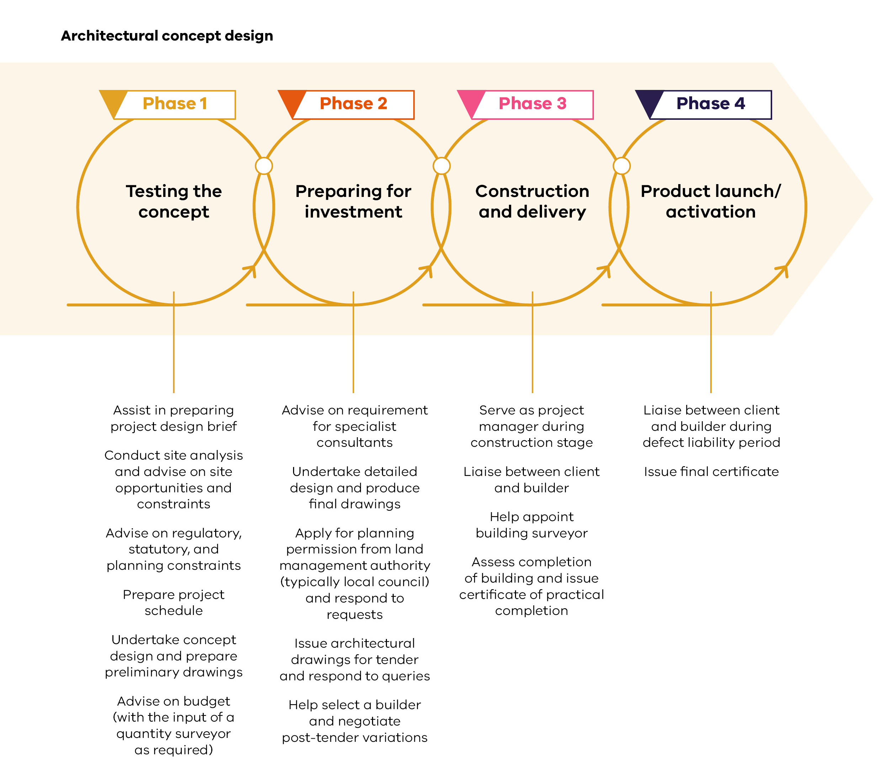
The nature of your engagement with an architect and the scope of services depends on the scale and complexity of your project. Discuss your needs during an initial consultation with an architect to understand what suits you – often, this initial meeting can be free of charge.
When engaging an architect, establish a clear scope of services within a client-architect agreement. This will ensure both parties understand their responsibilities, helping you plan your budget for services outside the architect’s scope. Select vic.gov.au/working-architect for guidance on engaging a registered architect. The Victorian Government page addresses:
- How to confirm an architect’s registration.
- An architect’s obligations, per the Victorian Architects Code of Professional Conduct.
- The stages of a typical architectural design process.
How to create a written client-architect agreement.
The Australian Institute of Architects website is also a useful source. Select architecture.com.au.
The following sections detail the architectural services aligned with Phase 1 of the investment process. These services have two design stages: pre-design and concept design. The services aligned with Phases 2 to 4 are explained later in this document.
Pre-design stage
During the pre-design stage, you synthesise your vision into a design brief. At the end of this stage, you will understand what is possible with your site and budget and have a clear design brief outlining your requirements and objectives.

Budget
Decide how much money you want to invest in your project, how much of this you wish to allocate to architectural design and construction. Also consider if you need to spend money on marketing, programming, and personnel.
Establish when your funding is available. Will you have access to all your funds at the start of the project, or will certain amounts only be available at a particular time in the future? This will factor into the timeline of your project and can impact the construction stages.
If you determine that your budget is insufficient for your desired outcome, you may choose a different business structure. Phase 1: Early business planning – Business structure explores the different business structures further.

Design brief
Your design brief should capture the requirements of your overarching idea and the visitor experience you intend to offer. It will guide your project by explaining your motivations, priorities, requirements, and time frames. A registered architect can help you create a detailed project brief.
To create your design brief, you should:
- Refer to your initial idea and the guidance in Phase 1: Idea development.
Refer to the target market and audience identified in Phase 1: Market Assessment – Identifying and testing the potential.
You should also include:
- The spaces your intended visitor experience will need (e.g., a lobby restaurant would include a dining area, commercial kitchen, bar, and back of house area).
- Site opportunities (e.g., an attractive view towards a nearby lake).
- Anticipated visitor volume, based on your market research.
Intended design quality.
A well–considered design brief can reduce the risk of your project becoming overdesigned and expensive.
Your market research should offer insight into an appropriate capacity for your project, the level of design and build quality. Size and quality have significant impacts on project cost, so balance your investment against your initial budget and expected revenue.
For example, for a ticketed attraction, higher initial construction costs might need higher ticket prices to ensure a reasonable return on investment. Is there a market and audience for your offering at this price point? If not, your operation may fail to generate enough revenue to be financially viable.
The architect can give advice about your site possibilities, and any regulation and planning issues through your design brief. They will consider your budget and work with you to reduce the risk of overspend, as well as help assess whether your budget is sufficient for your aspirations.

Concept design

Concept design stage
The concept design stage involves progressing the design brief to preliminary design for the architectural and landscape components of the project. This concept design should:
- Be code compliant and meet planning requirements.
- Take advantage of the unique qualities of the site.
- Meet the functional and spatial requirements of the business.
The design brief will inform the concept design process. The architect may provide multiple design options to choose from, depending on the terms of the client-architect agreement.
Different architects will have different design approaches, but generally the architect will first undertake site analysis and review the compulsory planning documents relevant to the site. They will then carry out a process of concept sketching, form explorations, and material studies to arrive at their concept design. The architect may also engage specialist consultants to assess your site’s opportunities and constraints.
The architect will prepare preliminary drawings of their concept design; either sketches or more formal drawings. There may also be revisions based on your feedback if the client–architect agreement includes the provision of multiple drafts.

Preliminary costing
At this stage, it is important to have a hold point in the design process. Your architect should complete a preliminary costing of your concept design. Adjust your design if the estimated cost of your project exceeds your budget or what would be commercially viable in your business model. Alternatively, you may need to consider a different business structure that provides more initial capital.
Once you are comfortable with both the concept design and the preliminary costing, your architect will undertake further detailed design, as outlined in Phase 2: Detailed design.

Importance of sustainable and inclusive design
Successful tourism projects increasingly have strong sustainability credentials and provide accessible experiences for visitors of all backgrounds and abilities. Sustainable, inclusive design principles can positively impact the community and environment, while providing a more attractive product for an increasingly eco-conscious and diverse audience.

Sustainable design and construction principles
New tourism projects can reduce the industry’s carbon footprint by aligning with changing travel trends through implementing more sustainable design and construction principles. These principles include:
- Increased efficiency in use of materials, energy, and other resources.
- Maximise use of renewable materials and construction methods with low embodied carbon.
- Respond and align to the natural environment and cultural context.
- Minimise pollution of soil, air, and water.
- Identify opportunities for material and water reuse and recycling.
Identify opportunities to increase biodiversity.

Benefits of sustainable design
Sustainable design and construction strategies generate a wide range of significant environmental benefits. These benefits include increased biodiversity and reduced landfill, pollution, carbon and resource consumption.
Sustainably designed and constructed buildings may incur a small green premium above standard construction costs, yet throughout the building’s lifetime, they can achieve reduced operational costs and deliver increased value. Green buildings can attract higher resale values, as the market becomes sustainability focused. Other benefits include enhanced occupant comfort and a positive public image for your business.
Enhancing the sustainability of your project may also drive visitor demand. Sustainability-minded tourists may be willing to pay a premium for sustainable tourism products, seeking out these products when travelling.

Inclusive design principles
Inclusive design principles will facilitate greater accessibility for your tourism project. Inclusive design ensures that everyone can equally participate in tourism activities and offerings, as tourism experiences should be able to be enjoyed by all. It addresses accessibility for people with mobility impairments, supports people with visual and hearing impairments, poor mental health, invisible disabilities, and neurodivergent conditions. Inclusive design also benefits children, the elderly, pregnant people, people with strollers or mobility aides and people who speak languages other than English.

Inclusivity
All users should be able to experience and interact with the site safely, easily, and with dignity.

Responsiveness
Projects should consider the needs and wants of a diversity of users.

Convenience
All users should be able to use the site without undue effort.

Accommodating
Projects should accommodate the diversity of their users and not impose barriers, regardless of the user’s age, gender, mobility, ethnicity or circumstances.

Realistic
Projects should offer multiple solutions to balance everyone’s needs and recognise that one solution may not work for all.
To be effective, consider inclusive design throughout all stages of the design development process. Inclusive design can be included in many aspects of your project, such as the design and accessibility of physical infrastructure, the layout of your buildings, wayfinding, signage, lighting, visual contrast and materials, and transitions between functional areas, as well as staff training, online engagement, and including people with disabilities in the design process and the workforce.
Benefits of inclusive design
People with a disability and other accessibility needs are less likely to engage in tourism experiences, due to inaccessibility. By using inclusive design principles, you will be increasing inclusion in the tourism sector and boosting your potential reach; there are an additional 4.4 million domestic tourists (an estimated $8 billion market) with accessibility needs.

Business structure
The optimal business structure for your project depends on three main factors:
- The size and type of business and how you intend to run it.
- The level of risk you are willing to take on as an individual.
Your investment motivation, as defined in Phase 1: Idea development.
Now is the time to consider if you need to engage a tax, business or legal advisor to help you.
There are three main business structures applicable to product owners. These are: sole proprietorship, partnership, and proprietary company. Others may be suitable depending on the project. Each structure has its own specific rules and regulations, with a different appeal, depending on factors such as:
- Set up costs.
- Licences and ongoing paperwork.
- Asset protection.
- Control over the business.
- Potential personal liability.
- Amount of tax to be paid.
You can change the business structure as your operation evolves, but initially selecting one that best suits your business needs will help ensure success from the outset. The table on the following page outlines the characteristics of, and differences between, the three primary business structures.

Sole proprietorship
Description
A business that one person owns and manages. There is no legal separation between the owner and the business.
Benefits
- Simplest legal structure.
- Easiest and cheapest way to set up a business.
- Least onerous legal requirements and regulation.
- Full control of management and profits.
Maximum privacy.
Considerations
- Owner has responsibility for all debt and obligations.
- Limited access to capital as interest in the business cannot be sold and limits access to debt.
- Limited access to skills and knowledge beyond the owner and employees.
Less favourable tax rates.

Partnership
Description
A business with two or more owners who are jointly liable for business debts and obligations.
Benefits
- Two heads (or more) are better than one.
- Easy to establish and start-up costs are low.
- More capital is available for the business through the multiple owners.
- Greater borrowing capacity.
Limited external regulation.
Considerations
- Owners are responsible for all debt and obligations.
- Risk of disagreements and friction among partners.
- All partners are agents of the partnership and are liable for actions by other partners.
Less favourable tax rates.

Registered company
Description
A distinct separate legal entity from its owners that has regulatory and reporting requirements.
Benefits
- Limited liability of owners.
- Tax rates can be more favourable.
- Wide access to skills and knowledge.
- Best access to capital.
Simple ownership transfer process.
Considerations
- Most costly and difficult to set up.
- More record keeping required.
- Increased regulation.
Available for public scrutiny

Operating model
Your business’s operating model will depend on the nature and scale of project, encompassing:
- People and capabilities.
- Functions and processes.
- Physical infrastructure and equipment.
Digital hardware and software.
In the investment proposal stage, you should have an idea of your operating model and recognise any potential barriers to smooth operation. Questions to ask include:
- In what areas of your business can you engage with Registered Aboriginal Parties (RAPs), Traditional Owners, and First Peoples majority-owned businesses locally to enhance operations?
- In what areas of your business can you engage local First Peoples as employees or trainees?
- How will you ensure the availability of a skilled workforce? Do you need to provide training and accommodation for employees?
- What state and local regulations apply to your business? Does the business need any permits or licenses to operate? Will employees require special certification or training?
- Where will you source goods and raw materials required for your operation? How will you respond to supply chain disruptions?
- What additional services will you need (e.g., marketing, social media, website, etc.)?
- What technology will your business require (e.g., POS system, computers, etc.)?
How do you plan to insure your business? This will be relevant in higher risk locations, where insurance costs are higher, reflecting this risk.
These considerations have an associated cost and will need to be addressed in the commercial viability assessment. See Phase 1: Early business planning – Commercial viability for more information.

Business Resilience
Taking action to build resilience at every stage of the investment lifecycle is crucial for the tourism industry, local communities, and Victoria. For project owners, it’s also good business practice.
Resilience is ‘The capacity of individuals, institutions, businesses and systems… to adapt, survive and thrive no matter what kind of chronic stresses and acute shocks they experience’. Thriving despite shocks and stresses, differentiates resilience from disaster preparedness, response and recovery, and requires focus on a whole-of-systems approach.
A resilient business is one that ‘can adapt to disruptions and keep operating while looking after its people, assets and brand equity’. Business Victoria identifies four areas of focus to reduce vulnerability, with the relationship outlined below.
You can enhance your project’s resilience by:
- Planning with an understanding of potential future shocks and stresses that could impact your project, such as heatwaves, drought, bushfires and flooding, and the impacts to your visitors, employees and the local community.
- Understanding any critical interdependencies of your project with other sectors and systems, such as supply chains, which, if disrupted, may negatively impact your ability to deliver services on an ongoing basis.
- Embedding actions to reduce any vulnerabilities in strategies and procedures, such as having backup plans for operating during heatwaves or drought or having agreements with local suppliers during an international supply chain disruption.
- Taking advantage of opportunities to contribute to your local community, economy, culture, and environment, which strengthens the adaptive capacity of all.
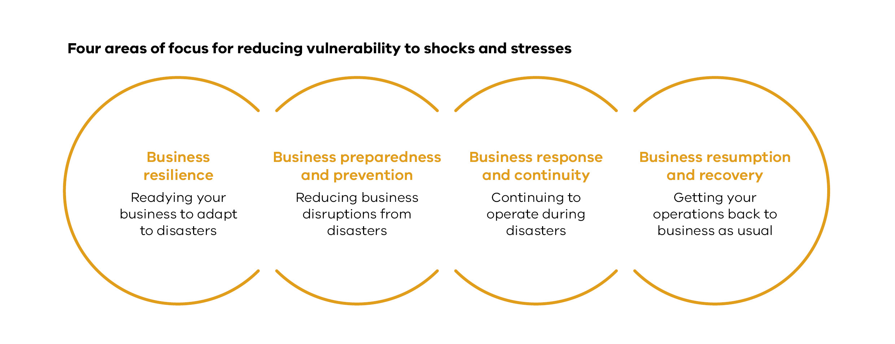

Early business planning
Things you will know by the end of this stage:
- Is the project commercially viable, aligning with the set project budget.
- The proposed business structure and if there is a need for project partners.
- The scale of the project’s economic impact.
- Project risks and ways to manage them.
- The project’s construction requirements.
- How to create a marketing plan.
Business planning sets out how your project will come alive and clarifies your objectives. It brings together all the information about a project, creating a road map to finance, develop and operate your project. This gives you clarity on the best way to move towards project viability.
Now is the time to consider if you need to engage business planning consultants or financial advisors to help you.
The early business planning process can be split into two steps:
- A feasibility study: a tool that can be used to assess potential options, their viability and if you should progress the idea.
- A business plan: refining and providing further detail on a specific project option/idea, recommended from the feasibility study.

Feasibility study
A feasibility study assesses your project at a high level. It brings together your idea, market assessment, site details, investment proposal and operational structure to assess your project’s likelihood of success.
In some cases, multiple project variations may be considered. You can use them to select the right project to progress to the initial business plan.
Project variations should not be systematically different. They should be modifications of the same concept. For example, it may consider different sizes, locations, or products.

Business plan
A business plan builds on the feasibility study. It looks at delivery and operational strategy, commercial viability, confirms partners and identifies risks.
Not all projects need a feasibility study and a business plan. As complexity and size increases, so does the need for a feasibility study before a business plan. Consider the documentation required by potential investors and partners when deciding whether to complete a feasibility study and a business plan.

Feasibility Study
Level of detail?
Low.
Consider multiple project variations?
Yes.
Commercial viability?
Indicative.

Business Plan
Level of detail?
High.
Consider multiple project variations?
Typically, no.
Commercial viability?
Proven.

Why do business planning?
Business planning helps guide the project to success by:
- Clarifying project context and objectives.
- Understanding visitor experience, market potential, preferred site (if applicable).
- Outlining day-to-day operational requirements and business structure.
- Demonstrating the ability to generate enough revenue to cover costs.
- Recognising potential partners to assist in funding, delivery and operations.
- Identifying and assessing risks that may impact project success.
Considering how to construct the project.
Investors usually want documentation showing alignment to their objectives, either financial, social, economic or environmental, and your ability to generate acceptable returns on these objectives, demonstrated in a business plan.

How will a business plan be used?
- Project owner: a guide to create shared alignment and direction. Used to understand the strategic actions to deliver the project and monitor progress.
- Financial institutions (including banks): will only provide debt financing to viable projects. Revenue generated must cover costs and debt obligations (interest and principal payments) over the loan term. They may also use the business plan to assess your capability to manage and deliver the project and identify risks that may impact loan repayments.
- Investors and partners: to understand the project, execution strategy and the ability to generate a return. This can be through a lens of financial, economic, social or cultural returns, or any mixture of these types of returns.
- Operators: you may need to engage an experienced operator if you don’t have the capabilities to operate the project yourself. The business plan should present an attractive opportunity and confirm the project generates sufficient cash to make payments to the operator.
Government agencies: may use the business plan to understand the project, its community and economic impact. This could be important during the planning and approvals process, or if you’re applying for government funding.

Before starting the business plan
The business plan is the final part of Phase 1. If the Phase 1 tasks are completed properly, you should be able to answer these questions before starting on the business plan.

Idea development
Clearly articulates the proposed project concept, visitor experience and defines the investment motivation as detailed in Phase 1: Idea development. Ask yourself:
- What is my project?
- How will visitors engage with my product or experience?
What am I seeking from this investment?

Market assessment
Identifies market penetration, competition and alliances, positioning and brand, market risks and market parameters relating to the project to ensure there is sufficient demand as detailed in Phase 1: Market assessment. Ask yourself:
- How does the project respond to real market need and consumer demand?
- Which market segment(s) will best respond to the project?
- What are the expected service standards by that market segment(s)?
- What is the project attractiveness to target markets?
- What is the target market’s willingness to visit and price sensitivity?
- Who is the competition that already exists?
What is the product fit within the region’s branding and market positioning?

Site analysis
Ensures an appropriate site has been confirmed for the proposed project as detailed in Phase 1: Site analysis. Ask yourself:
- What are the environmental conditions and protections to be considered?
- Are there any regulatory requirements that must be satisfied for approval?
- Is there any social context or First Peoples and post-settlement heritage to consider?
- How may economic indicators affect the success of the project?
- What is the state of existing transport connectivity and quality?
- Are there any existing land use constraints?
- Are there any heritage requirements or limitations?
Is there appropriate provision of existing infrastructure?

Investment proposal
Presents a clear architectural vision and a costed concept design, an understanding of how business structure will impact your project. Ask yourself:
- Does the design brief clearly articulate your intended visitor experience, budget, and functional requirements?
- Has the project budget been clearly defined and communicated with your architect and design consultant?
- Does the preliminary costing of your concept design reconcile with your budget and business plan?
- How have sustainable and inclusive design principles been considered?
How will the day-to-day operations and business structure deliver the desired visitor experience?

First Peoples engagement
Early and appropriate engagement with Registered Aboriginal Parties (RAPs) and Traditional Owners creates opportunities to deliver shared benefits. Ask yourself:
- Have the RAP and Traditional Owners been consulted? Do they support the use of the project site?
- Does the project rely on First Peoples culture as part of an experience or product, and have the local RAP and Traditional Owners been consulted to obtain approval?
Are there any opportunities for the project to benefit the local First Peoples community?

What needs to be considered in a business plan?
The business planning process should consider:

External factors
- Economic and market conditions.
- Consumer needs.
- Current and future demand.
- Competition and alliances.
- Industry trends.
Stakeholder requirements.

Internal factors
- Day–to–day operations.
- Business and management structure.
- Facilities and infrastructure requirements.
- Technology needs.
Investment needs.

Commercial viability
You can use financial analysis to assesses the commercial viability of your project. Commercial viability considers costs and revenues associated with delivery and operations.
There are two types of commercial viability you may need to meet:
- Operational viability: the project is cashflow positive during the operational period. i.e., anticipated revenues can cover operating costs.
- Financial viability: in addition to being operationally viable, the project can generate sufficient surplus cashflows over its operating life to recover its initial upfront capital investment.
Example business plan structure
- Executive summary: business plan summary.
- Project profile: description of the project, site, and design (if applicable).
- Market assessment: market assessment findings, target market and audience, current and future demand, competition, alliances and branding.
- Operational plan: day-to-day operations and requirements, internal processes supporting operations, approach to staffing.
- Financial analysis: identification of costs and revenues, commercial viability assessment and financing strategy.
- Economic analysis: description of social, economic and environmental benefits.
- Business structure and management: governance structure and project management.
- Risk assessment: risks and mitigation measures.
- Implementation plan: overview of project development and delivery strategy.
- Marketing plan: target markets, communication tools, media and collateral.

Key concepts
Financial analysis uses unique concepts and terminology. The following pages outline definitions of some key terms.

Revenue and costs
Money generated (inflows) through a project’s everyday operations. Examples include:
- Experiences such as a tour.
- Food and beverage.
- Merchandise.
- Accommodation or rooms.
Wellness treatments.

Capital costs
Expenditure on assets to develop or expand a project. Capital expenditure covers major purchases that will be used over the long term.
Examples include:
- Purchase of land.
- Construction of a building.

Ongoing costs
Everyday expenses that a project incurs. Operating costs are the ordinary costs incurred as part of running the project. This is different to capital costs, which are strategic investments to develop or improve a project.
Examples include:
- Staff salaries.
Electricity.

Refurbishment costs
A form of capital costs reflecting future investment into existing assets to ensure they continue to operate at their current level. Refurbishment costs differ from operating costs as they are a longer-term strategic reinvestment in an asset to ensure it keeps operating for an extended period.
Examples include:
- Development of new experiences to attract repeat visitors.
Major machinery service, including replacement of some components.

Cashflow
The net position resulting from movement of money in and out of a business. Cash received is an inflow, and cash spent is an outflow.

Financing

Debt
Debt: money financial institutions loan to the project that must be repaid, over a fixed term, with interest. Repayments typically include principal and interest payments. Lenders have the right to recoup their investment if the project fails. For example, a loan from a bank taken out by a restaurateur to fit-out a new restaurant is a form of debt.
Principal: the original sum of money borrowed in a loan. Principal is typically repaid in equal instalments across the loan term.
Interest: the amount of money a lender or financial institution receives for lending money. Interest is paid at regular intervals (e.g., monthly, quarterly) across the loan term and is calculated based on the remaining outstanding loan balance.
Interest rate: the amount a lender charges a borrower per year, as a percentage of the amount borrowed. Interest rates can change over the course of the loan term (variable), or they can be fixed for periods of time.
Leverage ratio (debt–to–equity): compares a project’s level of debt to equity to assess the reliance on debt. Leverage ratios are used to assess a project’s ability to meet its financial obligations and service debt.
Example: Restauranteur wants to fund a renovation.
- Borrows $350,000.
- Contributes $150,000 of equity.
- Debt to equity ratio is 70:30 (or 70% / 30%).
For every $0.3 of equity invested, the business borrows $0.7 of debt.
Coverage ratio (debt service): measures whether a project has enough cashflow to repay its debt. Used by debt providers to assess projects.
Example: Restauranteur is looking to repay debt.
- Net cashflow position for the year is $662,500.
- Principal and interest payment for the year is $530,000.
- Debt service coverage ratio (DSCR) is 1.25, which has been calculated by dividing the net cashflow amount by the principal and interest owing amount.
A DSCR of 1.25 means that the business is making 25% more cashflow per annum than it needs to cover its annual debt payments.

Equity
Equity: capital contributed by the project owner or other investor(s) that determines project ownership. If the value of the project changes beyond the initial investment, equity can grow or shrink based on the project’s prospects and a third party’s willingness to pay for the project or business. Equity does not need to be repaid, but investor(s) will seek a return on their investment, through the distribution of project profits. This can be thought of as the cost of equity, similar to how interest expense is thought of as the cost of debt. For example, if the capital contributed to overnight visitor accommodation is a form of equity, return could be generated in the following ways:
- The owner gets a return on their investment if the property is sold for more than the purchase and development costs, or if the overnight accommodation generates a profit that over time will accumulate to more than the purchase and development costs.
If a new major visitor attractor opens near the overnight visitor accommodation resulting in it operating at near 100% occupancy over the long term, increasing the value of the business and equity in the business.
Equity return: return on investment required by equity investors (including the project owner), which will vary by investor and project type.

Debt vs equity
Debt can be the cheapest form of finance (requires lowest return) and means the project owner does not have to give up any control of the business. Debt requires a commitment to repay the loan amount, plus interest, which can put strain on the viability of the business. Using high amounts of debt can be risky as it increases the amount of money that must be repaid every period (e.g., year, month).
Equity is often used where debt is not available, where cashflows are uncertain, to support debt financing, or where a project owner wishes to retain 100% control and flexibility to raise debt finance in future. If third party investors are providing equity, then you must give up some ownership and control of the business.
The mixture of debt and equity should be considered when deciding on the business and management structure. Factors to consider working out the right level of debt for your project include:
- Available funds.
- Project size, cost and complexity.
- Tax impacts.
- Amount of debt typically used for other similar precedent projects.
- Current and future interest rates.
- Project ownership.
Risk profile and uncertainty of cashflows.
Now is the time to consider if you need to engage a financial advisor to help you.
Assets
Assets: resources owned by a project that have a value. Typically, assets are required for operations or will provide a future benefit. For example, buildings, land, digital products or permits.

Returns
Operating profit: money earned by a project after deducting all operating costs from revenue. Operating profit does not take capital expenditure, interest, or taxes into account.
Return on investment (ROI): measure used to assess project profitability. Calculated by dividing the return (or benefit) over the cost of an investment and expressed as a percentage. Investors may use ROI to test the attractiveness of a project and compare it to the ROI of other investments.
Internal rate of return (IRR): metric used to assess return on capital that measures the annual rate of return of an investment over time, expressed as a percentage. Investors may use IRR to test the attractiveness of a project and compare it to the IRR of other investments.
ROI vs IRR: ROI indicates the total growth (or increase in value) of an investment over its life whereas IRR is an annualised rate of return on an investment.
Hurdle rate: the minimum rate of return required by an investor on a project. Hurdle rates will vary by investors and projects, and can apply to both ROI, IRR and other profitability measures. Investors will require an investment to be above their hurdle rate to warrant consideration of investment. Other factors beyond hurdle rate, like risk tolerance, will also be important considerations.

Estimating costs
Considering project costs including planning, set up, construction and operations costs helps determine if the project is commercially viable, and if financing is required. Some of the key costs you may need to consider are shown below.

Capital costs
- Base cost: total cost of construction including direct, indirect, owner’s and consultant costs.
- Direct costs: construction costs that include labour and material. • Indirect costs: contractor’s preliminaries, contractor’s overhead and profit.
- Owner’s costs: costs incurred to progress a project to construction phase. Typically includes land and other third-party costs such as engineering studies, permits and licensing fees.
Consultant costs: incurred through the engagement of consultants and/or advisors to support project development and delivery. This can include financial advisors, planning consultants, architect fees, QS fees, etc.
The total cost is the base cost, plus contingency and escalation allowance.

Project contingency
Allowance on top of the base cost for increases in cost due to uncertainty and risk exposure.

Escalation allowance
Provision for changes inflation over time and the base cost.

Operating costs
Labour costs: employee wages, benefits and payroll taxes.
- Inventory and consumable costs: costs associated with purchasing and holding inventory for use or sale.
- Leasing costs: costs associated with leasing land, buildings and/or equipment.
- Maintenance costs: maintenance of buildings and/or assets.
- Utilities costs: electricity, gas, internet, waste collection, water and sewage costs.
- Sales and marketing costs: costs related to selling and marketing a product.
- Taxes: costs associated with tax obligations of operating a business including payroll tax, GST, income tax, land tax, rates and charges.
- Insurance costs: costs associated with holding insurance(s).
General administration costs: legal, finance and other administration costs.
Why is project contingency important?
Unforeseen events during project development can result in delays or additional costs. You should account for such events, to ensure you can complete your project under changing circumstances.
Contingency can vary, depending on the project’s risk exposure. Assess project risks to identify any factors that may impact project delivery. This includes during the site acquisition, planning and approvals, and construction stages.
Methods for calculating contingency:
- Percentage of base cost: a fixed percentage applied to the base cost to calculate the contingency amount. The percentage used can vary by sector and project. It can be influenced by industry experience or advisor guidance.
Expected value: quantifying the identified risks. The probability of occurrence of a risk is multiplied by the resultant cost. The cost impacts for each risk are then added together to calculate total contingency.
For standard projects, set aside an additional 10-20%, and for more complex projects, the contingency could be 20-30%. These contingency values are approximate and should be discussed with your Quantity Surveyor (QS) or architect.
Why is escalation allowance important?
Escalation adjusts prices to their expected future value. Escalation relates to changes in price levels, driven by inflation, and adjusts prices to an expected future value.
The Consumer Price Index (CPI) estimates the monthly changes in prices paid by Australian consumers, and this data is published by the Australian Bureau of Statistics (ABS) and Reserve Bank of Australia (RBA). Historical CPI trends show changes in prices over time. You can use these trends to estimate cost increases over the project life, if specific data is not available. Including an escalation allowance ensures there is enough budget for increases in input prices over time.
Why are consultant costs important?
Engaging consultants to support project planning and development, especially for large and complex projects, can simplify the process, helping you reach the right outcome. Consultants come with significant costs. Evaluate which consultants would be most useful, confirming value for money. Seek quotes from different parties for the best possible price.
Consultant fees should be included in your budget as part of the base cost capital estimate for a project.
How can I make sure the cost estimate is appropriate?
When applying for debt financing or working with a project partner, you will need to demonstrate that cost estimates are accurate and not underestimated.
One option is to engage a Quantity Surveyor (QS) to estimate capital and operating costs. A QS can provide cost estimations based on the design brief, determined in the investment proposal stage, and consider material, labour and contractor costs. As the project design is further progressed in Phase 2, costs can be further refined for the detailed business plan. Cost estimates are reflective of current market conditions. Discuss inclusions and exclusions with the QS to understand the included costs. Cost estimates can use sources such as recent historical benchmark data.
Now is the time to consider if you need to engage a quantity surveyor to help you.
Forecasting revenue
To understand if you have enough cash to cover the operating costs, you must estimate revenue anticipated over the project’s life. Creating a revenue forecast will assist with budgeting and resource planning.
Revenue forecasting should aim to be realistic and use relevant data. This can help reassure investors and stakeholders, in showing them the assumptions and method used to forecast demand and pricing, and ensure buy-in to project viability.
Consider the following when forecasting revenue:
Demand
- What is the target market of the project offering?
- What is the total demographic of the target market?
- What portion of the target demographic is expected to be captured by the project?
- What is the expected increase in demand over time and what are the drivers for this?
What factors may impact demand?
Pricing
- How will the pricing of the offering be determined?
- How does the pricing rate compare to competitors in the region?
- Will the price point be accepted by the market?
- Will discounts be offered at the start of operations to drive demand?
- Will discounts be offered to certain groups e.g., locals, pensioners, seniors, students, children, health care card holders or carers?
- If so, when will full pricing of the project offering be introduced?
What factors may lead the pricing of the project offering to change over the operational period?

Proving commercial viability
Demonstration of commercial viability through financial assessment can help you understand if your project needs adjusting or discontinuation. It is also critical to obtaining finance. Commercially viable projects generate:
- Consistent positive cashflows through operations, where revenue exceeds (or at least meets) operating costs. This avoids the need for ongoing funding.
A return on the capital expenditure, as measured by the project’s IRR. Different investors will seek a different level of return.
Key considerations for commercial viability as part of Phase 1.
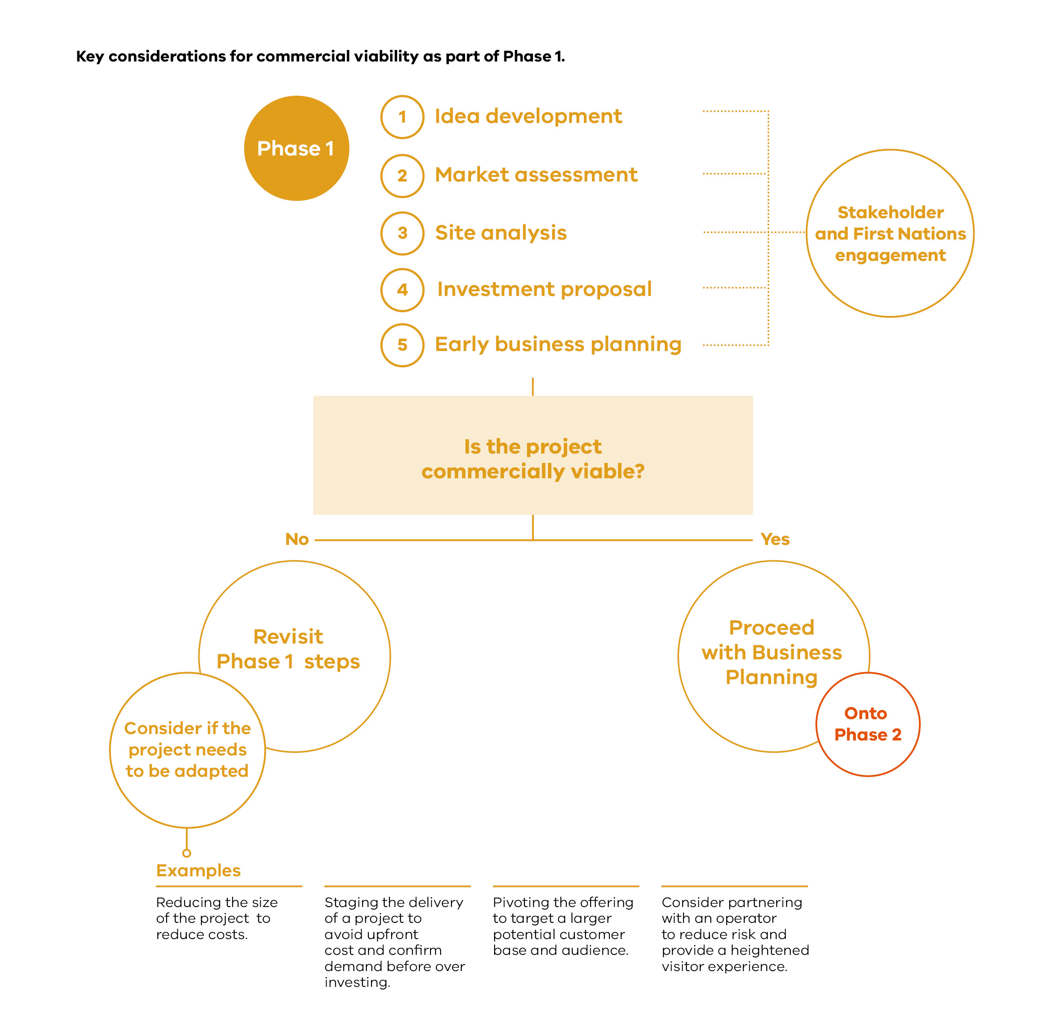

Image Description: Key considerations for commercial viability as part of Phase 1
Diagram showing what considerations should be made to determine if your project is commercially viable, and what to adapt if the project is not commercially viable.
What timeframe should the financial analysis cover?
Aim to conduct financial analysis for at least the first ten years of operation, to ensure a sufficient time horizon to generate returns on capital. To understand the impacts of seasonality, present the first three years’ figures in more detail; monthly or quarterly.
The timeframe and level of detail of cash-flow projections depends on the needs of financial institutions, investors and other relevant stakeholders. Professional advice should be sought if you are unclear.
Now is the time to consider if you need to engage a financial expert to help you.
Sensitivity analysis
By testing the key project drivers, you can understand your project’s sensitivity to market changes. This will help you gauge the factors that impact project viability and the project’s resilience to realistic shocks and stressors.
In practice, sensitivity analysis is undertaken within the financial analysis. This is done by varying inputs to test their impact on project outcomes such as profit and IRR.
Examples of sensitivity analysis:
- Capital costs +50%: a coastal visitor centre tests viability with a 50% increase in capital costs. The project faces the risk of poor ground conditions, which could require a re-design of the facility and more civil work.
- Visitor capacity –20%: a museum tests viability at 80% operating capacity. The project faces staffing and recruitment challenges that may prevent the safe operating of parts of the venue.
Interest rates + 3%: a wellness lodge tests viability with a 3% increase in interest rates. The project is part funded by a loan, and interest costs may rise due to market fluctuations.

Potential partners
The business plan should identify any gaps in capability, and where potential partners can assist in development and operations. When partnering, ensure that all parties’ objectives and values align. Early consultation with potential project partners, particularly debt providers, is essential. Cover all partner requirements, including analysis, in the business plan (and any other documentation).
Phase 2 further discusses funding a project through debt raising. The following table identifies key considerations for different potential partners.

Financing
Debt
Debt providers will help you to explore business loan options. Debt funding can be obtained from financial institutions such as banks, building societies, finance companies and credit unions. Debt providers use metrics to assess your project before approving a loan, including leverage and coverage ratios. A financial advisor can help a project owner through the debt raising process.
Equity
Equity investors will have varying investment objectives. They may target financial returns as well as social, economic, and environmental outcomes.

Operations
Operational partners
Operational partners may be required if there is a gap in capability or capacity to operate the project. An experienced operator can partner with the project to provide specialist services.
Partnership agreement with RAPs and Traditional Owners
Formal agreement with a RAP and Traditional Owners may be required, if the project relies on those with cultural authority to share cultural knowledge as part of an experience or product. This formal agreement may also need to cover requirements for the protection of Indigenous Cultural and Intellectual Property (ICIP).

Economic analysis
Tourism projects have greater impact than financial returns, often impacting culture, society, the environment, community, local and Victorian economies.
Wider project impacts should be understood and conveyed to stakeholders. Potential benefits of tourism projects include:
- Job creation.
- New economic opportunities for the local community.
- Attraction of visitors to the region, who will spend in the local area.
- Creation of a complementary offering, increasing the attractiveness of existing businesses.
- Development of new infrastructure, amenity and services.
- Increased awareness and respect for culture and history.
Restoration and funding for natural habitats and ecosystems.
A project’s social and economic benefits can be leveraged to obtain support from other stakeholders, especially the local community and government. Often, these are the parties concerned by tourism projects; for example, residents in regional Victoria may be impacted by additional traffic from new attractions. Explaining how the new attraction will create jobs and increase customers at local venues can engage community stakeholders and increase support for your project.
Articulating these benefits can also support project marketing. This will be explored in the Phase 2: Detailed business planning and funding strategy.

Risk assessment
A risk assessment identifies factors that may negatively impact a project, evaluating their likelihood and measures to mitigate them. This ensures you and any investors are aware of, and can manage any risks proactively, minimising impact to project delivery and operations.
Financial institutions and investors will need a risk assessment. Potential operators and partners may also require this to gauge and manage their own exposure to project risks.
A risk assessment should consider:
- Risk categories (see next page).
- Risk likelihood: assessment of the likelihood of a risk occurring over project lifetime. A five-point scale ranging from rare, unlikely, possible, likely to almost certain may be useful.
- Risk consequence: estimation of the impact if the risk occurs. Risks may range from insignificant, minor, moderate, major and catastrophic. Catastrophic risks will result in a large impact to finances, reputation or even closure if the risk event occurs.
- Risk level: provides relative importance to risks using their likelihood and consequence. A likely risk with a catastrophic impact is an extreme risk and needs mitigation. A rare risk with a moderate impact is a low risk.
Mitigation strategies: identification of actions, approaches or considerations that help prepare for, reduce the likelihood of, or lessen, the consequence of a risk.
The risk assessment should be further developed in Phase 2. The final risk assessment should be dynamic and constantly updated during the project. Key phases where risks change include, funding and set up, procurement and construction, and operations.
Now is the time to consider if you need to engage a quantity surveyor or risk consultant to help you.

Risk categories
Categorise risks based on their impact to the project. Below is a list of some of the risk categories that can be applied to tourism projects.
- Commercial: commercial risks have impacts on the financial viability of a project e.g., changes to loan interest rates.
- Funding: funding risks affect the ability to secure finance / funding for the project e.g., investor backs out of project due to market shifts.
- People and community: these risks involve the perception of the project held by stakeholders, local community and residents e.g., community backlash due to increased traffic in the area caused by the project.
- Operational: operational risks impact how the project operates e.g., inability for staff to operate the project at full capacity.
- Planning and approvals: these risks impact your project’s ability to navigate approvals, permits and regulations associated with delivery and operations e.g., inability to secure registration of a commercial kitchen.
- Design and construction: design and construction risks impact your ability to navigate the construction stage of your project quickly, safely and affordably e.g., noise created during construction impacting / limiting daily construction hours.
- Environmental: environmental risks impact on your project’s ability to be safely and responsibly constructed and operate on your chosen site e.g., unknown ground conditions on proposed project site.
Program and schedule: program and schedule risks impact on a project’s predicted delivery program and opening date e.g., longer than expected lead time on securing planning approval.

Getting ready for construction
Preparing your project for construction includes planning and business set up, getting materials, and engaging with suppliers and contractors. Ask yourself these questions before preparing for construction. If you cannot answer these questions, revisit other parts of your business plan.
- How complex is the project? Would it benefit from engaging specialists, advisors, or consultants to support in delivery?
- Does the project have any specialised components with unique construction or operations? Are specialist contractors or advice needed?
- Do project owners or partners have the capability and capacity to deliver and operate the project?
- Are there any market conditions that may impact the ability to deliver the project? e.g., Is this project sized to ensure appropriately skilled contractors will bid for construction?
- Have you identified all your key suppliers? Have you identified opportunities for RAPs, Traditional Owners and First Peoples majority-owned businesses to be involved in construction, and employed them?
- Are there anticipated long lead times for any of the materials or equipment? When would be the right time to begin engaging contractors and suppliers?
- What activities need to be completed to begin the planning and approvals process?
- What is the planning and approvals lead time? What is a realistic timeline for this project (this will be further explored in Phase 2, but often can present project owners with significant challenges regarding timing)?
- When will you begin engaging with stakeholders? Will different stakeholders require different approaches?
Does the project have any cultural aspects to be considered? What is the relationship to Country, RAPs and Traditional Owners?
Getting ready for construction requires competent management. For larger projects, this may require a project management team or firm. This may include the investor and other stakeholders, such as the landowners, architect, builder, subcontractors, quantity surveyor, development company, and financier.

Thinking about marketing
As a final step in early business planning, think about how you will attract visitors on launch day and beyond. You should consider the following items:
- Objectives: what is your marketing goal? Who, and how many visitors do you want to attract?
- Marketing budget: what is your overall marketing budget?
- Marketing strategy: what is your go-to-market strategy?
- Online presence: do you need a website? Will you use Search Engine Optimisation (SEO) to boost web search results, and will you encourage reviews?
- Social media: what is your social media strategy? What is your capacity to regularly create and post engaging content?
Content creation: what written, visual (video and still imagery) and audio content needs to be created? How much time, money and effort is required to do this?
Marketing activities should be tailored to your target market and audience. Development of your Marketing Strategy should begin 12 to 24 months prior to opening for some projects, with consumer marketing commencing between 6 and 12 months prior to your planned opening date.
It may be helpful to commission a marketing or public relations agency to develop your strategy and launch the project. They can help you create a unique brand that appeals to your customers. Marketing will be further explored in Phase 4: Product launch. You can also visit the Visit Victoria website at corporate.visitvictoria.com or the Business Victoria website at business.vic.gov.au for free advice on getting started with marketing.
Now is the time to consider if you need to engage a marketing or public relations agency to help you.

Phase 2

Preparing for investment
Stakeholders to engage with during this phase:
- Local Government.
- State Government authorities and utility service providers.
- Registered Aboriginal Parties (RAPs) and Traditional Owners.
- First Peoples majority–owned businesses.
- Regional Tourism Boards (RTBs).
- Local community, landowners, residents and business owners next to and near the site.
Things you will know by the end of this stage:
- The results of stakeholder engagement.
- Opportunities from stakeholder engagement.
- Any concerns with the proposal, and opportunities for refinement.
- Strategies for effective stakeholder and community engagement.

Stakeholder and community engagement

The importance of stakeholder engagement
Stakeholder and community engagement is an important part of any project. It reduces risk and delays, leading to a more robust and resilient project. It provides you with local knowledge and can address any concerns.
The engagement process can include meetings with the following groups:
- Landowners, residents and businesses near the site, interested community groups and the wider community.
- Registered Aboriginal Parties (RAPs), Traditional Owners and First Peoples majority-owned businesses.
- Local governments.
- State government authorities; such as the Department of Energy, Environment and Climate Action (DEECA), Parks Victoria, Melbourne Water, Heritage Victoria. Regional Tourism Boards.
Utility service providers.
The extent of engagement depends on the project’s complexity and the planning approval process. More complex projects may need an engagement strategy. Phase 2: Project planning and approvals outlines specific engagement requirements for project planning and approvals.

Approach to engagement
The goal of engagement is to increase trust from all stakeholders in the decision-making process and ultimately improve project outcomes. The IAP2 Quality Assurance Standard in Community and Stakeholder Engagement is the recognised international standard and explains how to plan for, and implement best practice stakeholder and community engagement.

Early engagement
Early engagement helps you discuss your concept with people and organisations with an interest in the project before the planning approvals phase.
Additionally, early engagement with the local community and First Peoples builds trust and support. It helps identify, understand and resolve any local issues early in the design process, reducing delays and significant costs during the approvals process.
Early engagement usually takes the form of targeted, one-on-one or small group meetings to introduce people to the project and seek feedback. By starting your engagement process with local government, you can minimise future objections and be guided by the most relevant stakeholders.
Now is the time to consider if you need to engage an IAP2 certified consultant to help you.
To ensure your project adopts best practice community and stakeholder engagement, use these engagement principles that align with IAP2’s core values.
- Meaningful: all affected stakeholders have adequate time, resources and meaningful opportunities to provide feedback before decision-making.
- Inclusive: engagement is respectful, inclusive and accessible.
- Transparent: all stakeholders understand what they can, and cannot, influence.
- Informed: all stakeholders receive relevant, accurate and timely information that is easy to understand.
Accountable: concerns or requests from all stakeholders are addressed, and they understand how they influence decisions.

Engagement across the investment lifecycle

Phase 1

Purpose
Understand local issues and opportunities related to the concept and any market considerations.

Engagement level
Consult.

Engagement goal
Provide balanced and objective information about the project in as much detail as possible and obtain feedback on your proposal.

Promise to stakeholders
Continue to keep them informed, listened to and acknowledge any concerns and aspirations. Provide feedback on how their input influenced the decision.

Engagement requirement
Highly recommended.

Phase 2

Purpose
Understand any outstanding local issues, seek support and approval for the project. Important for planning and approvals.

Engagement level
Consult.

Engagement goal
Provide balanced and objective information about the project in as much detail as possible and obtain feedback on your proposal.

Promise to stakeholders
Continue to keep them informed, listened to and acknowledge any concerns and aspirations. Provide feedback on how their input influenced the decision.

Engagement requirement
Mandatory/statutory requirement for some projects.

Phase 3

Purpose
Ensure affected stakeholders are aware of any impacts of construction and delivery of the project.

Engagement level
Inform.

Engagement goal
Provide as much information as possible about any changes stakeholders can expect during this phase.

Promise to stakeholders
Keep them informed about any changes associated with construction and delivery.

Engagement requirement
Mandatory/statutory requirement for some projects, highly recommended for all other projects.

Phase 4

Purpose
Maintain and generate ongoing support for project.

Engagement level
Inform.

Engagement goal
Provide as much information as possible about the current status of your project and respond to any enquiries.

Promise to stakeholders
Keep them informed with consistent information and updates on changes.

Engagement requirement
Highly recommended.

Introduction meeting outline
Below are recommended agenda items for an introductory presentation to stakeholders:
- Introduce your organisation. Include relevant experience, expertise and local interests.
- Introduce your project. Include site location, site plan, details of the project and any useful visual to help stakeholders understand your intentions.
- Explain the expected benefits and potential impacts of your project. Highlight any mitigation strategies you will put in place to reduce potential impacts.
- Stakeholder feedback: provide a genuine opportunity for stakeholders to share their feedback. Be clear about what you are asking of the stakeholders and community.
- Next steps: explain how stakeholder input may influence the project. Explain the approvals process. Highlight future opportunities for stakeholders to provide their feedback (if applicable).

Role of Local Government
Before you finalise project concept in Phase 1, initiate preliminary discussions with the planning department of the relevant local government area. This is generally referred to as the ‘pre-application’ phase and the local planning department will provide:
- Advice on relevant planning, heritage and environmental approval processes – including specific information on what must be provided with an application and indicative time frames for processing.
- Information about the site, and the relationship of the development to the surrounding land uses.
- Identification of relevant local government policies to be considered as part of an approval application.
- Identification of local issues that must be considered in any external or community consultation that occurs during concept development.
Identification of authorities and other organisations to be contacted at the concept stage (e.g., Department of Energy, Environment and Climate Action (DEECA), water and sewerage authorities, Department of Transport and Planning (DTP).
You can find out which local council to contact - select https://www.vic.gov.au/know-your-council.

Role of State Government
Early engagement with State Government departments and agencies can clarify key site considerations and approval requirements. Some approval processes require applications to DTP and DEECA, rather than local councils.
The Victorian Government can also give advice on the approvals process, assisting with early consultation between project owners and stakeholders, communities and government departments.

Role of First Peoples stakeholders
Engagement with RAPs, Traditional Owners and First Peoples majority-owned businesses should start from the idea development stage. Early and respectful engagement is essential in establishing meaningful relationships with First Peoples stakeholders and provides mutual benefits to everyone. As tourism directly engages with First Peoples’ cultures, seek approval from those with cultural authority.

Registered Aboriginal Parties (RAPs)
Description and role
RAPs are representative corporations, inclusive of Traditional Owners of an identified Country. RAPs have important roles and functions as the decision makers for their cultural heritage over an appointed area of Victoria (Aboriginal Heritage Act 2006).
How to identify and engage
There are 11 RAPs covering approximately 75% of Victoria. If there is a RAP on the selected site, they should be engaged and consulted early.
To identify a RAP, refer to the online or downloadable map, which shows Victoria’s Current RAPs – The Aboriginal and Torres Strait Islander Heritage Council website provides the RAP boundaries, contact information and history of applications. Select aboriginalheritagecouncil.vic.gov.au/about-victorias-registered-aboriginal-parties.
All RAPs have their own website, which can include their contact information, services, Country Plan and/or Economic Development Strategy.
Some RAPs may have a Consultation Request Form, including a consultation fee.
RAPs have a wide range of responsibilities and may not be able to respond immediately to a request. Keep this in mind when organising your first meeting.

Traditional Owners
Description and role
Connections to Country and culture held by Aboriginal peoples, custodians of the land and waters.
How to identify and engage
If there are no RAPs, there will be other organisations in the area to contact. These may include Traditional Custodians, local First Peoples and community-controlled organisations.
To identify these organisations, contact your local council or government for advice on the most appropriate person.

First Peoples majority-owned businesses
Description and role
First Peoples majority–owned businesses could be either:
1. Majority–owned by the Traditional Owners for that Country where they are operating.
2. Majority-owned by Traditional Owners from other parts of Australia.
How to identify and engage
You can identify First Peoples majority-owned businesses by consulting Kinaway (the Victorian Indigenous Chamber of Commerce), Supply Nation or the local RAP.
Supply Nation is the only organisation to recognise two levels of Indigenous ownership:
- Registered businesses are at least 50% or more First Peoples owned. This caters for equal partnerships with non–First Peoples owners.
Certified businesses are 51% or more First Peoples owned, managed, and controlled.

Project planning and approvals
Things you will know by the end of this stage:
- The types of planning, environmental, cultural heritage and heritage approvals that may be required for your project.
- The process and suggested timeframes for key approvals.
- How public land is managed, and how that relates to tourism projects.
- The relevant utility service providers across Victoria.

What types of approvals are required?
Before proceeding with your project concept, you may need a range of planning, environmental, cultural heritage and heritage approvals, under both Victorian and Federal legislation. Early assessment will identify whether the project is:
- Permitted without requiring further approval.
- Permitted, but needing further planning and environmental assessments, or modifications before seeking and obtaining approvals.
- Not permitted, and an alternative site or concept should be considered.
Key approval processes that need to be considered include:
- Planning approvals under the Planning and Environment Act 1987.
- Cultural heritage and native title approvals under the Aboriginal Heritage Act 2006 and the Commonwealth Native Title Act 1993.
- Heritage permits, consents, and exemptions under the Heritage Act 2017.
- Environmental assessment under the Environment Effects Act 1978 (Vic) and Commonwealth environmental approval under the Environment Protection and Biodiversity Conservation Act 1999.

Victoria’s planning framework

Overview of planning schemes
Planning schemes apply to all land in Victoria and regulate how land is used and the nature of development. These schemes are prepared and administered by local councils, with the Minister for Planning also playing a key role through the process.
Planning schemes have a standard format, and there are several standard provisions across Victoria. There are also local provisions unique to each local government area, applied to specified areas, sites or activities. Each project will have different planning requirements and issues to consider.
To find out what planning controls apply to your site, select planning.vic.gov.au and generate a planning property report.
In Victoria, a planning scheme has the following components:

Municipal Planning Strategy (MPS)
Overarching strategic policy directions of a council.
Sets up the planning scheme’s policy foundation, based on location and regional context, history, assets, strengths, key attributes and influences.

Planning Policy Framework
Includes the state, regional and local policies when deciding on a project.
How the authority will implement the strategic directions in the MPS and how state policies will be enacted at a local level.
Planning applications should demonstrate how the relevant policy framework is implemented.

Zones
Zones specify purposes for land, such as business, industrial or residential.
Define prohibited and permitted land uses, and controls relating to buildings, works and subdivision.
Standard zones are available across Victoria, applied in each scheme as required.
Councils cannot vary zones or introduce their own zones; however, some zones have schedules for local requirements.

Overlays
Overlays operate in addition to the zones.
Apply to a single issue or a related set of issues - heritage, environmental concern, flooding, or bushfire management. Where more than one issue applies to land, multiple overlays can be used.
Influence how land can be used or developed, and will be considered in assessing a planning application.
Many place-specific risks will be captured through overlays. Undertaking a detailed site analysis will help identify these risks. You can find more information in Phase 1: Site analysis.
Common overlays that could impact tourism projects include: Bushfire Management Overlay, Significant Landscape Overlay, Vegetation Protection Overlay, Environmental Significance Overlay, Heritage Overlay and Land Subject to Inundation Overlay.

Other Provisions
Standard provisions that apply to specific land uses, or development activities in planning schemes.
Includes advertising signs, access to main roads, car parking, multi-unit development and a range of other activities.
Exemptions from planning permit requirements may apply to a project, and can be found in the general provisions of the planning scheme.
Planning schemes contain information on procedures and interpretation, affecting the administration of the scheme and permit decision-making.

Planning scheme in Alpine Resorts
The Victorian Alpine Resorts at Falls Creek, Mt Buller, Lake Mountain, Mt Baw Baw, Mt Hotham, and Mt Stirling sit under the Alpine Resorts Planning Scheme.
The Minister for Planning is the Planning Authority and Responsible Authority for all planning matters. DTP administers the planning scheme on behalf of the Minister.
The approval process is like elsewhere in Victoria, however there may be different application requirements.
Contact the development approvals and design team at DTP to obtain advice on planning controls, information requirements and pre-application meetings.

Potential planning approval pathways
Early review of the planning scheme will identify what planning permit requirements apply to your project. Consultation with local councils and planning professionals can help to determine the best way to obtain approval for your project.
The appropriate approval pathway will depend on the site’s features, the scale of the project and the existing planning scheme controls. Generally, you can obtain planning approval via a planning permit, a Planning Scheme Amendment or using the provisions described below.

Planning permits
What is a planning permit?
A planning permit is a legal document that allows a certain use and/or development on land. It contains a written document with conditions and a set of plans. Most applications for a planning permit will be made to the local council, but some are made to the Minister for Planning.
The Planning and Environment Act 1987 outlines the planning permit application process, including setting assessment timeframes for planning authorities, requirements around public notice of permit applications, and procedures for appeal processes through the Victorian Civil and Administrative Tribunal (VCAT).
What is the application process?
- Lodge application and engage early: engagement with Council, Registered Aboriginal Parties (RAPs), Traditional Owners, and the local community will help build support for your project by minimising impact on cultural heritage. It will help you understand the key risks and requirements, guide documentation and may uncover suggestions to enhance your project design.
- Resubmitting and Public Notice: once you have provided a satisfactory application, council will refer the application to statutory referral bodies and determine the public notification required. Notification may be letters to neighbouring property owners and occupiers, on-site signage, or newspaper notices. Objectors can make submissions, usually with at least 14 days to lodge a submission on the application.
- Decision: depending on development scale and number of objections, council officers or councilors will make a decision.
- VCAT Appeal Process: an approval may contain a range of conditions that you must meet. You can apply for a review of the decision by VCAT if you think the condition is inappropriate, unnecessary, or onerous, or if the application has been refused. If there have been objections, those parties can also request a review by VCAT. There are time limits for the right to request a review by VCAT for both applicants and objectors. Find more information on the VCAT website, select vcat.vic.gov.au.
Note: You can make some smaller scale permit applications through the VicSmart pathway, a fast and streamlined assessment process for straightforward applications. VicSmart covers assessment of specific types of applications by councils within ten days. Contact your local council planning office or select planning.vic.gov.au/guides-and-resources/guides/all-guides/vicsmart-permits for more information.
Now is the time to consider if you need to engage planning professionals to help you.
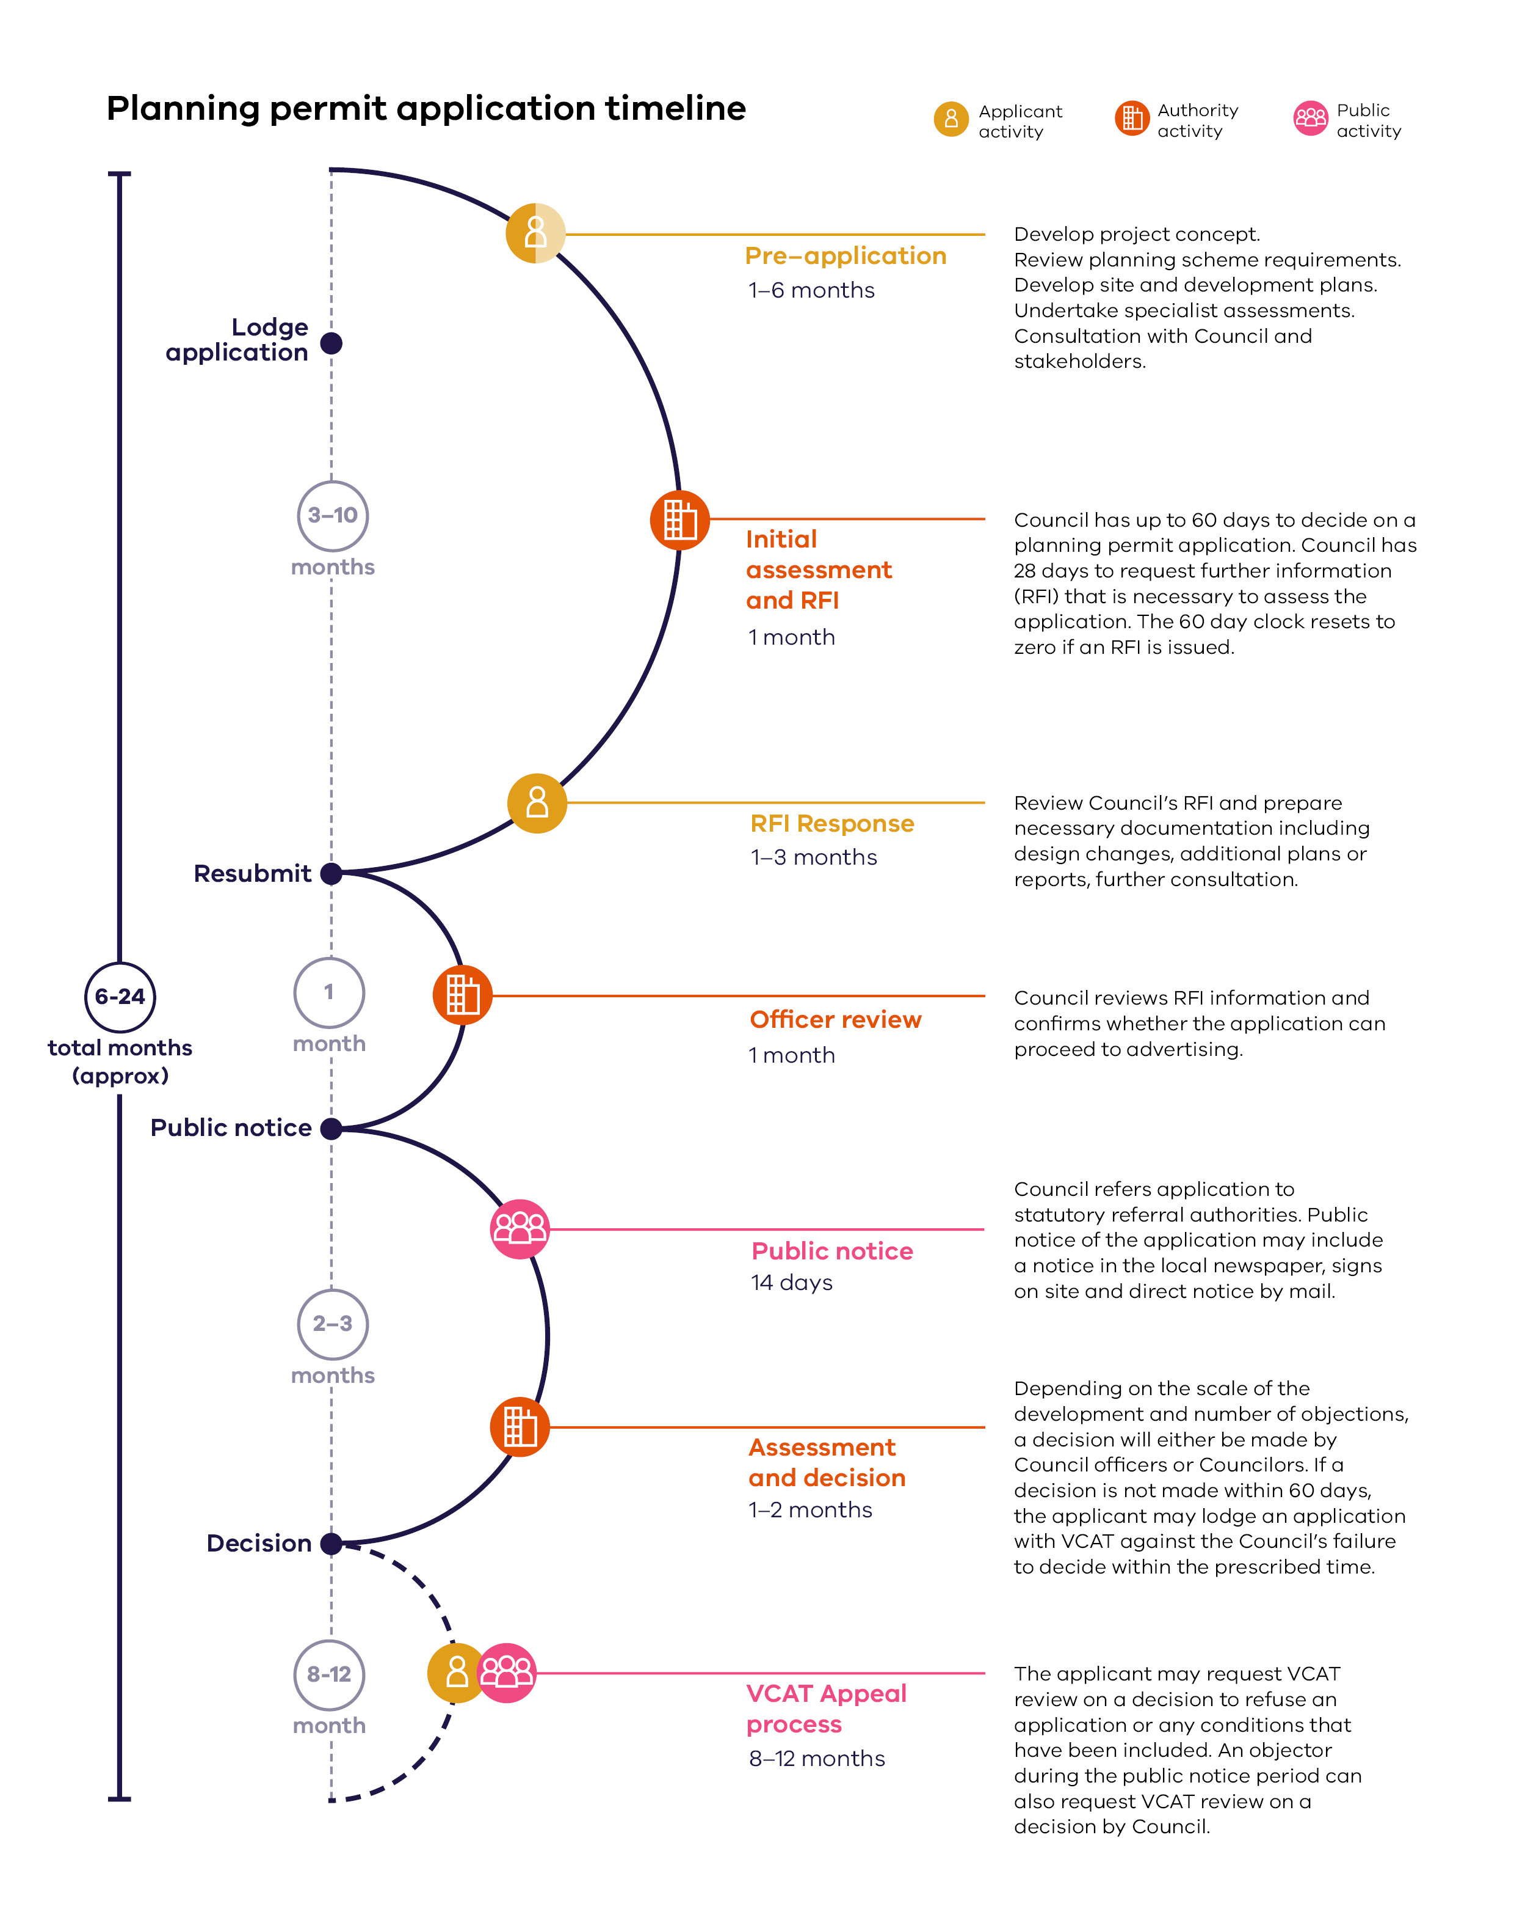

Image Description: Planning permit application timeline
Diagram showing the expected timeline and milestones for a planning permit application, including lodging the application, potential resubmission, public notice, decision, and potential VCAT appeals. The entire process is expected to take between 6 and 24 months.
Below are indicative timeframes for a proposal, depending on project complexity, site conditions and requirements:
- A simple application made via the VicSmart pathway – under two months.
- A straightforward application with pre-application engagement, short RFI process, limited third party issues and objections, and no VCAT appeal – 6 to 12 months.
A complex application, subject to public notice and a VCAT appeal process – 12 to 24 months.
What can cause delays in your application approval?
Councils are required to make decisions on applications within 60 days, not including time spent responding to further information requests or providing public notice of the application.
Delays can be caused by:
- Lodging incomplete documentation resulting in further information requests from council and referral authorities.
Formally amending an application due to a significant design change, resetting the 60-day period.

Planning scheme amendments
When proposing a project on a site that is not permitted under the planning scheme, you must be able to make a strong case in order to have the planning scheme amended and the project considered, as shown in the following Planning Scheme Amendment timeline.
Planning scheme amendments require support from the Council and DTP. Any request should consider if:
- The current controls on the land are inappropriate.
- The project outcomes are supported by the Planning Policy Framework.
- Significant economic, community or environmental benefits can be demonstrated.
The change would achieve a better strategic planning outcome.
An amendment to the planning scheme will need expert assistance, and take approximately 12 to 30 months to prepare, consider and gain approval. Approval of an amendment may need a subsequent planning permit application.
Select planning.vic.gov.au/planning-schemes/amendments/amending-a-planning-scheme and Planning Practice Note 46 – Strategic Assessment Guidelines of Planning Scheme Amendments for further information on planning scheme amendments.
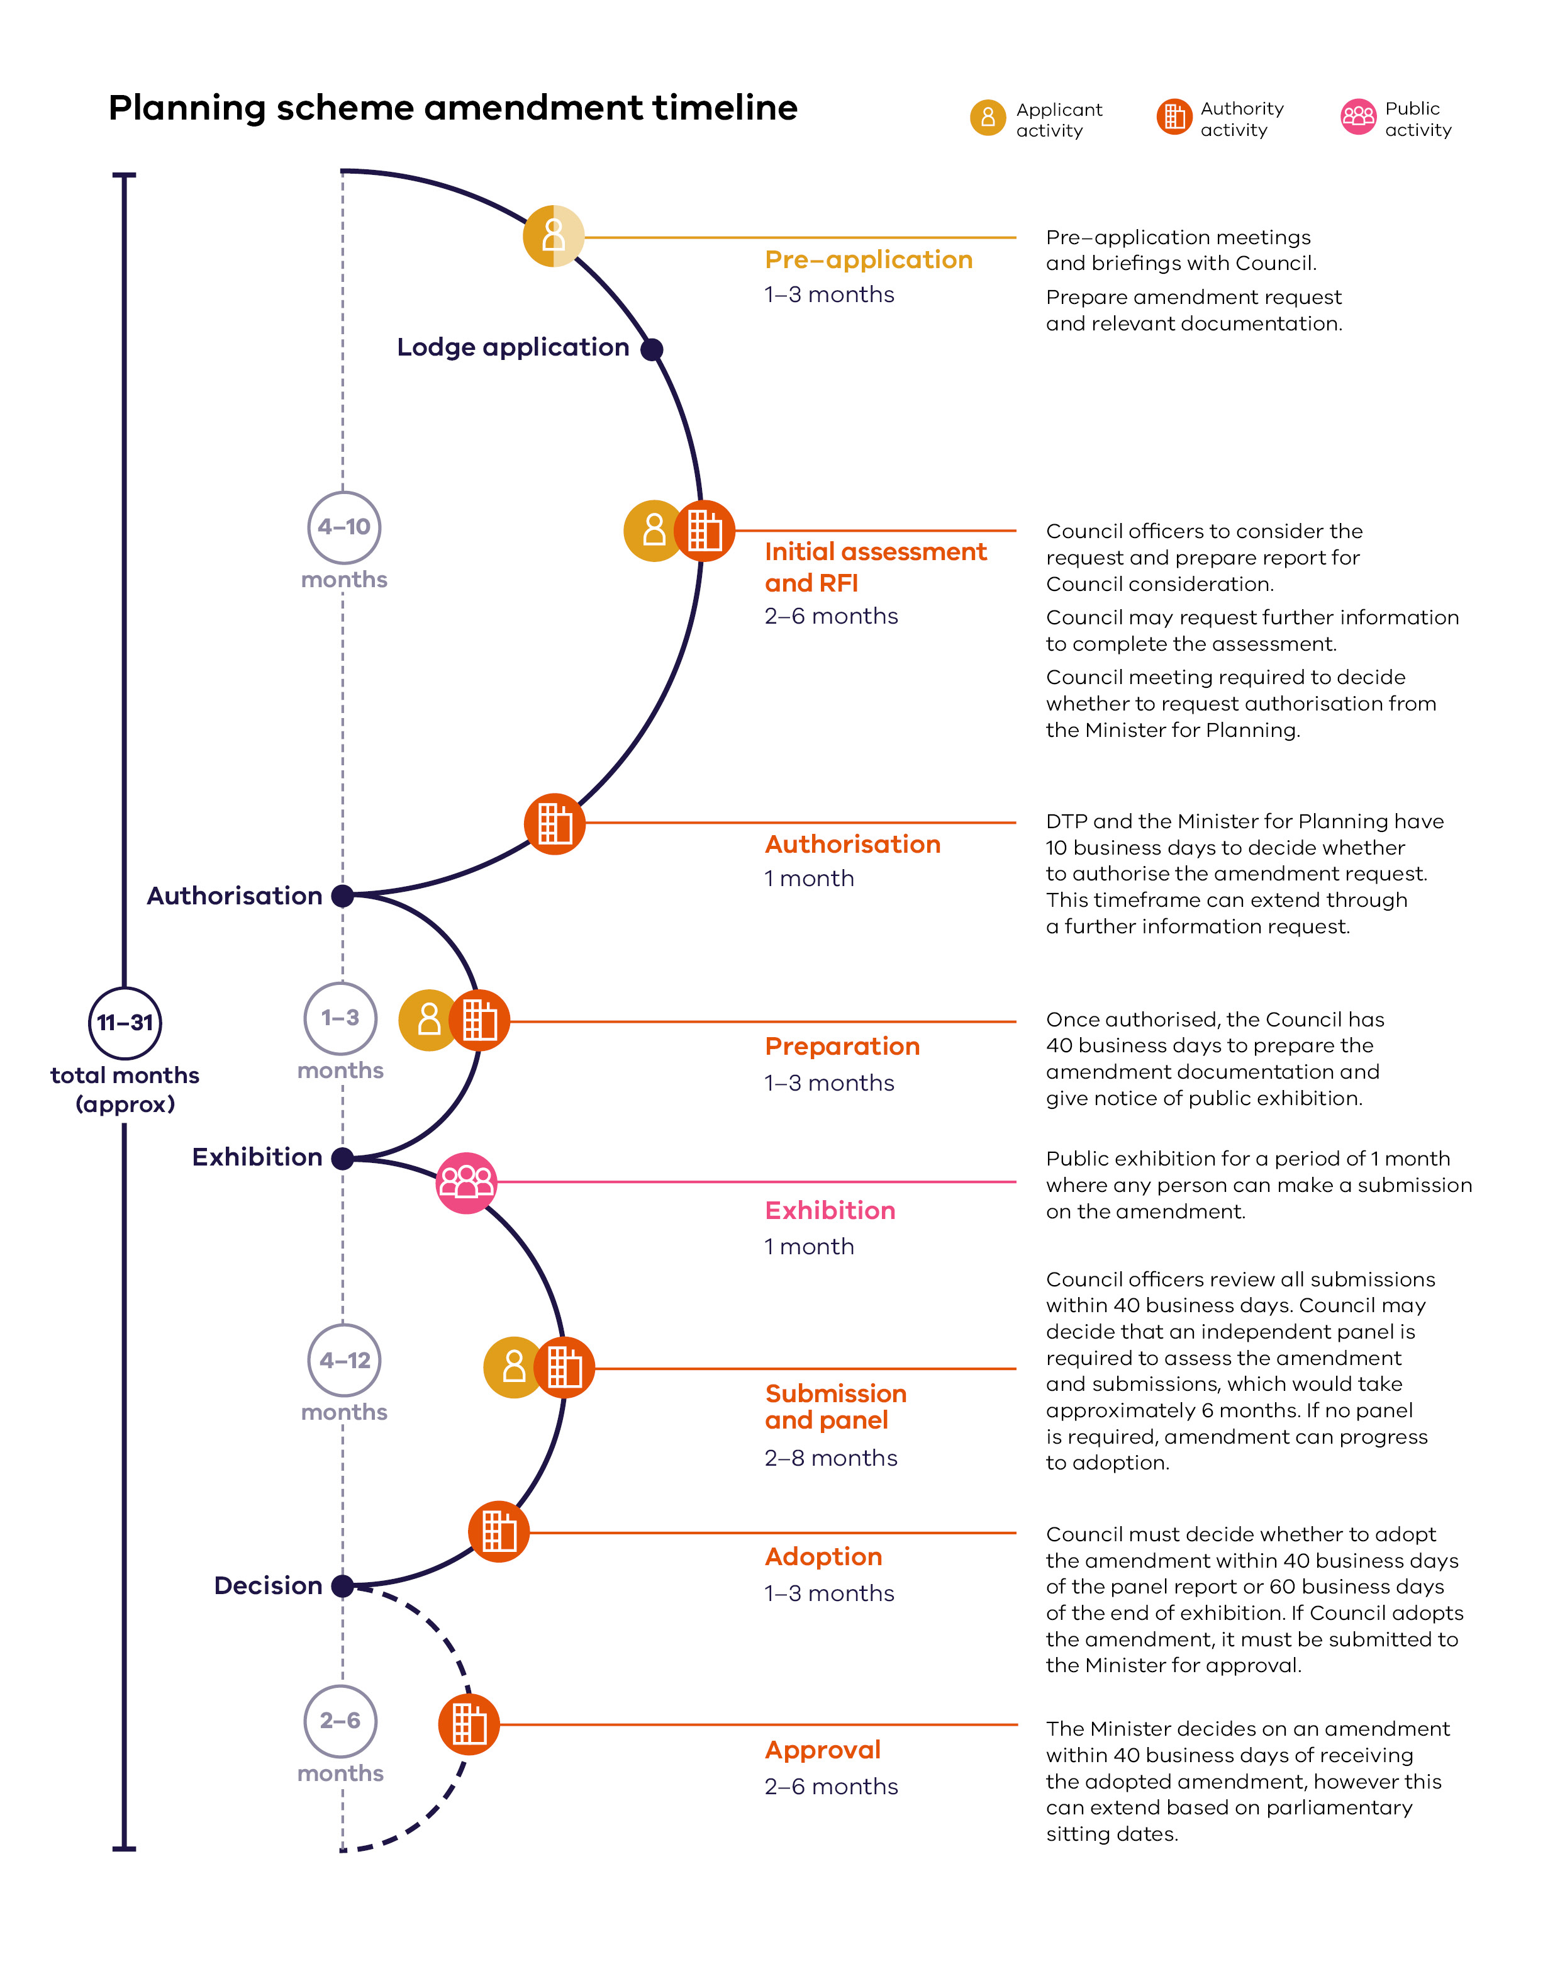
Image Description: Planning scheme amendment timeline
Diagram showing the expected timeline and milestones for a planning scheme amendment, including lodging the application, authorisation, exhibition, and decision. The entire process is expected to take between 11 and 31 months.

Clause 52.22 (State Projects)
The Minister for Planning has established the Development Facilitation Program (DFP) to make faster planning application decisions for priority projects. The DFP was introduced into the Victorian Planning Provisions (VPPs) on 20 September 2023 through Planning Scheme Amendment VC242 and is an accelerated assessment pathway for priority projects in identified sectors. Tourism (Visitor Economy) is identified as a priority sector eligible to be considered as part of the Program.
Clause 53.22 (Significant Economic Development) which now forms part of the VPPs provides that The Department of Transport and Planning (DTP) can consider new applications or existing planning applications facing undue delays in the planning system that meet the DFP eligibility criteria. The Minister for Planning is the Responsible Authority for all applications considered as part of the DFP which are considered on their planning merits.
The DFP is focussed on projects that have the potential to make a significant contribution to Victoria’s economy and provide substantial public benefit. The Program requires tourism projects to have a minimum development cost of $5 million in regional areas and $10 million in metropolitan areas for eligibility to be considered. Specifically, Clause 53.22 sets out identified permit application requirements including an assessment of deliverability and investment certainty where project proponents should demonstrate overall project feasibility.
You can find out more on the DFP at planning.vic.gov.au/planning-approvals/applications-for-state-government-projects which includes a portal to seek a pre-application meeting or lodge an application with DTP.

Planning application requirements
To reduce the risk of delay, a comprehensive planning application should address all relevant issues, enabling the planning authority to make an informed decision.
Application requirements for each project will change depending on the approval pathway, planning scheme requirements and environmental issues related to the site, but will generally include the following:
- Planning report including detailed description of proposal, business operations, identification and assessment of the relevant planning policy framework of the planning scheme.
- Site analysis, identifying site opportunities and constraints.
- Specialist reports assessing the potential impacts of the project on ecology, flooding, traffic, noise, visual impact, and contamination.
- Details of consultations with RAPs, Traditional Owners, and the community, local government and other service agencies.
- Final versions of the project’s site plan and architectural development plans that:
  - Are drawn to scale and fully dimensioned.
  - Show the site, floor layout and elevations, clearly showing building height above natural ground level, with floor / roof levels relating to site contours, and building finishes and materials.
- Landscape drawings detailing existing trees and shrubs to be removed / retained, plus proposed landscaping, including species of trees and shrubs, and their estimated heights at maturity.
Proposed signage or interpretative facilities.
Professional assistance can help provide complete, correct documentation, minimising delays. Referral bodies and the general public may have access to this documentation; it must clearly respond to all requirements and address potential project issues.
Now is the time to consider if you need to engage planning professionals to help you.

Aboriginal Heritage

Native Title
Legislated in 1993, the Commonwealth Native Title Act 1993 established the protection of a range of native title rights, including future regimes and compensation, as well as determinations over future grants and acts affecting native title to land and water. The Act requires you to notify native title claimants, potential claimants, or owners if you want to develop on or use public land. During early consultation with First Peoples, State Relations and DTP, clarify the Act requirements and any associated issues.

Aboriginal cultural heritage
The Aboriginal Heritage Act 2006 manages and protects Aboriginal cultural heritage1 across Victoria. Understanding the potential impact to land containing Aboriginal cultural heritage is critical. The Act sets out a cultural heritage management planning process that reduces the risk of adverse effects to cultural heritage.
The Act recognises the responsibilities Traditional Owners and RAPs have in managing and protecting Aboriginal cultural heritage on Country. The Aboriginal Heritage Regulations 2018 define areas of high cultural sensitivity and activities that may impact on Aboriginal cultural heritage values. If a RAP is not appointed for the area, heritage advisors will also provide advice about the other Traditional Owners that have interest in the area.

What is a CHMP?
You may require a Cultural Heritage Management Plan (CHMP), or Cultural Heritage Permit, to protect places or objects of heritage value. If you require a CHMP, it must be approved before a planning permit can be issued.
A CHMP is required if:
- All or part of the activity area is an area of cultural heritage sensitivity; and
All or part of the activity is a high impact activity.
A high impact activity is one that is likely to harm Aboriginal cultural heritage. Examples include works:
- That would result in significant ground disturbance.
- Associated with land uses such as camping grounds, caravan parks, car parks, sports and recreation facilities, or Alpine Resorts.
- To develop a bicycle or walking track with a length exceeding 500 metres.
That require an Environment Effects Statement.

Other Approvals

Heritage
The Heritage Act 2017 provides for the protection and conservation of places, objects and archaeological sites that are of cultural heritage significance to Victoria. Heritage Victoria is responsible for recommending which places and objects should be included in the Victorian Heritage Register, and deciding whether or not to allow changes to heritage places. Heritage Overlays are also administered by Councils to protect places of local heritage significance.
If your project is likely to harm the heritage significance of a place, then a heritage permit, exemption, or archaeology consent may be needed before works can commence.
Some heritage controls restrict the changes you can make to a heritage site. For example, demolition or major alterations to the façade of a heritage building may not be permitted. Determine if a heritage overlay applies to the site. Some key heritage issues to consider are:
- Preserving heritage fabric.
- Appropriate design responses for additions and alterations to heritage fabric and avoiding mock heritage.
Appropriate material choices for repairs, additions and alterations.
Engaging contractors with expertise in heritage works.
For more information on heritage requirements, select heritage.vic.gov.au.
Now is the time to consider if you need to engage a heritage advisor to help you.
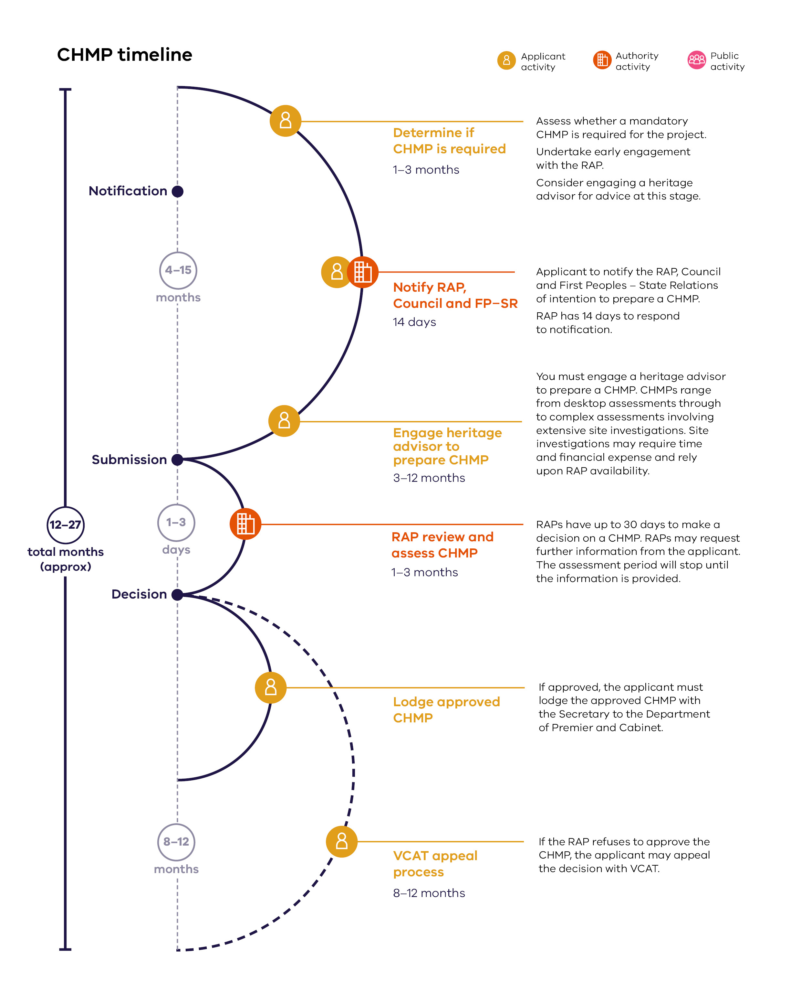
Image Description: CHMP timeline
Diagram showing the expected timeline and milestones for a CHMP plan, including notification, submission, decision, and potential VCAT appeals. The entire process is expected to take between 12 and 27 months.

Environment
Environmental Impact Assessment
Environmental assessment of the potential impacts of a proposal may be required under the Environment Effects Act 1978 (EE Act).
The EE Act is not an approval process, enabling statutory decision makers (Ministers, local government and statutory authorities) to make decisions on projects with potentially significant environmental effects.
You may require Environment Effects Statement (EES) if certain referral criteria are met individually or in combination. Examples of referral criteria include:
- Clearing of ten hectares or more of native vegetation.
- Long-term loss of a significant proportion of known remaining habitat, or population of a threatened species within Victoria.
Extensive long-term effects on the health or biodiversity of aquatic, estuarine or marine ecosystems.
The EES process includes detailed consultation with key stakeholders, government departments, Traditional Owners and the general public.
You can find the process and framework to assess a project under the EE Act at ‘Ministerial guidelines for assessment of environmental effects under the Environment Effects Act 1978’ or select planning.vic.gov.au/environment-assessment/environment-assessment-home.
Environment Protection and Biodiversity Conservation Act 1999
The Environment Protection and Biodiversity Conservation Act 1999 (EPBC Act) provides a legal framework to protect and manage nationally and internationally important flora, fauna, ecological communities and heritage places – defined in the EPBC Act as matters of national environmental significance.
Early environmental assessment might find that the project has substantial impact on matters of national environmental significance, and recommend applying for approval to proceed under the EPBC Act. Approval decisions under the EPBC Act are made by the Federal Department of Climate Change, Energy, the Environment and Water.
For more information on the EPBC Act, select dcceew.gov.au/environment/epbc.

Tourism on public land

What is public land?
Public land in Victoria comprises most of the coastal edges and foreshores of the State; National Parks, State Parks, State Forests and other reserves; river and lake reserves; Alpine Resorts and a range of other special purpose public reserves such as flora and fauna reserves, gardens, cultural and historic sites.

How is public land managed?
State Government Ministers are responsible for managing public land, and this management is generally carried out by agencies such as DEECA and DTP, and government bodies such as Parks Victoria, Melbourne Water, councils, Alpine Resorts Victoria and Committees of Management.
Guidelines for the use and development of public land for tourism are generally found in strategic policies and management plans, which identify the nature, location and level of tourism related facilities and services provided on public land. The State Government provides most facilities through the organisation responsible for the management of a particular area.
Victorian Alpine Resorts are Crown land, and are subject to specific arrangements for planning approvals and leases. Alpine Resorts Victoria is responsible for the management of Crown land in Alpine Resorts, the provision of several services and promotion of the resorts as legislated in Alpine Resorts Management Act 1997. Alpine Resorts Victoria makes recommendations to the Minister for Energy, Environment and Climate Change on granting new leases or extending existing leases.

What tourism opportunities can occur on public land?
The private sector can use public land for guided tours and interpretation, boat and equipment hire services, skill development, recreation experiences, special events and many other activities. These activities can be seasonal and generally require minimal built infrastructure. A public land manager can provide a licence to conduct a tourism or recreation service on public land.
A management or master plan for a particular area may outline opportunities for development, such as major tourism facilities on public land, accommodation, boating facilities, cafes/restaurants, and sports facilities. These plans identify the need for private sector development, its suitability, potential impacts, and examine alternatives to the use of public land. The provision of a major development on public land is also normally pursued through public tender processes, with environmental and heritage approvals needed before commencing a development.

How long are lease and licence terms?
If you have a recognised tourism accreditation, a public land manager may issue a standard licence. The licence term can be between one and ten years.
Generally, lease terms for proposals on public land have a limit of 21 years. The ‘Leasing Policy for Victorian Crown Land, May 2018’ provides guidance on provision of lease terms longer than 21 years under the Crown Land (Reserves) Act 1978 and the Forest Act 1958.
On Crown land within Victorian Alpine Resorts, lease terms are managed differently. Long-term standard leases apply to all new development at Victorian Alpine Resorts, with leases of up to 51 years available for major investments. For an acceptable business case, 51 to 99 year lease terms may be possible.

Relevant legislation on public land
Crown Land (Reserves) Act 1978
Purpose
To provide for the reservation land owned and managed by the State government.
Agency
DEECA
Marine and Coastal Act 2018
Purpose
To plan for and manage the sustainable use of Victoria’s coastal resources.
Agency
DEECA
National Parks Act 1975
Purpose
To preserve and protect National and State Parks.
Agency
DEECA, Parks Victoria
Alpine Resorts Act 1983
Purpose
To provide for the reservation of Alpine Resorts.
Agency
DEECA
Alpine Resorts (Management) Act 1997
Purpose
Provides for the establishment and functions of Alpine Resorts Victoria.
Agency
DEECA
Planning and Environment Act 1987
Purpose
Legislative framework controlling planning approvals and scheme amendments.
Agency
DTP, DEECA, councils
Forests Act 1958
Purpose
To protect and manage State forests.
Agency
DEECA, Parks Victoria
Local Government Act 1989
Purpose
Controls local government functions and responsibilities.
Agency
DEECA, relevant councils
Environmental Effects Act 1978
Purpose
An Act to require the environmental effects of certain works to be assessed. This Act provides for the environmental assessment of development that has the potential to impact on the environment.
Agency
DEECA
Environmental Protection and Biodiversity Conservation Act 1999 Commonwealth Legislation (Cth)
Purpose
Protect biodiversity and associated environmental issues.
Agency
Federal Government

Information sources for tourism opportunities on public land
- Victorian Marine and Coastal Strategy May 2022 and Coastal Action Plans.
- Relevant National Park or Foreshore Management Plans.
- Approved Park Management Plans or concept plans.
- Alpine Resorts Strategic Plan 2020–2025, Alpine Planning Scheme.
- Public land legislation (see above).

Utility providers
You should consult with relevant Victorian utility providers as part of your project proposal. Early consultation can reduce the risk of delays. Utility providers are likely to need access to land to operate and maintain their assets and networks.

Electricity
There are five electricity distributors, each responsible for a geographic region of Victoria. These include:
- Powercor Australia, servicing Melbourne’s western suburbs and western Victoria.
- Jemena, servicing Melbourne’s northern and south-western suburbs.
- Ausnet Services, servicing Melbourne’s outer northern and eastern suburbs, and eastern Victoria.
- United Energy Distribution, servicing Melbourne’s southern suburbs and Mornington Peninsula.
Citipower, servicing Melbourne’s city and inner suburbs.
To find out which distributor services your area, select https://www.aer.gov.au/consumers/understanding-energy/who-your-distributor

Water
Victoria has 18 water corporations providing urban and/or rural services. Below is a list of four of the water corporations providing rural water services:
- Goulburn-Murray Water, covering 68,000 square kilometres, bordered by the Great Dividing Range in the south to the River Murray in the north, and stretching from Corryong in the east, downriver to Nyah.
- Southern Rural Water, covering 88,000 square kilometres, from the South Australian border to the New South Wales border, and from the Great Dividing Range to the Victorian coast.
- Lower Murray Water, covering 14,000 square kilometres from Kerang to the South Australian border, taking in the municipalities of Mildura, Swan Hill and Gannawarra.
Grampians Wimmera Mallee Water, covering 62,000 square kilometres across the Grampians, Wimmera and Mallee regions of Western Victoria.
Approval may be required from water authorities if your proposal requires access to a reticulated water supply, and/or ground water reserves.
To find out which water corporation distributes water to your area, select water.vic.gov.au/about-us/how-we-work-with-water-corporations.

Gas
Gas distributors own and manage the pipelines which deliver gas to homes and businesses across the state. The gas distributors in Victoria are:
- Australian Gas Networks.
- Multinet.
- AusNet Services.
To find out more information regarding the gas distributors in Victoria, select aer.gov.au/consumers/who-is-my-distributor/victoria.

Detailed business planning and funding strategy

Things you will know by the end of this stage:
- Approach to project funding or financing if external investment is required.
- If the project is financially viable to meet expected rates of return.
- Tax implications.
- The approach to construction and development.
- Your plan for day one and project launch.

Reviewing the initial business plan
A detailed business plan builds on your work in Phase 1. For a reminder of business plan contents, refer to example business plan structure in Phase 1: Early business planning.
To confirm if your business plan needs updating, ask yourself the following questions:
- Time: how long ago did you develop the initial business plan?
- Site and design: is the original site and design still relevant? Has anything changed through the planning and approvals process?
- Market demand: have there been major shifts in market demand? Does the market assessment need to be refreshed? Do you expect the same demand levels, to ensure commercial viability?
- Competition and alliances: has the competitive landscape changed? Have any new tourism offerings opened (or closed) in the region?
- Branding: is the branding strategy still valid? Have market or consumer preferences changed?
- Operations: do you expect the operations to be the same? Will there be any additional processes or requirements?
- Staffing: have there been changes in staff availability and expected salaries?
- Capital costs: are capital costs still valid? Does contingency or escalation need updating?
- Operating costs: if planned operating requirements or processes have changed, are there any new costs?
- Commercial viability: have any assumptions changed? Is the project still viable; can the required rates of return can be achieved?
- Business structure: is the current business structure still appropriate? Would a change be beneficial?
- Management: do current management practices work well?
- Partners: has the project secured funding or operating partners?
- Risks: are there any new or changed risks? Have mitigation measures changed?
- Delivery: how is delivery progressing? Is more thought needed around contractors?

How do you fund a project?
Many projects require funding to get off the ground. If you are looking for funding from financial institutions and external investors, they need a robust business plan and sometimes an Information Memorandum (IM) to assess project viability. There are also a number of government grants that may be available to support a project. A robust business plan will also be required for this source of funding.
Revisit Phase 1: Early business planning for a refresh on:
- Potential funding sources and partners.
- Debt, equity and their relationship.
- Debt funding considerations.
Return measures and requirements of investors.
Engage a financial advisor for support, and seek advice from the following specialists:
- Accountant.
- Tax professional.
Financial advisor, mortgage broker or similar.

How do you get a loan?
Debt funding is available from financial institutions such as banks, building societies, finance companies, credit unions or professional debt providers. Each provider will have different requirements. Professional advice can help you select the right one.
Banks are likely to be the main source of debt funding for most project owners. Their business banking teams can assist you in:
- Loan process and securing debt funding.
- Project structuring for tax and financial reasons.
Setting up the structure of the project.

From a lender’s perspective, what is a ‘good’ project/customer?
Lenders look at five key factors (the five c’s) when deciding whether to give a loan: character, capacity, capital, conditions and collateral.
A good project demonstrates strong credentials across the first three factors: character, capacity and capital. Conditions are negotiated between the lender and borrower. Collateral is not always necessary but can help you secure a loan on more favourable terms.

Character
Integrity, reputation and willingness to make good on the debt. Lenders will look at:
- Personal and business credit history.
- Financial history, including spending behaviours and savings.
Relations with other lenders (if applicable). Professional and personal stability, including previous legal issues or business ventures.

Capacity
Ability of the project and project owner to repay the loan. Lenders will look at:
- Projected business costs, revenues, profit and commercial viability.
- Leverage and coverage ratios (see definitions in section Phase 1: Early business planning – Commercial viability).
- Any other debts or obligations.
Anticipated stability, consistency, and resilience of earnings.

Capital
Amount of capital in a project that could be sold off to meet loan repayments, presenting an exit strategy for the lender. Lenders will look at.
- Ability to sell assets (liquidity).
- Project financial position, including historical and projected balance sheets, cashflow statements and profit and loss statements.
- Extent of contributions by the project owner, and capacity for future contributions under downside scenarios.
- Leverage ratios (level of debt against other key metrics).

Conditions
Terms and conditions of the loan. Lenders will look at:
- Purpose of loan and use of funds.
- Loan amount.
- Interest rates and fees. Length of loan and repayment schedule.
- Debt servicing arrangements and coverage ratios.
Other specific considerations.

Collateral
Ability to provide security for a loan, by offering asset(s) as collateral. Providing collateral is not required by law, but may be required by lenders’ internal credit policies. Offering collateral helps to de-risk a project for the lender and provides ability to seek more favourable terms. Lenders will look at:
- The type of collateral available e.g., property, vehicles, land, other assets.
- The current and future value of the collateral.
Any insurances which may offer protection.
To secure a loan, documentation you will need to provide includes:
- Business plan.
- Financial analysis and cashflow projections.
- Valuations of collateral and proof of ownership.
- Any consultant reports, including QS, architect, surveyor, engineer, etc.
- Legal documentation.
- Business and management structure.
All relevant approvals and permits.

Equity

How can you find equity investors?
Equity financing involves sourcing funds from an investor, with an agreement to give them a share of the business. This means the investor becomes a part owner of the business and shares the profit.

What types of equity investors are there?

Business angels
Business angels are wealthy individuals who invest their own money in exchange for a share of the business. They generally want to be involved in business decisions and may often act as a mentor, bringing their expertise to your operations.

How do you find them?
You can find a business angel by accessing Business Angels, select businessangels.com.au and the Angel Investment Network, select australianinvestmentnetwork.com/business-proposal. These investor registers match the needs of the business with private investor criteria.
The Victorian Government can connect you with potential funding and operating partners. They can facilitate introductions to potential project partners and support you throughout the investment lifecycle. Reach out to industry associations for information about equity funds their members have had success with. Key industry associations in Victoria:
- Accommodation Association of Australia, select aaoa.com.au.
- Australian Hotels and Hospitality Association, select aha.org.au.
- Business Events Victoria, select businesseventsvictoria.com.
- Cultural Tourism Victoria, select culturaltourismvictoria.com.au.
Restaurant and Catering Victoria, select rca.asn.au.
Speak to your accountant or financial advisor, as they may have other clients who have been successful in raising equity or that are looking to invest in businesses.

Family and friends
Asking family and friends for an investment can be the quickest way to access funding. They may be more patient about getting a return.

How do you find them?
When asking for funding from family and friends, approach it in the most business-like manner possible. Be professional and document the terms of the investment formally, outlining the level of financial commitment and risk involved.

Crowdfunding
Involves asking the public to contribute money in exchange for a good, service or equity. It can sometimes be a donation. This has become a popular way to fund new projects, as small amounts of money can quickly grow when sourced from large groups of people.

How do you find them?
There are crowdfunding websites, select pozible.com and equitise.com, amongst others. On these crowdfunding websites, you can post details about your project, funding goal, and explain why people should invest in your business.

What makes a good investor for your business?
Having the right investor involved in your business often means they can offer more than money. A good investor can provide guidance and connect you with the right people. They may be able to introduce you to new customers, suppliers, accountants, financial advisors, and other potential investors. For the best outcome, be clear of your ask from the investor, your negotiables, and non-negotiables.

Qualities of a good investor
In your industry: they can provide guidance based on their own experience in the industry and contribute their business skills.
Connected: they can introduce you to the right people to help you grow your business.
Committed: they are with you for the long haul, and want to see the business succeed.
Good communicator: they communicate openly with you, and you have access to them.
Alignment of values: their investment philosophy is aligned with your business values, including the impact you want to make in the local community.

What does an investor want to know about your business?
Investors will want to know if your project is commercially viable, and that set-up and operations are well thought out. Using your business plan, you can show them the market assessment, project viability, the site and location, and planning and approval constraints. Some investors like to see architectural drawings.
If you are using an institutional investors or have a project that requires fundraising you may need to develop an Information Memorandum. This will summarise the findings of all four phases of the investment lifecycle.
Note that investors have different targets for financial returns, and diverse priorities for social, economic, environmental and cultural outcomes. Ensure you’re clear about your expectations for their involvement in your business and their share of the profit.

Tax considerations
Tax is an important, complex consideration when planning and setting up a project. Tax can impact commercial viability, through increased costs or deductions. How you structure your business can help you manage your tax liability. Ensure taxes have been addressed when assessing your project’s commercial viability.
Consult a tax professional, such as an accountant or lawyer, to confirm your project has the most appropriate business and tax structure. Tax laws are constantly changing; if you do not have internal specialist tax accountants then you should engage specialist advisers. You can find simple tax related information, including generic tax calculators on the Australian Taxation Office (ATO) website.

Depreciation
Depreciation is the allocation of the cost of an asset over its useful life. It reflects how much of an asset’s value that has been used up.
Example: A restaurateur purchases a new oven for $100,000 and will use it for the next ten years, at which point it will need replacing. Using straight-line depreciation, the restauranteur can claim a tax deduction of $10,000 per year.
From a tax perspective, you can’t deduct spending on capital assets immediately. Instead, depreciation is used to claim the cost of the asset over time.

Tax expenses
Money paid to the government or administrative bodies. The key types of taxes include:
- Income tax.
- Goods and services tax (GST).
- Payroll tax.
- Land tax.
- Local government rates and charges.
- Deposits and withdrawals taxes.
License fees and charges.

Tax deductions and incentives
Expenses incurred during ordinary operations and in pursuit of generating revenue can be deducted from income to reduce your tax expense. This could include wages, utilities, inventories, etc. Businesses can claim tax deductions for the decline in value of depreciating assets.
The government sometimes offers tax incentives to encourage certain activities, projects, and businesses. Some tourism projects may be eligible for tax incentives. E.g., accelerated deductions for depreciating assets: an instant asset write-off allows the entire value of an asset to be claimed/deducted within the period it is purchased rather than gradually over the asset’s lifetime.

Detailed design

Things you will know by the end of this stage:
- Whether your original architectural design brief is still appropriate.
- Whether your project design aligns with the project budget and return on investment expectations.
- How First Peoples expert consultants can be engaged to improve your project.
- Which design areas may pose risks to your development.
- Who your building surveyor is.
Before moving to the detailed design stage, make sure the final architectural concept design is right for your budget and business plan. Your architect can then provide a preliminary costing of your chosen concept design, as outlined in Phase 1: Investment proposal – Architectural concept design. If the cost is unviable, revise the concept design.
During the concept design stage, you should have consulted with Registered Aboriginal Parties (RAPs) and Traditional Owners, ensuring that connection to Country has been considered. Additionally, ask your architect to recommend First Peoples expert consultants, especially if your project is being constructed on a culturally or environmentally significant site and/or if you are offering cultural experiences or products. To find these qualified professionals, your architect may consult the local RAP, Kinaway (the Victorian Aboriginal Chamber of Commerce) or Supply Nation (a non-profit that enhances the Aboriginal and Torres Strait Islander business sector through supplier diversity).
After approving the final concept design, your architect will then proceed to the detailed design stage. Here, they should confirm the design meets regulatory and authority requirements and local design standards and coordinate the preparation of detailed documentation. If the design documentation is incorrect or unsatisfactory, the design intent can be misinterpreted, leading to time and cost overruns. The architect can also help you find other required consultants, such as engineers, environmental scientists, heritage advisors, quantity surveyors, and landscape architects.
During the detailed design stage, your architect will produce drawings that represent, among other aspects, your project’s:
- Siting: position of built forms on the site, in relation to existing site features, including site entrance(s), vegetation, roads, and outdoor parking.
- Functional layout: building floorplans showing internal rooms, external areas, doors, and windows.
- Form and mass: physical size, shape, and bulk of building(s), including envelope and façade design.
- Material selection: proposed materials and finishes of internal and external surfaces, including the façade.
Interior design: design of internal fixtures, fittings, and furnishings.
Cultural elements: design elements that have been developed consulting with Traditional Owners, local First Peoples artists and designers.
Landscape design and site works: layout of important landscaped areas and required site works, including earthworks, fill and excavation, vegetation retention and removal, erosion remediation, and land stabilisation.
Civil works: roads, car parks, pathways, service connections and distribution throughout the site, service areas, drainage and storm water management, and waste storage and disposal.
Structural design: layout and sizing of primary and secondary structural elements.
Building services design: layout and design of cooling and heating systems, electrical services (e.g., lighting), and hydraulic services (e.g., fire sprinklers) as well as lifts, security, and IT services.
Other: design elements including signage and wayfinding.
All detailed designs should address access and facility requirements for elderly, disabled, or impaired persons, and for people with children and prams. The detailed design should align with any sustainable or inclusive design ambitions articulated in the concept design stage. Further information on sustainable and inclusive design can be found in Phase 1: Investment proposal – Architectural concept design.
To prevent issues resulting in extra costs and delays, communicate with your architect to understand the design areas which impact receiving planning approval, your construction budget, and the smooth day-to-day operation of your business.
Once complete, reassess the detailed design. You can engage a Quantity Surveyor to estimate or confirm construction costs prior to formal tender. If the cost is found to be unviable, refine your design to bring the project under budget.

Design risks
Consider design risks, and discuss with your architect. There may be other design areas which are more relevant to your project, so keep an open mind during discussions with your architect throughout the design process.
Design areas where risk can arise:
- How the architectural design meets planning requirements, including any facade details and finishes.
  - Example: the façade material is not likely to be approved by the local council, or the façade extends beyond the building space, failing the planning envelope requirements.
- How the architectural form integrates with the urban fabric or landscape.
  - Example: an overly tall building located on a flat field may appear out of place, and face difficulties in receiving a planning permit.
- How the design elements relate to the local setting.
  - Example: a new building with an abstract glass façade, nestled amongst older brick buildings, may be too reflective and out of character for the streetscape. Residents might oppose the design, and it may not receive council approval.
- What the functional requirements are for your project’s design.
  - Example: the area dedicated for open-air parking may be insufficient for actual visitor numbers, leading to congested roadways and frustrated visitors.
- What materials, finishes, and fixtures you are specifying.
  - Example: a specific marble floor tile from overseas is unavailable during construction, leading to project delays, or the need to pick either a lower quality/more expensive alternative.
- How RAPs and Traditional Owners are being consulted for advice on connecting to Country.
  - Example: at the beginning of the project, the architect did not consult the local RAP, and/ or Traditional Owners on connecting the design to Country.
- How existing vegetation is addressed.
  - Example: the proposed removal of a grove of protected tree species on the site needs an extra permit or development consent from the local council.
- How the detailed design progresses the concept design.
  - Example: due to cost considerations, sub-consultant input or new information arising, the detailed design may end up deviating significantly from the initial concept design.

Engaging a building surveyor
Building surveyors are trained in building law and provide independent oversight of building work throughout the design and construction process. It is a legal requirement that building surveyors are insured to be allowed to practice. Depending on the scope and nature of your project, you may only need to engage a building surveyor at the pre-construction stage.
Key responsibilities of a building surveyor on a project may include:

Responsibilities of a building surveyor

Detailed design
Consult with architect and oversee compliance of proposed design.
Approve or disapprove any deviations from National Construction Code (NCC) requirements.

Pre-construction
Assess proposed works and issue building permit (building work cannot commence without a building permit).

During construction
Regularly inspect buildings and building works to affirm safety and compliance with relevant permits, laws, and standards.
Issue building notices and orders (e.g., to evacuate building or stop building works) if non-compliance occurs.
Give directions to fix non-compliant building work.

Post-construction
Issue occupancy permits/certificates of final inspection.

Types of building surveyors

Municipal
Municipal building surveyors are appointed by the local council. They ensure compliance, resolve complaints and building issues. When you apply to the relevant local council for a building permit, they will appoint a building surveyor for you. Note that once a municipal building surveyor has started surveying tasks for your project, you cannot change your mind and switch to a private building surveyor. The appointed surveyor via the local council must remain as the building survey or for the whole project.

Private
Private building surveyors are appointed by you or a representative agent. Depending on your client-architect agreement, your architect may act as your agent. By law, your builder cannot appoint the building surveyor. A private building surveyor must be independent; they cannot be appointed if they have contributed to the design of the building, or if they have any financial interests in the project.
You or your agent will need to enter a contract with your appointed private building surveyor. Before signing an agreement, confirm you:
- Understand how and when the building surveyor will be paid.
- Understand if there are any limitations on the building surveyor’s liability.
Confirm the building surveyor has the appropriate insurance for the project.
For detailed information about the roles and responsibilities of building surveyors, select vba.vic.gov.au/surveyors.

Phase 3

Construction and delivery
Stakeholders to engage with during this phase:
- Local Government
- Registered Aboriginal Parties (RAPs) and Traditional Owners
- State Government authorities and utility service providers
- Local community, landowners, residents and business owners near your selected site.
- First Peoples majority–owned businesses.
Things you will know by the end of this stage:
- Permits you require from land management authorities and building surveyors.
- The range of contractors you will need to deliver your project.
- Opportunities you have to engage local First Peoples majority-owned businesses.
- Procurement challenges associated with delivering your project.
- How you will manage design changes and contract variations.
- How you will manage records of important documents.
- Your contingencies for the builder contract.

Pre–construction
This section outlines the various approvals you must obtain and professionals you will need to engage in preparation for construction. It also discusses some important construction considerations and planning tools which will maximise your chance of success and mitigate the risk of delays and cost overrun.

Planning and building approval

Planning permit
Before beginning construction and applying for a building permit, you should have secured planning approvals from relevant authorities. Ensure compliance with the requirements of the surrounding neighbourhood and landscape, plans and policies relevant to landscaping, traffic management and construction management. Planning permit application requirements are outlined in Phase 2 – Project planning and approvals.

Building permit
Almost all building works require a building permit, certifying that the proposed development complies with all relevant building regulations. Building permits are issued by a registered building surveyor, either appointed by the local council or appointed privately by you, or representative agent. Detailed Design ‘Engaging a building surveyor’ explains the tasks of building surveyors.
Now is the time to consider if you need a building surveyor to help you.
The building surveyor may issue the building permit with or without conditions to be met during construction. The building permit specifies the mandatory inspections during the construction stage and whether your project requires an occupancy permit, or a certificate of final completion at the end of construction. The building surveyor will assess the completed project and issue this permit/certificate.
A building permit ensures:
- The contractors on your project are registered, carrying the required insurance.
- Adequate documentation is produced so construction can be carried out correctly and in line with building regulations.
Construction work is independently inspected at key stages.
Once you obtain the building permit, you must ensure you commence, and complete construction works within a specified time period. If works do not commence or finish within these times, the building permit will lapse. The following table specifies the time limits associated with various project types.
The Victorian Building Authority (VBA) charges a fee per building permit application. This fee is a percentage of the estimated overall cost of works for the project. If the final cost of the building work is significantly greater than the initial estimated cost, you may be liable to pay an additional fee.
Additional information about building permits can be found on the VBA website, select vba.vic.gov.au/consumers/home-renovation-essentials/permits.

Houses and outbuildings
Required commencement date
Within 12 months of the date of issue of the building permit.
Required completion date
Within 24 months of the date of issue of the building permit.
Swimming pools and associated barriers or fences
Required commencement date
Within 12 months of the date of issue of the building permit.
Required completion date
Within 6 months of the commencement of the work (except if carried out in conjunction with other work).

Re-erection of houses and outbuildings
Required commencement date
Within 6 months of the date of issue of the building permit.
Required completion date
Within 12 months of the date of issue of the building permit.
All other building work
Required commencement date
Within 12 months of the date of issue of the building permit.
Required completion date
Within 36 months of the date of issue of the building permit.

Tendering for a builder
You will need to hire a builder to complete the construction work for your project. Tendering is the most common method of engaging a builder (or other contractors). It involves sourcing competitive quotes from a group of prospective builders. From these quotes, you select the successful tenderer. There are several tendering methods, including:

Selective tendering
Where three or more contractors are invited to submit a proposal/cost quote.
Contractors may be chosen from a pre-qualification list including organisations that have previously submitted general company information through a registration/expression of interest process. Government departments generally use this method.
Selective tendering is encouraged for tourism projects offering cultural experiences or products. It allows you to invite local contractors and contractors with prior experience undertaking projects in culturally or environmentally sensitive locations. These can include First Peoples majority-owned contractors, or contractors who make a point of employing and training First Peoples, and engaging First Peoples majority-owned sub-contractors.

Open tendering
Where an advertisement is placed in the newspaper, online or through an agency calling for a proposal.
In open tendering, you can ask contractors to provide details of their ownership (e.g., First Peoples majority-owned), their commitment to equal opportunity and sustainability, employment and training of First Peoples, engagement of First Peoples majority-owned sub-contractors, experience undertaking projects in culturally and environmentally sensitive locations, and their commitment to reconciliation (usually demonstrated in a Reconciliation Action Plan).
Engaging with more than one contractor gives you an accurate sense of a fair price to pay for the work, allowing you to negotiate on price. If multiple contractors are offering a similar price for the work, you can be confident quotes reflect an accurate cost estimate. Reference checks will help you select quality contractors with a proven track record in the type of project you are undertaking, with a commitment to delivering benefits to local First Peoples Community and providing an optimal cost estimate.
Your architect can respond to requests for information about the project from tenderers. They can help select a builder and negotiate any post-tender variations, such as cost reductions, revised time frames, and amendments to contract terms.

Procurement considerations
There are several issues to be aware of when engaging contractors. Some of these are outlined below.

Lack of suitable contractors
There may not be a large supply of available contractors to do your work, due to project complexity, insufficient local contractors, or suitable contractors already being booked. This is particularly relevant in regional and rural areas. Be aware of this during the procurement process, factoring this into your timelines.

Contract specificity
To minimise the risk of variations during construction, confirm your contract specifies everything you want before signing; scope should be clear. Ensure payment terms and responsibility for cost overruns are clearly stated. Be certain of brand and model names for fixtures, specific colours for materials and finishes, and painting and finishing techniques. Include any local building regulations or restrictions, and specify the need to consult you and/or your contract administrator on product choices, or deviations from what is specified in the contract.

Supply chain constraints
Depending on the profile and location of your development, you may encounter supply chain challenges to source materials. Be aware of current market supply chain constraints when preparing your design and development timeline. Select alternate materials if your preferred option is not available, or wait longer to receive them, and actively manage this challenge during construction.

Signing contracts
When signing agreements with contractors detailing the scope of the work, ensure you understand the technical and legal terms in the contract governing the relationship between you and your contractor.

Validating stated experience
When selecting a contractor to undertake work in a culturally sensitive location, or someone that intends to employ and train local First Peoples or engage local First Peoples majority-owned sub-contractors, ask them to nominate referees to validate expertise.
Now is the time to consider if you need to engage a contract lawyer to help you.

Engaging a contract administrator
Once the building contractor is confirmed and a contract is signed, a professional contract administrator can liaise between you and the contractor, particularly for more complex projects. They coordinate the construction team on your behalf and ensure all parties, including you, meet the contract terms. Their primary goal is to get the project to a practical completion stage, on time and within budget.
Depending on the budget, scale, and nature of your project, your architect or a separate project manager/site superintendent can fulfil this role. In some cases both might be needed, with the project manager managing the contractors, construction program and budget; and the site superintendent handling the on-site technical completion, ensuring the builders follow the documented design.
Regardless of who takes on the contract administrator role, the architect can be important if retained during the construction phase. As the designer and documenter, your architect should complete regular inspections of the construction works to ensure that the design intent is being correctly interpreted. This will also allow them to rectify any issues as they arise.
The information below explains key responsibilities of the contract administrator during the construction process.

Responsibilities of the contract administrator
Pre-construction
Manage selection and appointment of contractors.
Prepare and issue contract documents.
Develop project program.
During construction
Plan and manage building activities.
Engage with the Registered Aboriginal Party (RAP) and/or Traditional Owners of the site.
Regularly visit the construction site to observe progress, and ensure construction satisfies contract obligations.
Attend regular site meetings.
Ensure construction site and activities meet all Occupational Health and Safety regulations.
Provide regular time, cost, and progress reports.
Review contractor’s shop drawings and submissions.
Manage appointment of other specialist consultants.
Assess and manage contract variations and extensions of time.
Process progress claims for payment.
Monitor for, and notify contractor of, incomplete works and defects.
Assess and determine practical completion.
Post-construction
During defects liability period, notify contractor of incomplete work and defects.
Assess and determine final completion and issue certificate.
Now is the time to consider if you need to engage a separate professional contract administrator to help you.

Construction program
The construction program is a schedule outlining the scope of works, in sequence, defining resource requirements, and identifying constraints. It can also incorporate project budget and cash flows. The contract administrator is responsible for developing the construction program and ensures construction activities follow this program.
A well-planned construction program helps streamline construction, identifying tasks that can be completed simultaneously, and those that rely on the completion of other tasks. Contract administrators can use the program to allocate staff, minimising loss of time or money between construction stages.
In some regional locations, you need to factor into the program the timely sourcing of materials, specialist contractors, and specified fittings. If your site is culturally sensitive, include consultation time with RAPs and/or Traditional Owners during construction. Ensure your funding timeline matches your construction program, so you have funds to complete construction.
Update the construction program to reflect unexpected schedule changes and delays. You can share this with clients and contractors to communicate the construction plan, demonstrate progress, and manage expectations.

Common budget traps
It is essential to remain aware of the project budget, through regular budget update meetings with the contract administrator. This minimises the risk of project overrun, allowing you to course correct if financial issues arise. Some common budget issues are:
- Under-budgeting, due to a wide range of design factors (design complexity, unresolved details, expensive fittings, finishes or materials), site factors (ground conditions, vegetation, demolition/remediation works, etc.) or organisational factors, such as a lack of project contingency.
- Conservative cost estimates produced by quantity surveyors.
- Cost escalation during construction (fuel prices and materials) occurring between the detailed design and construction phases, or during construction. There are often many external factors impacting prices.
- Selecting a contractor based on a low price. This often indicates a lack of contractual contingencies, and that cost overrun risk will be passed on to you. This generally leads to price variations throughout construction.
- Under-estimating the construction period (e.g., due to bad weather), leading to delays and escalating costs.
Minimisation of pre-construction items in contracts, prioritising cost efficiencies rather than allowances.

During construction
Things you will know by the end of this stage:
- The contractual duties and responsibilities of your contractors.
- Value management approach if your original budget is no longer sufficient.
- When you will meet with contract administrators.

Contractor responsibilities
Throughout construction, the appointed contractors should fulfil their roles and responsibilities as stated in their contracts. Both your contract administrator and building surveyor are expected to conduct regular site visits, confirming work has been completed safely, on time, and on budget. If your architect is not your appointed contract administrator, the architect should also conduct regular site visits, ensuring builders are following the documented design intent. Any defects, inadequate work or unsafe practices should be identified and actioned as soon as possible.
Have regular meetings with your contract administrator for updates on progress and budget spent, as outlined in your contract. You can use these updates to make informed decisions around areas like value management and use of contingent funds.

Value management
Value management is where you adjust the design or overall project to manage costs. Building projects are inherently complex, and sometimes the construction budget is used up faster than anticipated, due to unforeseen circumstances or poor planning, such as underestimating costs or timeframes.
In these situations, you will need to make decisions about the future of the project; either increasing funds, or adjusting the project scope or quality. Potential cost reduction measures include:
- Reducing the size and capacity of your building.
- Selecting cheaper structural and construction materials.
- Removing non-essential architectural features.
- Selecting cheaper internal materials, fixtures, and furniture.
Reserving non-critical project components for future expansion.
Communicate these value management decisions to your contract administrator and contractors. Any significant changes in the scope of works is a contract variation, to be agreed upon in writing and signed by both the client and the contractor.

Contract variations
Changes to a contract after it is signed are referred to as ‘variations’. Variations can come from the contractor or the client, and are common in the construction industry. As variations can lead to time delays and added costs, and may cause confusion on site, keep them to a minimum. Some variations will arise from unforeseen circumstances, such as price changes in building materials, or unexpected complex ground conditions.
Variations during construction will generally relate to changes to the scope of works outlined in a contract. Changes can include:
- Increasing, decreasing or omitting works.
- Changing the character or quality of any materials or works.
- Changing the dimensions, positions or levels of any part of the documented design.
Changing the cost of works to be done.
Before the variation is implemented, it is important that you and your builder agree on the changes. Building disputes often occur due to inaccurately recorded and approved variations. Your contract may stipulate the correct way to lodge a variation proposal, but the important thing is to have the variation, including key details and any new costs, in writing and signed by both parties.
As the client, design changes you request during construction may constitute a change in the scope of works and create a variation. Changes in design or program will probably incur additional costs, especially as construction progresses, so it is wise to minimise changes.

Contingency
Contingency is a sum of money, reserved to cover unexpected project costs that occur after construction starts. Many building projects set aside between 10-30% of the total project budget for contingencies.
Contingent funds may be used in a variety of ways, including:
- Covering the cost of more expensive replacement building materials or fixtures, if the originally specified materials or fixtures are unavailable.
- Covering any additional costs arising from unexpected site conditions, from those outlined in the design documentation.
If contingent funds are still available late in the project, including items from the client’s wish-list that were originally excluded.

Record keeping
Keep records of all important documents during the development process. These records represent decisions and agreements made and are important if disputes occur. They can be valuable references for any additional future works.
These records include:
- Signed contracts with your builder, contract administrator, building surveyor, and any other contractors you engage.
- All communications, including emails, text messages, and written communications relating to the project.
- Submitted documents, including architectural plans and design briefs.
- Planning and building permits.
- Signed variation agreements.
- Construction programs.
Invoices and proof of payments.

Completion and post–construction
Things you will know by the end of this stage:
- Any building defects or incomplete works that contract administrators need to be aware of.
- That you have the correct occupancy and completion permits.
The limits of your builder’s warranty.

Final cost of works
Throughout the construction process, you or your contract administrator should monitor the cost of building works and maintain records. At the end of construction, you must calculate the final cost of building work. If this final cost has increased by the amount designated by the VBA from the initial estimate quoted in your building permit application, you must notify the VBA within 28 days of becoming aware. You may be liable to pay an additional fee.
Failure to notify, late notification of final cost or providing misleading information about the final cost may result in a fine.
For projects with a staged building permit, the VBA may contact you at the end of the building works and request the final cost of work and supporting documents.

Occupancy permit/certificate of final completion
At the end of your new construction, extension or alteration to existing buildings, you can apply to the building surveyor for an occupancy permit or a certificate of final completion. Your building permit will indicate which of the two your project will require. An occupancy permit states that a newly constructed building is safe for occupation. If you need an occupancy permit, it is an offence under the Building Act 1993 to occupy the new building before receiving the permit.
The building surveyor will assess the building, and may request certificates or documentation from the consultants involved in the construction. If the building satisfies the surveyor and is fit for occupation, they will issue the relevant permit or certificate. If the building does not, the builder or relevant contractors must fix any issues identified.

Practical completion certificate
Once the building surveyor issues an occupancy permit or certificate of final completion, another assessment of the building will be conducted by your architect or accredited certifier, appointed by the contract administrator. They decide if the works are completed, or identify any defects or incomplete works. The builder or relevant contractors must fix any major issues.
If the architect or certifier is satisfied that all works have been completed and any defects are minor, they can issue a practical completion certificate. This certificate confirms that the building is complete in accordance with the plans and specifications. The builder must still address the minor defects. The issuing of the practical completion certificate indicates the completion of construction, and the start of the defect liability period.

Defect liability period
The defect liability period begins after construction completion, where the builder must rectify any defects or incomplete works identified by the owner, building surveyor or architect. These issues will generally be minor and won’t impact the building’s operation. The contract between you and the builder stipulates the length of the defect liability period. It is usually between three and six months after project completion. The period may extend if the builder does not rectify the identified issues in time.
The defect liability period signifies the practical completion of the project, and you now can occupy the building. Before you or a tenant move in, complete a final inspection report to identify and document minor defects. Defects can include cracked tiles, paint marks, dirty surfaces, defective lights or fixtures, leaking roofs, broken doors and window frames. This report listing defects is important, as once you, or a tenant moves in, it may be difficult to prove defects are due to the builder’s poor workmanship. The builder will not be responsible for normal wear and tear, and items covered by manufacturers’ warranties. Generally, builders will consider defect claims on a case-by-case basis, especially after an occupant moves in.
Depending on when you launch your tourism operation, the defect liability period may overlap with actions in Phase 4 – Product launch. You may need to consider how to manage disruptions to business operations and visitors when rectification works are being done.

Final certificate and builder’s warranty
At the end of the defect liability period, and when all defects and incomplete works have been rectified, the contract administrator will issue a final certificate. At this point, the builder’s warranty begins, which will cover you for six years for structural defects, and two years for non-structural defects.

Phase 4

Product launch
Stakeholders to engage with during this phase:
- Local Government.
- Visit Victoria
- Registered Aboriginal Parties (RAPs) and Traditional Owners.
- Local community, landowners, residents and business owners next to and near the site.
- First Peoples majority-owned businesses.
Things you will know by the end of this stage:
- Your organisational structure.
- Business procedures and practices.
- If you need licences and registrations to operate.
- Your marketing strategy, developed over the previous 12 months, with marketing activities commencing at least six months prior to opening.
- Your tourism distribution channels to define how you reach your customers or how they find you.
- Potential marketing and product development opportunities, after engagement with Visit Victoria to discuss your tourism project.
- Engagement plan with Traditional Owners and relevant stakeholders to raise awareness on your tourism project.

Getting ready for operations
Getting the right people involved Revisit your business structure and management practices outlined in Phase 1 - Early business planning when launching to ensure they are still appropriate.
Now is the time to map out your organisational structure. This includes developing an organisational chart outlining each person’s roles and responsibilities.

An organisational chart defines roles and responsibilities, management accountabilities and provides clarity to the organisational structure. It provides a clear understanding of reporting channels for each organisational member and explains their role in relation to the wider team.
Prepare role descriptions for each position, clearly defining responsibilities. Below is an example organisational chart for a restaurant located in regional Victoria.
An organisational chart should have the following features:
- Names of people and their roles.
- Organisational hierarchy i.e., who reports to who.
- Business units e.g., kitchen, finance, logistics etc.
Description of the role and responsibilities (optional).
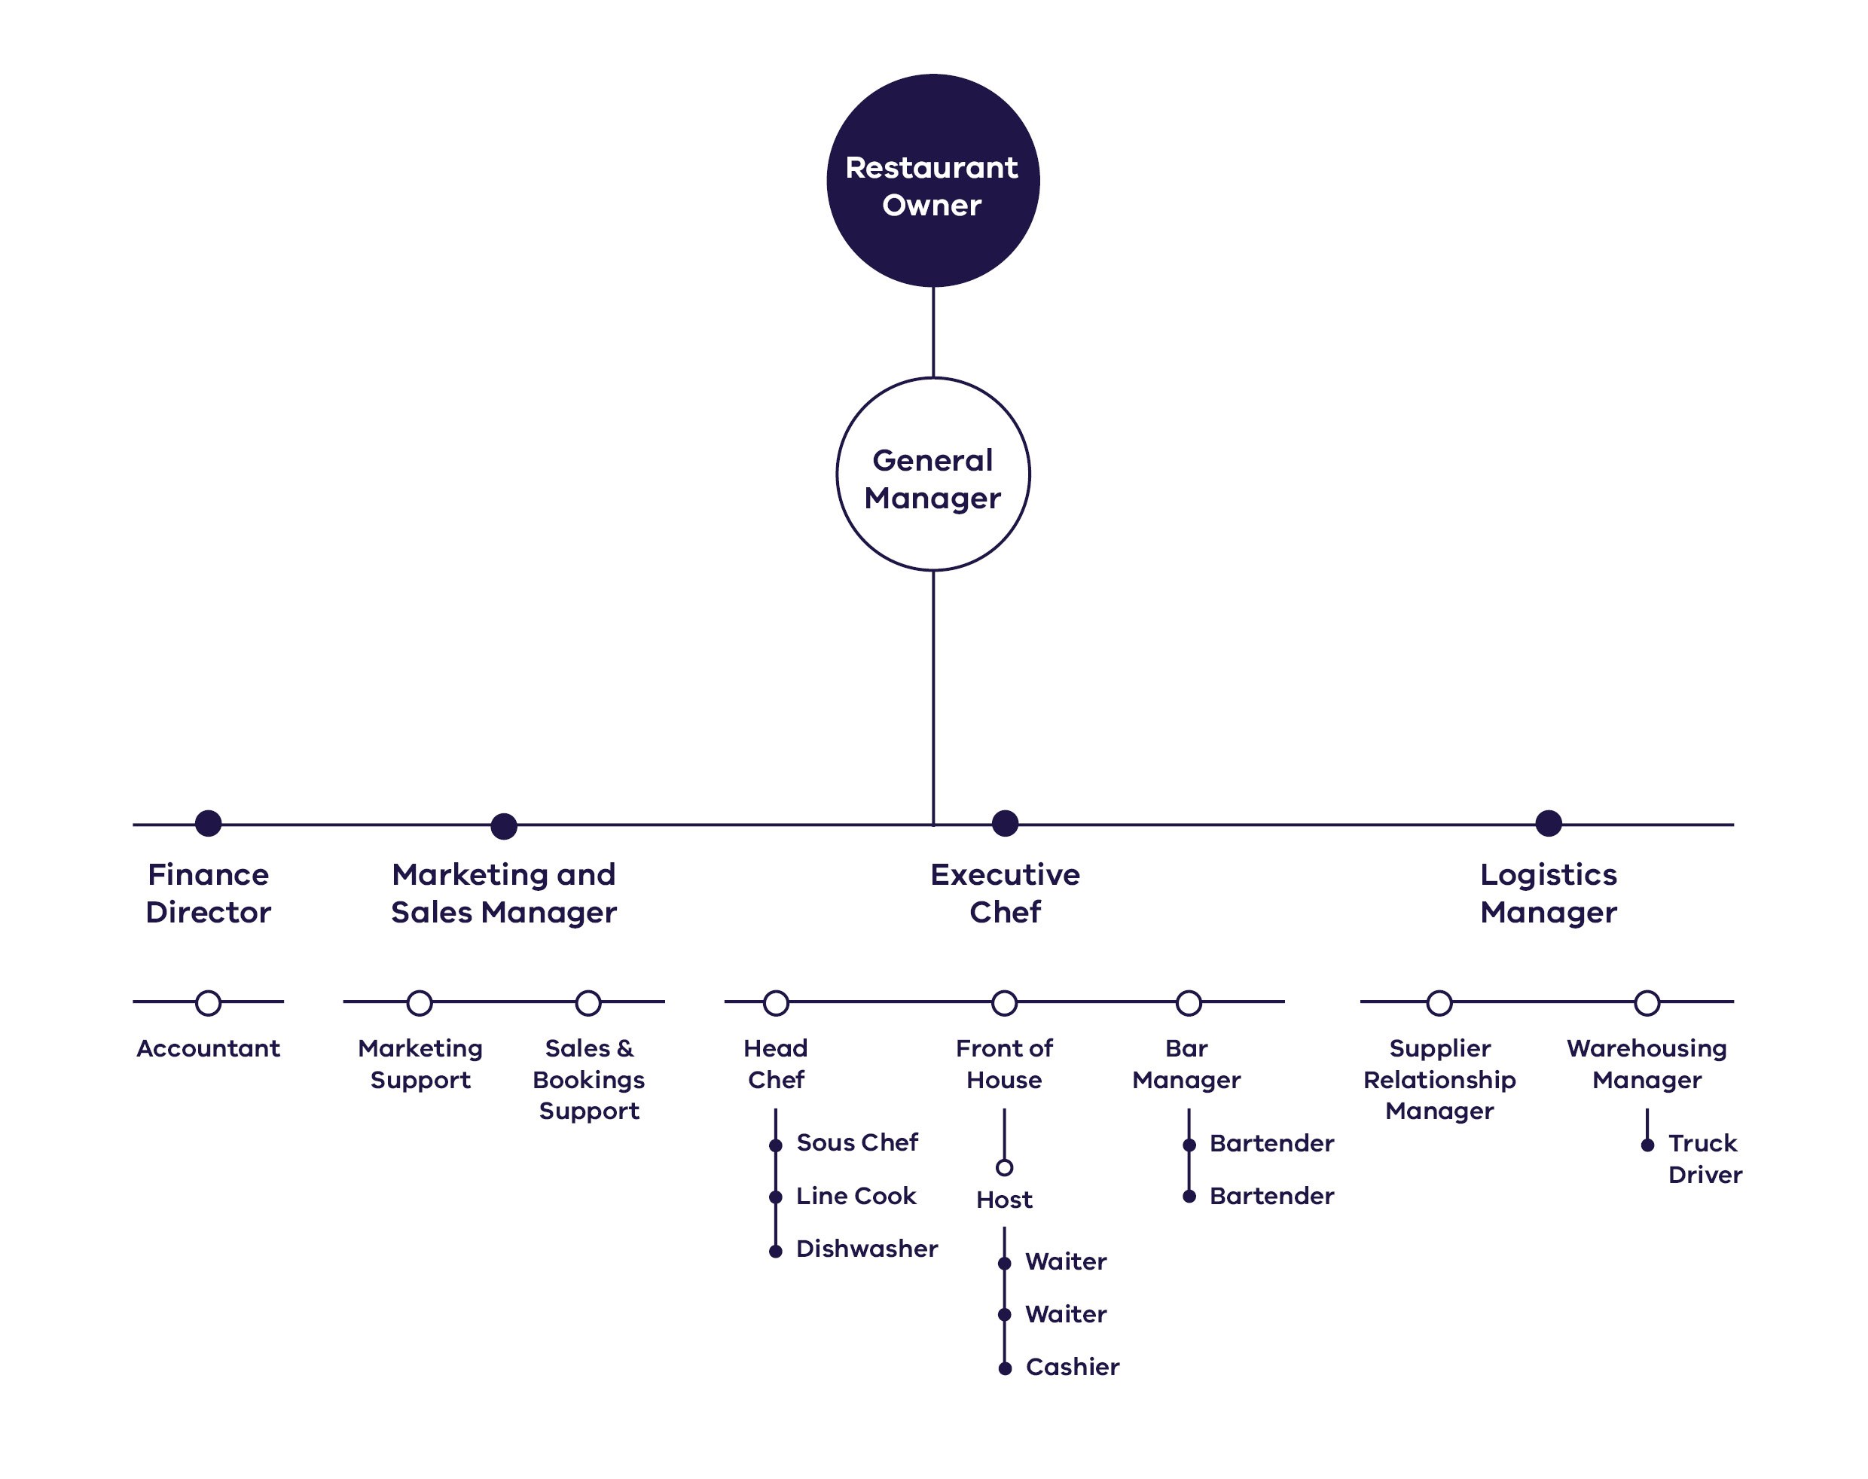
Mapping all the key roles and assigning them to people is a great way to identify gaps. This could identify the need for a role that wasn’t originally planned for, or show that you need to employ someone to fill a required role.

Who is the ‘right’ person for a job?
The definition of ‘right’ person for the job will be different depending on the business, role and the role’s specific responsibilities. Some key points to consider:
- Properly qualified.
- Well experienced.
- Reliable.
- Good leader.
- Good communicator.
- Problem-solving skills.
- Teamwork/team player.
- Work ethic.
- Honest.
Innovative and creative.
The importance of different characteristics also depends on the role. For example:
- For a new bathroom installed, the most important characteristic for the plumber is to be appropriately qualified.
If a restaurant is hiring a new head chef, they need to be qualified, able to cook delicious food, experienced, reliable, a leader and creative.
If your tourism project has First Peoples cultural experiences or products, consider working with First Peoples to recruit a suitable First Peoples employee for the job. Additionally, consider implementing disability and diversity awareness training for customer service staff, and training in cross-cultural communication skills for staff working with international visitors.

Refining your customer journey
Explore and refine the customer journey for your product. Map out everything a customer would do, buy, need, or experience while engaged with your product. This establishes if all systems, inventory, and people are ready to deliver the product, providing an excellent customer experience. For example, as the owner of a hotel providing accommodation and dining, map the following:
- Accessibility and ease of the online reservation system.
- Operations of the check-in desk.
- Rostering and capacity of room cleaning, and alignment with check-in and check-out timing.
- The capacity and turnaround of laundry services for linens.
Ordering process for restaurant supplies and other hotel consumables.
If any aspects of the customer journey are unsatisfactory, fix these issues before launching.

Ensuring the right processes are in place
Think about what you need to open on day one. Every project will have unique needs, but this general checklist might help:
Do you have the right processes, procedures, requirements and/or practices in place?
- Human resources.
- Cultural awareness.
- Health and safety.
- Business registration.
- Operating permits and licences.
- Insurances.
- Accounting practices.
- Record keeping.
- Payment of salaries and superannuation.
- Security – online and physical.
- Information technology and computer systems.
- Inventory ordering and management.
- Customer service.
- Staff training and education.
- Contract management.
- Tax.
- Submission of regulatory requirements.
- Project management plan.

Getting licences, registrations and permits
The easiest way to identify the range of licences, registrations and permits you will need is to use the Australian Business Licence Information Service (ABLIS). Select ablis.business.gov.au.
ABLIS creates a report of relevant licences for your business, application forms for those licences and details of the authorities you will need to contact.

Marketing

Before opening day
A marketing strategy outlines your marketing goals and objectives, your target market and audience, pricing and promotion.
Development of a brand and positioning strategy is critical to the success of any tourism project. Revisit your market assessment; it should capture your brand and how you will position your tourism project. Product and experience development should also be part of your marketing strategy.
Marketing activities should start at least six months before your launch. For larger, more complex or unique projects, begin at least 12 months before opening. Planning how you promote your project reduces the risk that you experience a slow opening period, with low visitation levels that harm viability.
Registered Aboriginal Party (RAP) endorsement will help create a positive project reputation in the local community.
Your marketing or public relations agency, or in-house marketing specialist will guide you. Some suggested activities are:
- Consumer marketing such as print, television or cinema, out of home or digital marketing.
- Public Relations.
- Leveraging Visit Victoria’s Marketing.
- Exploring marketing undertaken by your local Regional Tourism Board.
- Exploring opportunities available on booking websites.
- Developing a digital marketing strategy, including building a website, search engine optimisation, online reviews, listing your business on the Australian Tourism Data Warehouse and building a social media presence.
- Exploring accreditations that allow registration with travel agents and international tour operators.
Your marketing activities will be based on your target market, and their engagement preferences. You need to think about where they source information prior to and while travelling, and consider the tone of your communications – does it fit your brand and the channels you are using?
Business Victoria, Visit Victoria and the Victoria Tourism Industry Council (VTIC) provide training on marketing activities. Select the following industry resources:
- Business Excellence Guide.
- Understanding Visitor Needs.
- Marketing Excellence Guide.
People Excellence Guide.

Understanding your target market
To attract visitors, tailor your marketing activities to your target market.
During the Phase 1 - Market assessment you should have:
- Identified and tested the market potential.
- Identified potential competitors and alliances.
- Understood market penetration.
- Developed the brand and positioning.
- Understood price elasticity.
- Identified the channels available to you, to reach your target market.

Leveraging government marketing
Visit Victoria leads the Victorian Government’s tourism marketing programs, including campaigns and promotions. Specific, targeted campaigns and promotions are developed for intrastate, interstate and international markets. Visit Victoria also has a range of resources to assist businesses to develop and market their products, select corporate.visitvictoria.com/resources/marketing-opportunities.
The Australian Tourism Data Warehouse (ATDW) is the national platform for digital marketing in Australia. Visit Victoria is a shareholder and manages all Victorian businesses seeking to list on ATDW. Tourism Australia, Visit Victoria, Regional Tourism Boards and a range of third-party websites draw their consumer website product listings from ATDW. It is strongly recommended that new tourism projects list their product on ATDW, select corporate.visitvictoria.com/resources/marketing-opportunities/about-atdw.

Promoting overseas
Promoting your business to overseas visitors is an important step for tourism operators. Overseas guests are more likely to travel mid-week and off-peak than domestic visitors, providing income in quieter periods. The structure of the inbound distribution system will be specific to your target markets, and traditionally include:
- Inbound Tour Operators (ITOs) based in Australia, wholesalers based overseas, and international retail travel agents.
Online Travel Agents and wholesalers, who you may already be working with in the domestic market.
Industry commission rates vary between 10% and 30%, depending on the distribution level engaged. A healthy mix of direct bookings that incur no commission, and other commission rates, should result in an average commission cost of approximately 15% of gross income per annum.

Leveraging the benefits to the local community
Through the promotion of your project’s social, economic, environmental, and cultural benefits, as well as the promotion of benefits to the local community and Traditional Owners, overseas tourists interested in responsible tourism may be attracted to your project, especially if your project involves cultural experiences or products.
Working to build authentic relationships with other businesses, tourism operators, RAPs, Traditional Owners and First Peoples majority-owned businesses, and aligning with similar tourism initiatives, can also help you gain learnings that can be incorporated into your project.

Future expansion
Eventually, you may wish to expand your operations and undertake further works, either to cater to your growing customer demand or add components deferred due to budget. Ensure you develop a clear budget, and complete thorough market research to understand your vision and the viability of an expansion.
If you liked the work that your architect, consultants or project team initially completed, consider engaging them again. They know the site, existing buildings, and council requirements, your vision and motivations.
Refer to the relevant sections of this document to inform any future expansions.

Budj Bim Cultural Landscape
First Peoples-led experiences
The UNESCO World Heritage Budj Bim Cultural Landscape is a unique, ancient place, sacred to the Gunditjmara people. The site is particularly remarkable as it demonstrates some of the world’s oldest and most extensive aquaculture systems and ancient stone settlements. With support from the Victorian Government, the Gunditj Mirring Traditional Owners Aboriginal Corporation (GMTOAC) is developing a diverse, immersive and authentic tourism offering for visitors seeking to understand and experience Gunditjmara Country.
Due to its outstanding and unique qualities, GMTOAC has engaged professionals at all stages, and in all aspects of the project. They have also maintained a strong working relationship with local, state and federal governments who recognise the value of cultural preservation.
The vision for Budj Bim extends beyond tourism, providing an opportunity for Gunditjmara people to share and protect their stories and landscapes, as well as the opportunity to work and learn on Country.
Currently, Budj Bim offers a range of paid, guided cultural tours, from two hours up to a full day, as well as tailored school group tours. The Tae Rak Aquaculture Centre is open to the public, where visitors can experience ancient aquaculture practice. The Aquaculture Centre also features a gallery, retail space, and bush tucker cafe. This space also allows Gunditjmara people to continue to care for Country and culture sustainably.
In the future, Budj Bim will provide accommodation and a broader range of experiences so that Gunditjmara people and visitors can continue to deeply engage with the rich landscape. Developing infrastructure on culturally sensitive land can be challenging, so GMTOAC are working towards realising their vision by purchasing less sensitive land nearby for future development.
For more information on Budj Bim Cultural Landscape, select budjbim.com.au.
Quick tips
- Achieving World Heritage Listing takes time, and it is imperative to have an evidence-based nomination.
- Develop a clear master plan and investment strategy to guide the delivery of the project.
- Maintaining cultural and landscape values is paramount, and some aspects of your project may need to be provided off-site to preserve the landscape.
- Incorporate feedback into your project; this helps build relationships with stakeholders.
- First Peoples-led tourism provides a network of benefits for First Peoples.

Puffing Billy Railway Lakeside Visitor Centre
Nature based
The new Puffing Billy Railway Lakeside Visitor Centre leverages an iconic, heritage steam railway in the heart of the Dandenong Ranges to attract more visitors from around Australia and the world.
Before the visitor centre was built in Emerald Lake Park, Puffing Billy Railway saw significant patronage growth. Despite this, 90% of visitors would not travel past Emerald. This caused congestion on approximately half the railway line and limited revenue potential. As a major project with sensitive historical and environmental context, Puffing Billy Railway involved the Victorian Government early, consulting them throughout development.
The team engaged many experts including advisory architects, the Office of the Victorian Government Architect, engineers, landscape architects, and town planners, with the town planners being particularly helpful in determining the appropriate planning approvals pathway.
After detailed engagement with council, referral agencies and utilities providers during the planning phase, the team faced some delays addressing project specific issues. Cost and scheduling complexities also arose due to challenges around contingency allowances. Defining the visitor experience, interpretations, storytelling, and media activations as the project progressed also required further compromises and additional costs, which highlighted the importance of developing the visitor experience concept early.
Despite this, through sound governance processes and early engagement with stakeholders, the Victorian Government and project delivery team, the project was completed and opened in October 2021, successfully progressing from concept inception to construction within two years.
It features a modern café with the best produce on offer in the region, purpose-built indoor and outdoor event and dining spaces, a dedicated gift shop with locally designed treasures and a gallery of steam artefacts in the Lakeside Hall. The Lakeside Hall includes historical interpretive zones that give guests a glimpse into the early days of steam train travel, while the Lakeside Visitor Centre offers guests a unique tourism facility with world class amenities.
The result of this investment has seen a considerable increase in average customer spend, enhancing business resilience with increased annual revenue outcomes.
For more information on the Puffing Billy Railway Lakeside Visitor Centre, select puffingbilly.com.au.
Quick tips
- Implement good governance and management for large-scale, complex projects.
- To achieve community buy-in, conduct extensive, genuine community engagement.
- Adapt the project in response to feedback and continue to keep the community informed.
- Engage with the appropriate architects, designers and external utilities and agencies early to achieve strong design outcomes within required program targets.
- Undertake detailed master planning to define strategic investment opportunities.

Green Olive at Red Hill
Food and drink
Green Olive on the Mornington Peninsula is a whole-of-farm experience highlighting agricultural offerings in the region. The farm is a multi-year Gold Winner at the State and National Tourism Awards in the category of Excellence in Food Tourism.
As a flourishing establishment with a range of experiences and products on offer, Green Olive began twenty years ago as a blank canvas. To fulfil their “tree change” dream, the owners realised it needed to be completed in steps. Construction started in 2002, and since then, the owners progressively added an olive grove, vineyard, tasting centre, livestock, herb and vegetable garden, curated food and wine experiences, farm tours, picnic products and a bush food garden. At each stage, they reassessed their project, adapting to customer preferences and desires. They navigated planning scheme, licensing and staffing limitations throughout different stages of development.
As Green Olive is located in a Green Wedge Zone, the owners were tasked with running a commercially viable venture while ensuring they were aligned with planning scheme goals. Green Wedge land is designated for agricultural, conservation, environmental, historic, landscape, recreation and tourism opportunities, with sustainable farming activities encouraged. The owners exercised significant care when starting new ventures, engaging planning and marketing professionals when required. Their staged approach minimised planning challenges. However, given the relatively restrictive planning controls and potential for delay, this made debt financing challenging to access.
Marketing and outreach were organic, with patronage growing primarily through word-of-mouth reviews, using online distribution channels and adapting its experience in reflecting on nearby, similar offers. At one stage, they investigated rapid expansion, but quickly realised that organic growth was closer to the owners’ goals, financial capacity, and vision. The offering is now a thriving, multifaceted, whole-of-farm experience, appealing to a wide range of visitors on the Mornington Peninsula. Green Olive is now investigating opportunities for overnight accommodation to be embedded within their experience.
For more information on the Green Olive, select greenolive.com.au.
Quick tips
- In a restrictive area, it is essential to align your offering with the planning controls.
- Engage a branding consultant, and then commit to the brand.
- Listen to your customers and adapt your offering to their preferences, building strong products and services.
Never overextend financially, and only expand within your means.
You will need a heritage advisor to help you prepare a CHMP.
As well as the costs of the advisor, fees are paid to the RAP or First Peoples - State Relations to assess the CHMP. Heritage advisors will also provide advice about how to proceed, if a RAP is not appointed for the area.
A CHMP includes a desktop assessment and may involve complex site investigations to assess the potential for cultural heritage material.
You can prepare CHMPs voluntarily to manage potential impacts to Aboriginal cultural heritage. This helps in providing assurance that you are not impacting cultural heritage. If a CHMP is not in place and you encounter Aboriginal cultural heritage during construction, works may need to stop until you have a prepared and approved one.
The RAP or First Peoples – State Relations (where a RAP has not been appointed), will assess and approve CHMPs. If a RAP has not been established, Aboriginal people or First Peoples are to be consulted.
Select firstpeoplesrelations.vic.gov.au for the Aboriginal Heritage Planning Tool to determine whether a CHMP is required.
Other approvals

Metung Hot Springs
Wellness
Metung Hot Springs is Gippsland’s newest holistic wellness experience. It is a region-transforming destination, decades in the making. The facility offers a unique experience including a hot springs resort, golf club, restaurant, and future plans for a marina. Key to its success was a strong master planning approach, and implementation planning from inception.
The Metung Hot Springs team worked in partnership with the established operators of Peninsula Hot Springs, leveraging decades of experience and skill to ensure the project was well-scoped and sound for investment. Forward planning was essential for such a significant development. The team was focused on bringing a ‘modular’ vision to life by creating stages that were independently commercially viable, and could support the rollout of future stages, due to the significant upfront costs and the requirement for enabling infrastructure.
Its success in securing funding was based on a strong master plan and implementation strategy. The funding was linked to the rollout of each stage, requiring the operators to progress before receiving further funds. Another major strength of this project is that all the required planning approvals had been obtained years prior – resolving one stage of the investment lifecycle. The Metung Hot Springs did extensive business planning, contracting a financial advisor to complete an economic activity model demonstrating that each dollar spent at the hot springs was expected to deliver twelve more for the region. This showed the owners that their project would create mutual benefits for other tourism providers in the region, further solidified through deliberate partnerships and agreements.
However, the project faced some unexpected challenges. The procurement and construction phases were heavily affected by materials shortages and supply chain issues which required some scope, design and materials changes. Throughout the process, Metung Hot Springs was able to employ primarily local contractors, which helped build goodwill and support in the community. For more information on Metung Hot Springs, select metunghotsprings.com.
Quick tips
- Develop strong partnerships with experienced operators.
- Design in line with the planning scheme, avoiding hurdles and delays.
- Create a master plan and implementation strategy before applying for government support.
- Use local skills and materials, supporting the local economy and building goodwill.
- Create a product that can open in stages, allowing you to operate as soon as possible.

Silverwoods Resort Yarrawonga
Accommodation
Silverwoods Resort incorporates The Sebel Yarrawonga, a luxury boutique hotel and the 18-hole Thomson Perrett designed Black Bull Championship Golf Course in the Murray region border town, Yarrawonga.
Silverwoods has since completely transformed the visitor and local community experience of Lake Mulwala and wider Yarrawonga area. The range of activities and services on offer has made the resort a must-see destination in the region.
The developer, Lotus Living engaged a planning and economics firm to undertake rigorous market testing and economic analysis to understand the scale of risk and opportunity for a major development in the area. Lotus Living understood the site had potential and that there was an opportunity to create something special. The development has established a wide range of products including residential dwellings, a world class golf course, wellness experiences and fine dining. Their project portfolio is funded through a combination of debt financing and their own capital, allowing them to manage risk.
To deliver a high value experience they involved skilled, experienced consultants for every aspect of the project delivery. Developers engaged with Accor and branded the hotel under the Sebel umbrella. It was also critical for the project to foster strong ties to the Yarrawonga community, which was enhanced by partnerships with local businesses and hiring local workers to operate and maintain the facilities.
Silverwoods Resort Yarrawonga has enjoyed successful seasons and high room occupancy rates since launching, as Victorians seek luxurious wellness and tourism experiences closer to home.
For more information on Silverwoods Resort Yarrawonga, select thesebelyarrawonga.com.au.
Quick tips
- Explore new ideas: look for unique opportunities in untapped markets and regions.
- Ensure that there is strong linkage between hotel operations and design.
- Review funding strategies upfront to ensure project costs align with required capital returns.
- Consider diversifying your offering to appeal to a wider audience.
- Use local skills, materials, and knowledge wherever possible.
- Engage highly skilled specialists.

Melbourne Cable Park
Melbourne attraction
Melbourne Cable Park is a unique outdoor attraction for people of all ages and abilities, located in Melbourne’s south-east. Providing a wide range of accessible, water-based, family-friendly activities, the park is renowned for its accessibility, with activities including Cable Wakeboarding, an Aqua Fun Park, Urban High Ropes, and outdoor cinema. It offers a dedicated, accessible program for people with disabilities to enjoy water sports. This is core to its mission – to demystify and normalise disability in water sports.
Employees and the community love Melbourne Cable Park’s inclusive and welcoming environment, creating a loyal customer base and workforce. The park offers an attractive destination for both locals and visitors, transforming underutilised land into a high-value, multifaceted facility.
Park development was a major investment, requiring major earth works, landscaping, hydrology assessments, acoustic assessments, electrical works, and the construction of facilities never seen in Australia. The land was subject to complicated land tenure arrangements, a significant challenge when applying for approvals.
All these factors required a close working relationship with a local design and construction partner, and careful engagement with overseas vendors. Park opening was carefully planned; each stage opening as it was operational. Instead of partnering with equity investors, the project owners used debt financing. To ensure bank approval, debt was carefully structured and delivery was phased, which staged financial outlay.
From the beginning, the park has been a pay-to-play product, offering choice to visitors and allowing their families to be part of the experience as spectators.
For more information on Melbourne Cable Park, select melbournecablepark.com.
Quick tips
- Creating accessible facilities results in a more welcoming experience for the whole community.
- Be flexible with your offer, allowing your vision to flourish.
- Research your customer’s preferences through direct communication and market research, not just social media.
- Good communication and patience helps overcome challenging land arrangements.
- Staging development activity over time facilitates a simplified approach to financing.

Glossary
ABLIS
Australian Business Licence Information Service.
ABS
Australian Bureau of Statistics.
ATDW
Australian Tourism Data Warehouse is the largest digital marketing platform for all Australian products. ATDW product listings are used on the following websites: Australia.com, visitvictoria.com, Regional Tourism Boards websites and other third-party websites.
ATO
Australian Taxation Office.
Branding and positioning
Branding is the process of giving a meaning to your specific experience, products or services by creating and shaping a brand in consumers' minds. Positioning defines where your product stands in relation to similar products and services on the market.
Business plan
A business plan builds on the feasibility study. It looks at delivery and operational strategy, commercial viability, confirms partners and identifies risks.
Business resilience
Business resilience is the capacity of businesses to adapt, survive and thrive no matter what kind of chronic stresses and acute shocks they experience.
Business structure
There are three primary ways to structure a business. These are: (1) sole proprietorship, (2) partnership, and (3) proprietary company. Each structure has specific rules and regulations to comply with.
Channels
Channels refers to the specific media that you advertise your product through. Choose the channels best suited to your intended audience.
Content
Content refers to the material disseminated through channels.
Contingency
Contingency is your allowance for unexpected but possible incidental expenses
Country
Country is a term used by First Peoples to refer to the lands, waters and skies to which they are connected, through ancestral ties and family origins.
CPI
Consumer Price Index.
Cultural Heritage
You may require a Cultural Heritage Management Plan (CHMP), or Cultural Heritage Permit, to protect places or objects of heritage value. If you require CHMP, it must be approved before a planning permit can be issued.
CHMP
Cultural Heritage Management Plan.
DDA
Disability Discrimination Act.
DEECA
The Department of Energy, Environment and Climate Action of the Victorian Government.
DJSIR
Department of Jobs, Skills, Industry and Regions.
DSCR
Debt service coverage ratio.
DTP
The Department of Transport and Planning of the Victorian Government.
EE Act
Environmental Effects Act 1978.
EES
Environmental Effects Statement
EPBC Act
Environment Protection and Biodiversity Conservation Act 1999.
Engagement
Engagement is a planned process with to support decision making which encourages stakeholders to get involved in decisions that are of interest to them.
First Peoples
In Australia, First Peoples refers to Aboriginal and Torres Strait Islander people.
GST
Goods and services tax.
Heritage Victoria
Heritage Victoria makes decisions about the most important historic heritage sites in Victoria.
Hurdle Rate of Return
The minimum rate of return required to invest or initiate a project or investment. Hurdle rates give organisations or a project team an insight into whether they should pursue a specific project. The rate is determined by assessing the cost of capital, risks involved, current opportunities in business expansion, rates of return for similar investments, and other factors that could directly affect an investment.
IM
Information Memorandum.
ICIP
Indigenous Cultural Intellectual Property (ICIP) rights protect the rights of First Peoples to their heritage and culture.
ITO
Inbound Tour Operators.
IVS
International Visitor Survey.
Investment Lifecyle
The Investment Lifecycle includes the key steps required to establish a successful tourism project. It is a straightforward process to move from idea development to construction and product launch.
Investment motivation
Your motivation for investing will help you determine project objectives, your required return on investment and the strategic direction of your business.
IRR
Internal rate of return.
Local Council
In Victoria, local government is a distinct tier of government consisting of democratically elected Councils. They are responsible for a range of services, including land use planning and building control, public health services, domestic animal control and environmental protection legislation. They also maintain some community infrastructure and administer some local laws.
MCB
As a part of Visit Victoria, Melbourne Convention Bureau (MCB) leads the acquisition and delivery of national and global business events for Melbourne and regional Victoria. They offer membership marketing, partnerships and lead generation for events both locally and abroad. Co-located with Visit Victoria in Melbourne, the MCB also has representation in the United Kingdom, United States of America, China, and Malaysia.
MPS
Municipal Planning Strategy.
Native Title
Native Title is the recognition that First Peoples have rights and interests to land and waters according to their traditional law and customs as set out in Australian Law. Native Title is governed by the Native Title Act 1993.
NCC
National Construction Code.
NVS
National Visitor Survey.
Operating Model
Your business’ operating model is an important factor in long-term success. Depending on the nature and scale of your tourism operation, the operating model will encompass:
- People and capabilities.
- Functions and processes.
- Physical infrastructure and equipment.
Digital hardware and software.
Parks Victoria
Responsible for managing a diverse estate of more than 4 million hectares including 3,000 land and marine parks and reserves making up 18 per cent of Victoria’s landmass, 75 per cent of Victoria’s wetlands and 70 per cent of Victoria’s coastline.
Product
A tourism offering that is ready for market.
Project
A tourism offering that is still in development.
QS
Quantity Surveyor.
RBA
Reserve Bank of Australia.
RAP
Registered Aboriginal Parties (RAPs) are Traditional Owners, legally recognised under the Aboriginal Heritage Act, with responsibilities for managing and protecting Aboriginal Cultural Heritage on Country.
RFI
Request for Further Information.
Risk assessment
A risk assessment identifies factors that may negatively impact a project, evaluates their likelihood and considers measures to mitigate or manage them. This ensures you and any investors are aware of, and can manage any risks proactively, minimising impact to project delivery and operations.
RTB
Regional Tourism Boards (RTBs) can act as a key conduit between project owners, other tourism providers and local services to build capability and provide marketing opportunities to boost the local visitor economy. The regional tourism network is undergoing a reform process that will see RTBs transition into Visitor Economy Partnerships (VEPs).
ROI
Return on investment.
Self-determination
While Aboriginal self-determination means different things to different people, the United Nations Declaration on the Rights of Indigenous Peoples (UNDRIP) described self-determination as the ability for Indigenous people to freely determine their political status and pursue their economic, social and cultural development.
STOs
State Tourism Organisations.
Traditional Owners
First Peoples who are members of a local descent group having certain rights and responsibilities in relation to a tract of land or area of sea.
TRA
Tourism Research Australia.
Value Management
Value management helps you stay on top of the ongoing construction spend by adjusting the design or overall project.
VBA
Victorian Building Authority.
VERRP
The Visitor Economy Recovery and Reform Plan (2021) (VERRP) outlines key directions for reforming and directing Victoria’s visitor economy.
VCAT
The Victorian Civil and Administrative Tribunal (VCAT) is a tribunal that hears and decides civil and administrative legal cases in Victoria.
Visit Victoria
Visit Victoria is the State’s tourism and events company. Visit Victoria’s role is to drive visitation and expenditure through destination marketing and a strong pipeline of major, regional and business events, supporting the visitor economy.
VTIC
Victoria Tourism Industry Council (VTIC) is the dedicated peak body and leading advocate for Victoria’s tourism and events industry.
Visitor Experience
The visitor experience is the “how” and “why” visitors interact with your product. It's how they feel before, during and after engaging with your tourism product. It should be both marketable, and memorable.

Authorised and published by the Victorian Government
1 Treasury Place, Melbourne.
© State of Victoria, Department of Jobs, Skills, Industry and Regions
ISBN 978-1-76090-636-8 (pdf/online/MS word)

The aspirations of Traditional Owners and the local First Peoples community are set out in the Country Plan of each Registered Aboriginal Party. The Country Plan can be downloaded from the website of each Registered Aboriginal Party.
United Nations Declaration on the Rights of Indigenous Peoples, Article 3.
Yuma Yirramboi – Victorian Aboriginal and Torres Strait Islander Employment and Economic Strategy, page 18.
The Guardian (2021). “‘You can make money out of us’: the disabled people demanding more accessible travel and tourism”.
business.vic.gov.au/business-information/protect-your-business/risk-management/business-resilience#whatis; viewed 26 August 2022
Aboriginal cultural heritage means Aboriginal places, Aboriginal objects and Aboriginal ancestral remains’ as defined by the Aboriginal Heritage Act 2006
1 Evidence of a contractor’s Reconciliation Action Plan can be found on the website of Reconciliation Australia (‘Who has a RAP?) reconciliation.org.au/reconciliation-action-plans/who-has-a-rap/

