Visitor Economy Recovery and Reform Plan
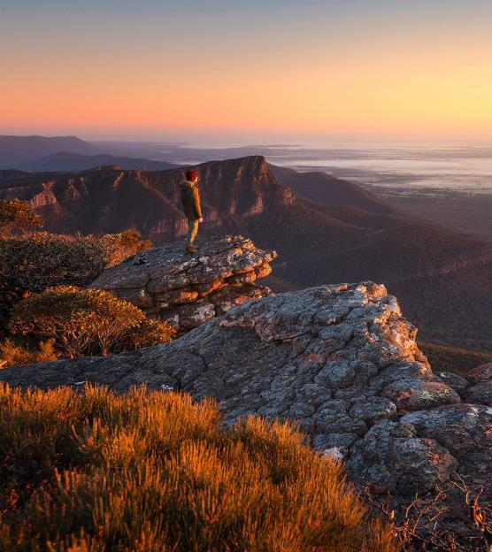
Minister for Tourism, Sport and Major Events foreword
Victoria is home to some of Australia’s best tourism offerings.
Our capital, Melbourne, is a vibrant metropolis, renowned for its culture.
Our diverse regions, from the sea to the snow, provide experiences and escapes that welcome millions of visitors annually.
In the year ending December 2019, tourism contributed $32.5 billion to the state’s bottom line.
It employed 263,300 people, delivering 6.5 per cent of gross state product.
However, 2020 dramatically changed the landscape, with bushfires and the ongoing impacts of the global pandemic resulting in a $19.5 billion decrease in visitor expenditure last year.
The Victorian Government recognises the critical need to support the tourism and travel sector as a significantly impacted industry and the Visitor Economy Recovery and Reform Plan confirms that commitment.
It will serve as a whole-of-state visitor economy strategy, with a goal of reaching $35 billion in annual visitor spend and generating 300,000 additional jobs by June 2024.
Informed by the findings of the Regional Tourism Review, the Visitor Economy Recovery and Reform Plan will strengthen the state’s enviable tourism offering by developing new experiences, products and infrastructure and attract more international, interstate and intrastate visitors by making the most of our marketing expenditure. It will enhance regional tourism boards and ensure statewide collaboration and planning.
Our investment of $633 million across four years will develop and improve the visitor experience and, as the tourism market grows more competitive, encourage public and private investment to not only grow the visitor base, but inspire them to stay longer and spend more. It’s a holistic look at how Melbourne and Victoria can achieve ambitious targets as we continue to work with industry, the community and other key stakeholders.
We are proud of what our state has to offer, and we are delighted to present the future of tourism in Melbourne and regional Victoria.
The Hon Martin Pakula MP
Minister for Tourism, Sport and Major Events

Minister for Regional Development foreword
Regional tourism plays a vital role in creating jobs, supporting thriving regions and strengthening communities.
As the Special Adviser for the Regional Tourism Review, and now the Minister for Regional Development, it was a privilege to travel to all corners of regional Victoria to find new ways to grow tourism and support regional Victoria.
Through an extensive consultation process with industry and government stakeholders, the Regional Tourism Review delivered a wealth of advice that has informed this Visitor Economy Recovery and Reform Plan.
Although our consultation took place before the bushfires and the global pandemic, the findings are the foundation for ensuring our critical tourism and visitor economy sectors come back stronger and more enviable than ever.
We heard from enthusiastic and committed visitor economy stakeholders across our diverse regions, including local business owners and government, Regional Tourism Boards and their partners, Traditional Owners, community groups and residents from Gippsland to the Grampians, from the Murray to the Mallee.
The findings of the Regional Tourism Review and the Visitor Economy Recovery and Reform Plan will ensure that regional Victoria is offered the best support and opportunities to increase visitation, boost local business and build a resilient sector that enables the long-term growth of our visitor economy.
The Hon Mary-Anne Thomas MP
Minister for Regional Development Special Adviser, Regional Tourism Review
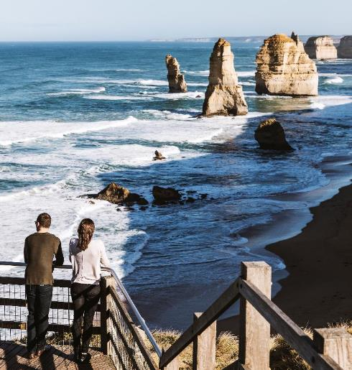

About the Visitor Economy Recovery and Reform Plan and the Regional Tourism Review
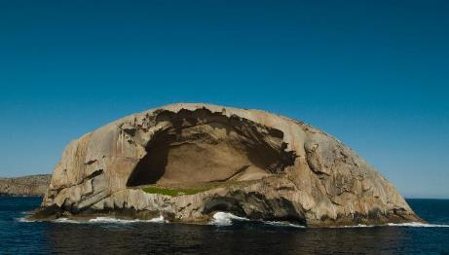
The Visitor Economy Recovery and Reform Plan (the plan) considers the unique, combined effects of the 2019–20 bushfires and the 2020 COVID-19 pandemic on the Victorian visitor economy.
It examines the uncertainties of the economic outlook and the likely effects on the industry as we recover from the pandemic.
The plan provides a framework for industry and the Victorian Government to work together to restore and grow this vital sector.
It is informed by detailed analysis and extensive consultation about the impacts of the bushfires and the pandemic – and the pathways for recovery.
The plan also concludes the Regional Tourism Review (the review), which was commissioned by the Victorian Government in March 2019 to ensure our regions get the support and opportunities they need to grow in the tourism market.
Consultation with stakeholders during the review identified five key themes that present opportunities for regional tourism:
- Strengthening our tourism offering
- Making the most of our marketing spending
- Supporting industry
- Enhancing Regional Tourism Boards
Better coordinating efforts.
Given the events of 2020, we did further work to confirm these themes remain valid, and to consider new implications for our state.
We held nine stakeholder consultation workshops in May to July 2020 with participants from local councils, regional tourism organisations and representatives from the tourism industry. We also met with industry representatives from the Victoria Tourism Industry Council and Regional Tourism Boards, and across government.
This plan is the result of that work. It provides a statewide response to the challenges.
It addresses the clear message from consultation and analysis: Victoria needs a long- term reform strategy to support growth and resilience.
The plan outlines this strategy.
It also recognises that it takes its place as one of several Victorian Government initiatives underway to support economic survival and recovery.

Victoria’s visitor economy
The economic impact of the COVID-19 pandemic on the visitor economy is severe and the recovery trajectory remains uncertain.

Sector baseline
Victoria is considered a leader nationally in the visitor economy. The industry contributes significantly to Victoria's economy, with $32.5 billion in visitor expenditure in 2019.

Impact of coronavirus (COVID-19)
↓ 60%  Fall in visitor expenditure between 2019 and 2020 | ↓ 58%  Decline in visitor nights between 2019 and 2020 | ↓ $19.5bn  Impact of COVID-19 on visitor expenditure for 2020 (of which $5.4 billion is in regional Victoria)

Recovery trajectory
The events of 2020 will likely be felt for years to come, with continued low levels of international travel and continued necessary public health safeguards. The sector’s recovery trajectory remains uncertain.
Broader economic conditions may also dampen demand for travel.
Tourism is discretionary spending, and it will take time to recover until households feel more confident in the economy.
Depending on a range of factors, domestic markets may not return to normal until 2022, while international markets may take until 2024 to return to 2019 levels – but these estimates are speculative.
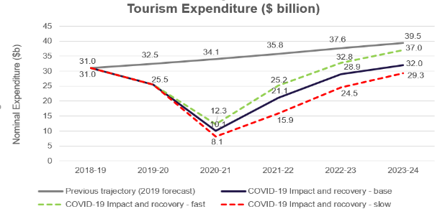

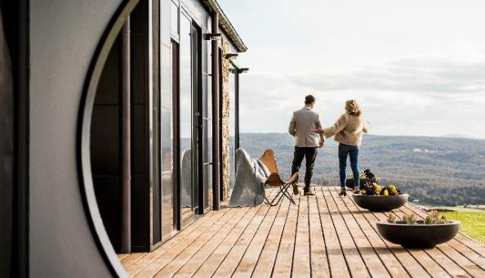

Challenges to the recovery of Victoria’s tourism industry
Our recovery
As we recover from the events of 2020, tourism is expected to face continuing hardship in the short to medium term.
The COVID-19 pandemic halted international travel completely and put domestic tourism into hibernation.
This will have significant economic impacts for both metropolitan Melbourne and regional Victoria.
Melbourne is more dependent than the regions on the international market and major events calendar. This means its visitor economy will be more affected, and for longer.
This also has statewide implications, because Melbourne is the main driver of Victoria’s visitor economy.
Regional Victoria will likely recover more quickly because of its appeal to the domestic market. However, several regions with a high dependence on tourism will continue to be affected if key products, services and events are not available.
Regional Victoria's recovery is also more vulnerable to underlying organisational and structural challenges, particularly on the supply side.
While these challenges are currently impacting the sector and there is some uncertainty moving forward, we have a plan to address them.

Challenges facing tourism in Victoria

Growing competition
There is increased competition from other Australian destinations for visitor spend in the immediate term, and this will be followed by international competitors in the future.
Australian destinations have invested significantly over several years to develop new tourism offerings, and have developed distinctive brands that resonate with visitors.
Victoria’s response requires immediate efforts to build a strong pipeline of demand-driving infrastructure to increase the supply of high-quality tourism products.
Marketing activity will need to be uplifted and reimagined to cut through a crowded marketing landscape.
Victoria will also face a highly competitive market for major events, regional events and business events. This is because other jurisdictions will also seek to propel their events industries out of the hibernation they also experienced during 2020.

Leveraging and supporting Melbourne
Melbourne plays an important role in the visitor economy. It is a key interstate and international brand for Victoria, and a stepping-stone for visitors to regional Victoria.
There is an opportunity to refresh the city experience, and particularly to adapt to a COVIDSafe world.
Melbourne’s branding incorporates diverse and authentic experiences throughout the city, which will need to adhere to COVIDSafe principles.
Supporting major and business events is also a priority to drive recovery.
These events are a major part of the Victorian brand, and attract many interstate and international travellers.

The Regional Tourism Review
In 2019, the Victorian Government commissioned the Regional Tourism Review to identify opportunities to grow regional tourism.
The review received 533 formal submissions in response to a discussion paper published in July 2019, and it heard from 662 participants at regional consultations.
The review consulted broadly, including with local businesses, industry leaders, local government, Regional Tourism Boards, Regional Partnerships, Traditional Owners and First Peoples communities, community groups and residents.
The plan delivers on the review's key findings. The findings are organised into five themes.

Strengthening our tourism offering
Victoria’s tourism offering is strong, but we can strengthen the experience for visitors.
This includes bolstering our unique, artisanal and authentic local offerings, as well as local ‘hidden gems’, history and heritage, and First Peoples’ led experiences.
Victoria can further leverage its strengths in natural attractions, arts and culture, epicurean experiences, and sport and events.
Separate work has identified design, fashion and retail as strengths for Melbourne.
Regional Victoria has many competitive strengths with significant growth potential. These include a nature-based strategy to extend tourism beyond existing icons, and a plan to develop First Peoples’ led tourism experiences.
However, we need a more refined understanding of how visitors access information so we can better match their needs. This could include face- to-face or better digital offerings for pre-visit planning.
Regional Victoria also needs further investment in accommodation to increase the level of high-end and boutique accommodation.

Making the most of our marketing spending
Our marketing activities need to be better resourced and better coordinated.
All marketing activities undertaken by Visit Victoria, Regional Tourism Boards, local tourism organisations and councils should be done collaboratively. We need to focus on the bigger picture, and make sure marketing funds are not spread across smaller campaigns that have less impact.
Visit Victoria should play a key role in setting the strategic marketing plan for Victoria, while Regional Tourism Boards should provide a means for industry, councils and communities to have a voice in statewide branding activities.

Supporting industry
The 2020 bushfires and the COVID-19 pandemic have highlighted the importance of crisis management and planning. They have also shown us the need to ensure businesses are resilient so they can bounce back from disasters and other shocks.
Two key issues for small businesses are:
- labour and skills challenges, including attraction and retention, industry seasonality, housing affordability, and the perception of tourism as a career
- digital capability, such as connecting to sales channels, promoting businesses and regions, and understanding markets.
Businesses and investors also want direction and support from government to ensure important tourism projects can be delivered through the planning and approvals system.
Providing this support will help unlock significant new opportunities.
There is also potential to improve community engagement, supporting industry to both maintain and gain social licence for tourism projects.

Enhancing Regional Tourism Boards
There is broad support for Regional Tourism Boards from stakeholders and across government, with some working well and others showing some strengths and potential for improvement.
People described the following key ingredients for success for Regional Tourism Boards:
- clear roles and responsibilities across boards, local councils and Visit Victoria to reduce duplication and support long-term success
- a collaborative, cross-regional approach led by boards, working with councils, industry and local tourism organisations to feed through to state government
- skills-based boards with senior local council and industry participation
- transparent priority setting, including strategy and advocacy that reflects the local community
- capability training programs to strengthen and rebuild industry
- increased capacity and capability supported by scale and resources to deal with complex issues.
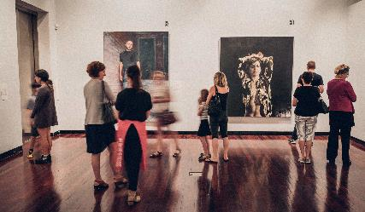
Overall, board remit, capacity and resources are vital for meeting regional tourism objectives.
Boards need to be given authority by councils and government to deliver clear outcomes for their region – and to have skilled staff and the means to deliver those outcomes.
Boards should also be able to reform their operations and coverage to ensure they are performing optimally.
Any changes to boards will recognise they are a partnership between government and industry, and we need to bring all our partners along with us.

Better coordinating effort
Tourism relies on many people across government, industry and the community, however, there is a sense we are not working together.
Stakeholders overwhelmingly called for a clearer strategic direction for tourism in the form of a more detailed statewide plan. This strategic planning should be collaborative, include all levels of government, and engage the community, industry and visitors to drive priorities.
There are also opportunities to improve relationships and collaboration. Clarity of roles and responsibilities at all levels is critical to avoid duplication and conflicting outcomes.

Regional Tourism Review recommendations
In response to consultation, the Regional Tourism Review recommended reforms that will unlock the long-term potential of regional Victoria.
These recommendations, and government's work to implement them, are outlined below.
Build a new pipeline of tourism products that align with an agreed, long-term approach to regional tourism development. The pipeline will be informed by new regional master planning that focuses on competitive strengths and outlines the Victorian Government’s vision for regional tourism.
The government has developed a statewide Visitor Economy Recovery and Reform Plan that will guide private and government investment, and clarify roles and responsibilities across state and local government, industry and other relevant stakeholders. Subsequent plans will be developed for product strengths, such as nature-based tourism and First Peoples’ led experiences.
Support new private investment in significant projects in regional Victoria. These projects will be supported to understand and navigate their way through the planning and approvals framework and take advantage of opportunities for streamlined approvals.
The government has established a new team in the Department of Jobs, Precincts and Regions to support the delivery of high-priority tourism projects. Work is also underway across government to deliver streamlined planning pathways for priority projects.
New government investment in infrastructure and projects to activate tourism opportunities, including opportunities for the private sector to leverage these investments.
The government recently announced flagship projects, and the Regional Tourism Investment Fund will support enabling infrastructure and projects to activate key tourism opportunities.
Deliver better regional marketing through more effective and coordinated marketing activities, and a co-designed and reinvigorated public brand for Victoria.
Visit Victoria is developing a statewide brand framework to drive marketing activities and lift visitation within Victoria, from interstate, and internationally once borders open.
Improve enabling supports for regional tourism. Regional Tourism Boards will be reformed to enhance their capacity and capabilities and clarify their remit. Businesses will be supported to strengthen their resilience and ability to grow.
The government is progressing reform activities to enable all regions to be included in the board network. Additionally, it will support vital industry development activities, including crisis management support, digital capability, and workforce skills planning.
The Visitor Economy Recovery and Reform Plan in the next section includes more detail on these activities and further initiatives to implement the Regional Tourism Review.
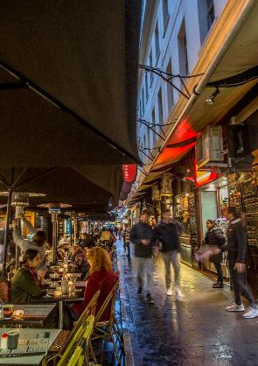

Visitor Economy Recovery and Reform Plan
This plan will be delivered by government and industry working together to ensure the tourism and events sector recovers strongly, drawing on industry and government consultation and analysis in the wake of the 2020 bushfires, the global pandemic and from the Regional Tourism Review.

Vision
Victoria’s visitor economy and tourism industry quickly recovers from the combined impacts of bushfires and the COVID-19 pandemic by growing and rebuilding its domestic visitor economy market share and preparing for growth and resilience when international borders reopen.

Objectives
The plan aims to ensure Victoria maintains and grows its visitor economy market share through and beyond recovery, quickly increasing economic activity. It will do this with new projects, a speedy recovery of the domestic market, and by building a resilient industry that supports long-term growth.
The plan focuses on supply and demand pillars and core enablers of the visitor economy.

Key themes
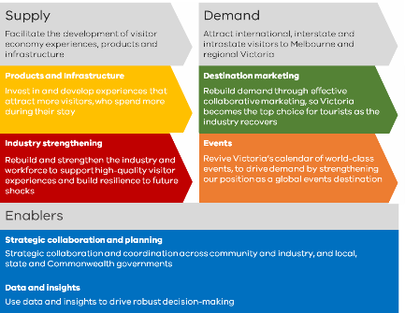

Supply
Facilitate the development of visitor economy experiences, products and infrastructure

Demand
Attract international, interstate and intrastate visitors to Melbourne and regional Victoria

Products and Infrastructure
Invest in and develop experiences that attract more visitors, who spend more during their stay

Destination marketing
Rebuild demand through effective collaborative marketing, so Victoria becomes the top choice for tourists as the industry recovers

Industry strengthening
Rebuild and strengthen the industry and workforce to support high-quality visitor experiences and build resilience to future shocks

Events
Revive Victoria’s calendar of world-class events, to drive demand by strengthening our position as a global events destination

Enablers

Strategic collaboration and planning
Strategic collaboration and coordination across community and industry, and local, state and Commonwealth governments

Data and insights
Use data and insights to drive robust decision-making

Action areas
Products and infrastructure to strengthen our tourism offering
Invest in and develop experiences that attract more visitors, who spend more during their stay.

Strategic statewide planning
While continuing to support traditional products, we will focus on key experience pillars that are sustainable competitive strengths for Victoria, and which provide significant opportunities for growth.
These are:
- nature
- epicurean
- arts and culture
- First Peoples' led experiences
- design, fashion and retail
- sport and events.
We will deliver a statewide destination master plan underpinned by priority sector plans, with $4.8 million to support strategic planning. We will also partner with regions to deliver regional and local destination planning.
The first sector priorities to be developed will be the Nature-Based Tourism Plan and the First Peoples' Tourism Plan.
We will also explore better facilitating tourism opportunities, including on public land.
This strategic statewide approach will leverage key growth opportunities and efficiently allocate efforts to improve the state’s tourism offering, while regional and local plans will capture community priorities.

Outcomes:
- A new strategic direction and a coordinated approach to investment in tourism products and experiences
- Strong offering of visitor products and experiences supported by tourism infrastructure
- Product and infrastructure development that aligns with recovery priorities

Infrastructure and investment
We are building a strong pipeline of demand-driving infrastructure, providing investment and planning facilitation.
We are also strengthening public infrastructure to encourage private investment and enable timely commencement of construction for new tourism products, including:
- investing $46 million in smaller-scale shovel ready tourism products
- investing $149 million to deliver flagship projects across Victoria that can create a halo effect and spur private investment and new products in surrounding areas
- establishing a $100 million Regional Tourism Investment Fund with support available for enabling infrastructure, priority private-led projects and nature- based products on public land
- establishing a $10 million Enabling Tourism Fund to explore new and innovative investment, and provide investment facilitation to unlock private investment.
To support these investments, we will facilitate priority tourism projects, including using the planning process to facilitate timely and consistent decision- making for nominated tourism projects.
These funds are in addition to the $100 million Melbourne City Recovery Fund partnership between the Victorian Government and the City of Melbourne, to support the CBD as it recovers.
Delivering a strong pipeline of demand-driving tourism infrastructure will generate construction jobs in the immediate term. In the longer term, it will help stimulate the economy and provide high-quality tourism products for industry, investors and visitors.

Flagship projects
The Victorian Government has provided $149 million for key regional tourism infrastructure projects to support jobs and local communities:
Wilson's Prom Revitalisation
- Strengthen Victoria’s iconic Wilson’s Prom as a protective habitat for endangered native animals and enhance visitor facilities and infrastructure.
Maximising Investment in Grampians Peaks Trail
- Invest in the trail heads in the four LGA's of Ararat, Southern Grampians, Horsham Rural City and Northern Grampians Shire. The project will also include an upgrade of facilities at the iconic Mackenzie Falls.
Falls to Hotham Crossing – Stage 1
- Create an iconic facilitated walk across the high plains between Falls Creek and Mount Hotham ski resorts.
Murray River Adventure Trail
- First stage investment in a long-distance cycling, walking and aquatic trail along and on the Murray.
Brambuk Cultural Centre Revitalisation
- Refresh Brambuk facilities and develop new visitor experiences that complement regional First Peoples’ led attractions.
Maximising Mallee Art Silo
- Improved visitor experiences, visitor servicing and enabling infrastructure needed to capitalise on silo art visitation to the region.
National Centre for Photography, Ballarat
- Deliver a Centre that will be Australia’s leading photographic destination with innovative year-round programming and international peer networking and collaboration.
Prosecco Road
- Deliver early infrastructure works such as outdoor art along ‘Prosecco Road’ (Wangaratta to Whitfield Road), township directional and interpretive signage and a visitor experience at Dal Zotto Wines.
Gippsland Tourism Recovery Package
- Create a vibrant destination of choice for visitors, including providing more options for visitors to get close to nature and relax in luxury surrounds.
Great Ocean Road
- Funding for a coastal trail from Fairhaven to Skenes Creek, including five swing bridges, upgrading visitor facilities and increasing camping spots on the Surf Coast.

Regional Tourism Investment Fund – stimulus projects
The Victorian Government has funded 30 new infrastructure projects to help the sector recover, drive visitation and create jobs from the $46 million stimulus round of the fund.
Daylesford and Macedon Ranges
- Hammon Park Trail Head & Bike Park, Creswick
- 1001 Steps All Accessibility & Sculpture Trail – Stage 2 Master Plan, Bacchus Marsh
Geelong and the Bellarine
- Bellarine Railway Rehabilitation Project, Drysdale
Gippsland
- Gurneys "The Arches" Experience, Foster
- Haunted Hills MTB Stage 2, Latrobe Valley
- Gabo Island Light House Accommodation Upgrade
- Thomson River Camping and Canoe Experience, Walhalla
Goldfields
- Goldfields Track Transformation - Stage 1 (Signage & Interpretation) - Ballarat to Bendigo
- Little Lon Distillery at the Goods Shed, Ballarat
- Welcome to Dja Dja Wurrung Country, Castlemaine
- Central Goldfields Art Gallery Upgrade - Stage 2 & 3, Maryborough
- Great Stupa Event & Tourism Infrastructure, Bendigo
Grampians and Wimmera Mallee
- Penshurst Volcanoes Discovery Centre
- Murtoa Stick Shed Visitor Experience Upgrade
Great Ocean Road
- Blow Hole Viewing Platform, Loch Ard
Greater Melbourne
- Royal Botanic Gardens Cranbourne, Eco- Tourism
Victoria's High Country
- All Saints Estate, Cellar Door & Restaurant
- Mt. Buller Mountain Biking Trails
- Blue Gums to Eildon Rail Trail, Alexandra
- Great Victorian Rail Trail - Art Installations & Signage
Mornington Peninsula
- Point Nepean Camping Development
Murray and Goulburn Valley
- Port of Echuca Discovery Centre Refurbishment
- Bonegilla Migrant Experience & Rail Trail, Lake Hume/Wodonga
- Swan Hill Pioneer Settlement Sound and Lightshow
- Visitor facility at the new Victorian Fisheries Authority Acadia Native fish hatchery, Shepparton
Phillip Island
- Rusty Water Brewing Experience, Phillip Island Brewing
Yarra Valley and the Dandenong Ranges
- Yarra Trail Northern Loop
- Warburton Redwoods Experience Uplift
- Dandenong Ranges Botanic Garden Rebuild of the 2013 Chelsea Best in Show Garden
- "Big Jeezley" Raptor Rehabilitation Facility, Healesville Sanctuary

Industry strengthening
Rebuild and strengthen the industry and workforce to support high-quality visitor experiences and build resilience. Funding of $8 million is being provided to support businesses to improve their digital and business capabilities and to support skills and planning.

Building digital and business capabilities
We will deliver local capability building programs to upskill businesses to adapt to COVIDSafe principles, address industry-specific challenges and build industry resilience.
We will establish tourism-specific digital capability building and business capability development programs.
These programs will advise and mentor in the use of digital platforms, digital marketing, business sustainability, crisis management and experience/product development.
New Visitor Economy Partnerships and partners in greater Melbourne will be supported to deliver tailored, localised versions of capability development programs.

Skills and workforce planning
We will collaborate with industry in a strategic and coordinated way to undertake a Workforce Planning and Skills Audit, to identify critical gaps and potential opportunities in the workforce as we recover from the pandemic.
Based on the recommendations of the Workforce and Skills Audit, funding will be available for Visitor Economy Partnerships to develop and implement tailored local workforce plans.

Visitor services
Funding of $3 million will support partnerships with industry to implement improved approaches and technology for visitor services that meet contemporary visitor needs.

Outcomes:
- Businesses have the capabilities to adapt to new market conditions, engage more effectively with consumers and develop innovative tourism products.
- Tailored workforce plans informed by detailed understanding of tourism workforce and skills needs are in place across the state.
- Visitor Economy Partnerships have the capacity and strategic focus to support businesses to recover.

Destination marketing
Rebuild demand through effective collaborative marketing so Victoria becomes the top choice for visitors.

Marketing
As domestic and international travel returns, there will be unprecedented competition for travellers’ interest and increased marketing spending by Victoria’s competitors.
Through the Click for Vic campaign, we have encouraged Victorians to purchase produce, wines, bespoke brews and spirits, and craft products from local Victorian businesses as a way of stimulating business for the tourism industry.
Funding of $58 million will support Visit Victoria’s marketing activities through the plan. Activities will be driven by a long-term post-coronavirus strategy to cut through a crowded marketing landscape and flexibly adapt to changing domestic and international travel conditions.
- As Melbourne reopens, an integrated intrastate recovery campaign – Stay close, go further – is being rolled out, including strategic partnerships with accommodation and travel organisations.
- A new interstate and New Zealand marketing campaign is underway to position the state as creative, cultural and progressive, and focus on new experiences for people who have been to Melbourne before.
- Major international markets will be targeted ahead of travel restrictions being lifted, based on consumer confidence and the aviation outlook, positioning Melbourne as the gateway to Australia.

Travel vouchers
Intrastate marketing is being supported by a $44 million campaign to drive immediate demand through travel vouchers. 200,000 vouchers (160,000 in regional Victoria and 40,000 in Melbourne) are being made available to Victorians to support travel across the state.

Industry partnerships
We will partner with Regional Tourism Boards, new Visitor Economy Partnerships, local government and industry to deliver marketing activity.

Brand framework
We will develop a new consumer-facing brand framework for Victoria, in collaboration with key stakeholders.

Outcomes:
- Melbourne and Victoria remain top-of-mind for future travel, supporting recovery of intrastate and interstate visitation as restrictions are lifted.
- Leverage Victoria's brand as a safe and trusted destination to promote Victoria on the global stage.
- Victoria has a strategic and coordinated approach to destination marketing that responds to market conditions.
- A cohesive and collaborative new brand for Victoria.

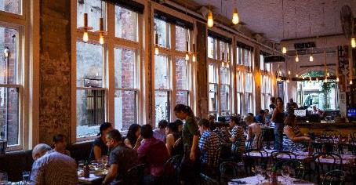

Events
Revive Victoria’s calendar of world-class events and strengthen our position as an events destination.

Events attraction
Events are a core part of Victoria’s destination brand, and they drive visitation.
Visit Victoria, the Melbourne Convention Bureau, and Business Events Victoria are actively planning for a strong forward calendar of events to help underpin recovery of the visitor economy.
Victoria's major events calendar will be strengthened by an investment of an additional $152 million over four years. This funding will allow Victoria to pursue new and innovative events that are being developed, and target events that have become more footloose, in a COVIDSafe world.
In addition, renewed investment in the Regional Events Fund of $20 million will support regional events across the state over four years, developing major iconic regional events and building the capability and capacity of regional communities to deliver strong and sustainable events.
Future funding will focus on Victoria’s competitive strengths in nature-based, sport, design and fashion, creative, and culinary events and festivals.
A more flexible Business Events Program will make funds available to attract domestic events, until international conferences return.
Event business development activities will be staged based on COVIDSafe requirements and reopening of intrastate, interstate and international markets, with a preliminary focus on regional and domestic events and alternative event delivery methods.

Outcomes:
- Visit Victoria and the Melbourne Convention Bureau have the flexibility to target events that will best support recovery of the visitor economy.
- Focus on national events supports intrastate and interstate visitation while international borders are closed.
- Strong forward pipeline strengthens Victoria’s brand as an events destination and rebuilds longer-term demand.

Strategic collaboration and planning
Collaborate and coordinate across community and industry, and local, state and Commonwealth governments.

Transition Regional Tourism Boards to Visitor Economy Partnerships
During the next three years, the Victorian Government will support the transition of the existing network of Regional Tourism Boards into a new network of Visitor Economy Partnerships.
Visitor Economy Partnerships will play a more significant role by 2023.
This transition will involve the formation of transition committees with representatives from Regional Tourism Boards, councils, government and industry. This reform is supported by $15.4 million to commence the transition so these organisations have greater scale, capability and coverage.
Under the new model, Visitor Economy Partnerships will:
- have a clear sense of purpose and defined responsibilities
- encourage local and industry leadership, with senior local council, industry and skills-based board membership
- include all regions, with boundaries co-designed and agreed in collaboration with local councils
- leverage benefits of scale
- have local ownership and flexibility with the broad geographic coverage to deliver region-wide initiatives.

Enhance leadership and coordination to drive recovery outcomes
The government is improving leadership and coordination through the Greater Melbourne Tourism Recovery Forum. This forum engages industry to re-activate tourism in Greater Melbourne.
A Visitor Economy Recovery and Reform Ministerial Advisory Council will also be established, bringing together industry leaders to provide guidance on whole-of-government management and implementation of this plan. It will be supported by the Department of Jobs, Precincts and Regions, and will report through the Minister to government on progress and any additional reforms needed to realise the plan's objectives.
We will work with industry to coordinate research and data insights with improved sharing to inform and measure progress in implementing this plan at state and regional levels.

Outcomes:
- Visitor Economy Partnerships have the capacity and strategic focus to support businesses to recover.
- Visitor Economy Partnerships provide strong leadership and links between community, councils, government and industry.
- Local stakeholders effectively coordinate and collaborate with Visit Victoria and government.
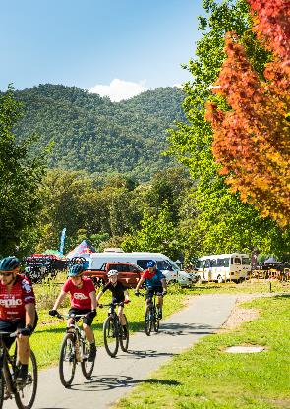

Outcomes 2020-24

A strategic whole-of-state approach to visitor economy recovery and reform
The Victorian Government is working to attract more tourists to the state, supporting regional jobs and delivering a significant recovery from the combined effects of bushfires and the COVID- 19 pandemic in 2020.
With a commitment of $633 million over four years, the Victorian Government will invest in infrastructure, marketing and major events, destination planning, industry development, and the transition of Regional Tourism Boards to a Visitor Economy Partnership model.
The Victorian Government will collaborate with Visit Victoria, the Victoria Tourism Industry Council, Regional Tourism Boards, new Visitor Economy Partnerships, Local Government Authorities, the Greater Melbourne Tourism Recovery Forum, industry, and local communities to deliver strategic actions outlined in the Visitor Economy Recovery and Reform Plan. The plan will provide cohesive and compelling statewide tourism offerings for visitors and strengthen the visitor economy.

Outcomes
$35 billon  Annual visitor expenditure by June 2024 | $12.4 billon  Annual regional visitor expenditure by June 2024 | 300,000  Jobs supported by the visitor economy in June 2024.

2020-21
2020–21 will focus on immediate recovery efforts that support quick wins. We will support businesses with domestic marketing and events campaigns, deliver support programs for business and commence smaller- scale infrastructure projects that provide immediate stimulus.
We will:
- Start delivering Regional Tourism Investment Fund stimulus projects and flagship projects
- Deliver an Enabling Tourism Fund
- develop an expanded major events calendar
- deliver tourism digital capabilities and tourism business skills and resilience programs
- commence tourism workforce audit to understand needs
- deliver a Regional Travel Voucher Scheme and Melbourne Travel Voucher Scheme
- activate intrastate and interstate marketing
- reopen the Regional Events Fund
- focus short-term on domestic business events
- commence transition planning for Regional Tourism Boards to Visitor Economy Partnerships
- establish the Visitor Economy Recovery and Reform Ministerial Advisory Council
- establish a Greater Melbourne Tourism Recovery Forum.

2021-22
Through 2021-22, domestic markets will continue returning to normal and it's likely some international markets will start to open. Smaller infrastructure projects will be completed. Some flagship projects will commence, and other priority projects will be identified and facilitated, consistent with the statewide plan.
We will:
- start delivering flagship projects
- start delivering the Regional Tourism Investment Fund
- release a statewide destination master plan
- release a Nature-Based Tourism Plan
- release a First Peoples’ Tourism Plan
- start developing regional and local action plans
- improve visitor engagement services
- when feasible, activate international marketing on a case-by-case basis
- develop a consumer-facing brand framework
- finalise establishment of Visitor Economy Partnerships.

2022-23
Domestic markets will have returned to pre-2020 levels by 2022–23, with international markets progressively recovering. Visitor Economy Partnerships will begin operating across regional Victoria. More recovery projects will be completed, and further infrastructure projects will commence. We will continue to deliver reforms and initiatives as recovery continues.

2023-24
All markets will have returned to pre-2020 levels and will continue to grow.
Unique tourism offerings will be developed and marketed by each region, led by Visitor Economy Partnerships. New private investment will continue to support the development of new and enhanced experiences.

